Press Release
Asahi Photoproducts Supports Comexi, in a Breakthrough Turnkey Project
Innovative solutions integrate prepress and print into client facilities
Tokyo, Japan & Brussels, Belgium, August 25th, 2020. Asahi Photoproducts, a pioneer in flexographic photopolymer plate development, today reported it is participating in an important project with Comexi and other industry partners. As part of this Turnkey Project, Asahi will place an Asahi AWP™ 4835 P water wash processor and Asahi AWP™ water-washable plates with CleanPrint at Comexi’s Manel Xifra Boada Technology Center in Girona, Spain. The project is designed to educate flexible packaging companies about the value of bringing flexo platemaking in-house and demonstrating how easy that is to do with today’s technology.
“We are proud to be participating in this very important project together with our partner Comexi,” says Philip Mattelaer, Asahi Photoproducts’ Head of Sales. “There is an increasing trend for flexographic printers to bring platemaking in-house, both to drive efficiency and improve quality. This project will demonstrate to the flexo market how easy it is to produce plates in-house, strengthening the value chain at the point of print production. In addition to improved efficiency and quality, this project also demonstrates how print providers can drive increased sustainability by incorporating Asahi CleanPrint technology on-site.”
CleanPrint flexographic plates from Asahi Photoproducts have been specifically engineered by Asahi’s chemical engineers to transfer all remaining ink to the printed substrate, reducing makeready time and press cleaning stops in comparison to other platemaking systems while delivering exceptional quality. Asahi CleanPrint flexographic plates are also ideal for fixed colour palette printing, a method that is increasingly being adopted to save time and money while still delivering the quality brands expect. This is made possible by the precise register of Asahi water wash CleanPrint plates. Its AWP family of plates and processors bring flexo platemaking into harmony with the environment, minimizing the use of water, eliminating noxious chemicals, and that way creating a cleaner direction for the flexographic industry.
Making flexographic plates in-house also means faster availability of plates, resulting in improved OEE. This is one factor driving the move to bring platemaking in-house – the same trend the offset printing industry underwent many years ago. Comexi’s Turnkey Project will host regular customer events demonstrating the power of “everything under one roof”.
“Visitors to the project will be pleasantly surprised to see how quickly and cleanly Asahi AWP water-washable plates with CleanPrint are produced, and they will have access to experts who can help set them on their own CleanPrint path toward a cleaner flexo printing future,” Mattelaer adds. “The key to controlling quality and service levels in flexographic printing is to control prepress, and the Comexi Turnkey Project shows visitors just how easily they can do that. It combines hardware, software, installation, optimization, training and production support to ensure a seamless transition to a clean future for flexographic printers of all sizes.”
For more information about flexographic solutions from Asahi Photoproducts that are in harmony with the environment, visit www.asahi-photoproducts.com.
--ENDS—
Images and captions:
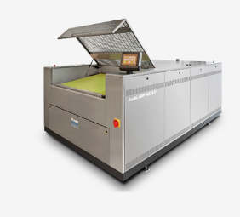
The AWP™ 4835 P plate processor is designed for the challenging demand of the mid-sized print operation using a plate format of 90 x 120 cm (35 x 48 inch). For wide-web sized customer, the new AWP™ 4260 PLF plate processor is the solution of choice with a plate format of 106,7 x 152,4 cm (42 x 60 inch). It reduces the use of natural water resources to a minimum, making it an environmentally sound solution for producing flexographic printing plates.

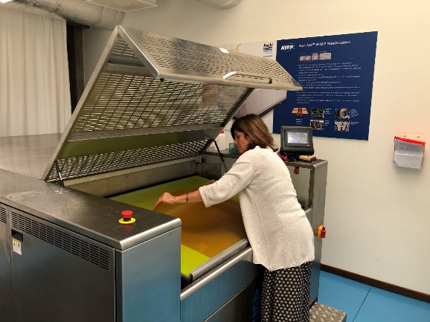
Asahi Photoproducts will place an Asahi AWP™ 4835 P water wash processor at the Comexi Manel Xifra Technology Center in Girona, Spain.

—ENDS—
About Comexi – www.comexi.com
Comexi, founded in 1954, has extensive experience in manufacturing equipment for the flexible packaging conversion industry. As a world leader, it operates five product lines, each specialized in a different conversion process: flexography printing, offset printing, laminating, slitting, and digital services. Furthermore, it has a Service and Technical Assistance Business Unit that offers service 24 hours a day, 7 days a week.
The company has two production plants: one in Riudellots de la Selva (Girona, Spain) and another one near the town of Montenegro, in the State of Rio Grande do Sul (Brazil). There are also two offices in Miami (USA) and Moscow (Russia). Moreover, Comexi is represented in more than 100 countries. This commercial network allows us to have proximity to our customers in order to optimally respond to their needs.
Comexi includes the Manel Xifra Boada Technological Centre, Comexi CTec, where the company provides support and shares its knowledge with various groups involved in the flexible printing industry process.

For further information:
Jesús Navarro – (+34) 677 489 237 – jesusnavarro@playbrand.info
Gemma Bessa – (+34) 972 477 744 – gemma.bessa@comexi.com
About Asahi Photoproducts
Asahi Photoproducts was founded in 1971 and is a subsidiary of the Asahi Kasei Corporation. Asahi Photoproducts is a leading pioneer in the development of photopolymer flexo printing plates. By creating high quality flexographic solutions and through continued innovation, the company aims at driving print forward in harmony with the environment.
Follow Asahi Photoproducts at .
More information is available at www.asahi-photoproducts.com and at:
Monika Dürr  duomedia  monika.d@duomedia.com  +49(0)6104 944895 | Dr. Dieter Niederstadt  Asahi Photoproducts Europe n.v. /s.a.  dieter.niederstadt@asahi-photoproducts.com  +49(0)2301 946743

