Press Release

Asahi Photoproducts Announces New FlatTop Flexographic Plates with Clean Transfer Technology
Asahi AFP™-BFTH plate, the only FlatTop plate in the market featuring premium Clean Transfer Technology
Tokyo/Brussels, February 4, 2019 – Asahi Photoproducts, a pioneer in flexographic photopolymer plate development, today announced the launch of the AFP™-BFTH plate in the first half of 2019, the only out-of-the-box built-in FlatTop plate in the market that features premium Clean Transfer Technology, which is designed to facilitate kiss touch printing pressure. This new plate, available in hard, fits seamlessly into any workflow and requires no special equipment.
“The AFP™-BFTH plate is the first plate with Clean Transfer Technology to boost solid ink homogeneity in printing,” says Dieter Niederstadt, Technical Marketing Manager at Asahi Photoproducts. “It also delivers consistent print quality throughout the run, with fewer press stops for plate cleaning. This adds up to increased productivity and throughput while significantly reducing waste. Asahi’s Clean Transfer Technology has found great market reception in our line of water-washable plates, and we are now excited to be extending this capability to other plate categories in our portfolio. Not only will this help flexographic printers increase productivity, but it will also extend the range of applications they can offer to their customers, including the ability to transfer more work from offset to flexo.”
AFP™-BFTH Plate: The Details
Asahi´s AFP™-BFTH digital flexo plate is the first built-in FlatTop plate to include Clean Transfer Technology, and it is available in hard (H). Benefits include:
- Printing plates remain clean during print production runs for consistent print quality and fewer press stops for plate cleaning.
- Plates are available in 1,14 and 1,7 mm.
- BFTH plates have been developed for water-based, solvent-based, and UV ink systems.
- In combination with solid area micro-screening technologies, it is possible to achieve 100% homogenous solid area coverage without any visible substrate voids.
- Plates deliver the same solid ink density levels in printing compared to today’s available FlatTop plate technologies.
- BFTH plates ensure very smooth tonal gradation in printing.
- They fit seamlessly in all plate making workflows available today, including standard tube UV, high energy UV diode exposure, or FULL HD imaging systems.
- One hardness grade is available: Hard for film and for paper substrates.
Benefits of Asahi Clean Transfer Technology
Asahi’s Clean Transfer Technology is designed to facilitate kiss touch printing pressure. Lighter printing pressure ensures constant repeatability of printing quality during the production run as well as longer plate life. This characteristic is achieved with unique Asahi-engineered photopolymer chemistry that reduces the surface energy of the printing plate and enables better ink transfer to the substrate during printing.
Clean Transfer Technology has the beneficial effect of reducing ink filling-in the mid-tone area during the printing run, leading to fewer cleaning intervals and less press downtime. Achieving graphical printing performance and improvement in productivity was the focus of Asahi´s Clean Transfer Technology plate development efforts. AFP™-BFTH plate technology improves press uptime during the printing process. Thus, Clean Transfer Technology signifies both productivity and reduced waste.
For more information about Clean Transfer Technology and other flexographic solutions from Asahi Photoproducts, visit www.asahi-photoproducts.com.
---END---

Captions:
BFTH_plate:
Very high screening resolution is possible with the Asahi AFP™-BFTH digital flexo plate due to the absence of oxygen in the plate making process.
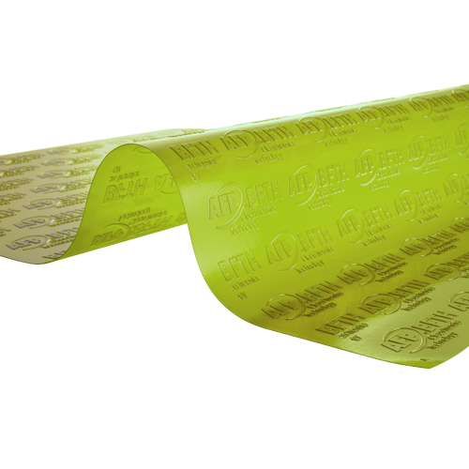
BFTH FlatTop highlight

About Asahi Photoproducts
Asahi Photoproducts was founded in 1971 and is a subsidiary of the Asahi Kasei Corporation. Asahi Photoproducts is a leading pioneer in the development of photopolymer flexo printing plates. By creating high quality flexographic solutions and through continued innovation, the company aims at driving print forward in balance with the environment.
Follow Asahi Photoproducts at
More information is available at www.asahi-photoproducts.com and at:
Monika Dürr  duomedia  monika.d@duomedia.com  +49 (0)6104 944895 | Dr. Dieter Niederstadt  Asahi Photoproducts Europe n.v. /s.a.  dieter.niederstadt@asahi-photoproducts.com  +49 (0)2301 946743



