Press Release
Asahi Photoproducts to Unveil CleanPrint at Labelexpo Europe 2019
The absolute best way to make flexographic printing a CLEANER technology (and more profitable!)
Tokyo/Brussels, 28 May 2019 – Asahi Photoproducts, a pioneer in flexographic photopolymer plate development, today reported it will be again exhibiting at Labelexpo Europe, scheduled for 24 to 27 September in Brussels. Asahi will be located on Stand 5a34 at the show and will be displaying its full array of flexographic plates. Featured at the show will be Asahi’s CleanPrint, a technology which has evolved over time to become the industry benchmark for CLEAN flexographic printing.
“Since Asahi first brought to market its innovative flexographic plate technology, which enabled complete release of ink onto the substrate for a cleaner image and fewer press stops for plate cleaning, our thoughts about the value of the technology have evolved,” said Dr. Dieter Niederstadt, Asahi’s Technical Marketing Manager. “Not only do we continue to improve our plate quality and performance, but we have also learned from our customers that the value of the technology goes way beyond the quality and productivity benefits it enables. Not only does it eliminate the need for volatile solvents in the platemaking process, speed up the process to consume less energy and deliver the same high quality and press productivity (OEE) our customers have come to expect, but the technology reduces makeready times and waste as well as the amount of time the press needs to run. All of these benefits add up to a much cleaner platemaking and flexographic printing process than can be achieved with any other plates on the market.”
At Labelexpo, Asahi will be featuring its popular AWP™-DEW water-washable plates, the first to use CleanPrint technology. “Our plan is to migrate this technology to other plates in our portfolio over time,” Niederstadt adds, “to ensure our customers can print CLEAN on the widest array of substrates in the market.”

Benefits of Asahi CleanPrint
Asahi CleanPrint is designed to facilitate kiss touch printing pressure. Lighter printing pressure ensures constant repeatability of printing quality during the production run as well as longer plate life. This characteristic is achieved with unique Asahi-engineered photopolymer chemistry that reduces the surface energy of the printing plate and enables better ink transfer to the substrate during printing.
CleanPrint has the beneficial effect of reducing ink filling-in the mid-tone area during the printing run, leading to fewer cleaning intervals and less press downtime for a highly sustainable flexographic printing process. Niederstadt notes, “Our customers are ecstatic about the quality of print they can deliver while also achieving as much as 50% less makeready time and 30% or more improvement in OEE.”
For more information about CleanPrint and other flexographic solutions from Asahi Photoproducts, visit www.asahi-photoproducts.com.
---END---

NOTE TO MEDIA: To schedule a one-on-one meeting with an Asahi Photoproducts executive, please contact monika.d@duomedia.com.

Captions:
AWP-plate: At Labelexpo, Asahi will be featuring its popular AWP™-DEW water-washable plates, the first to use CleanPrint technology,


Application images:
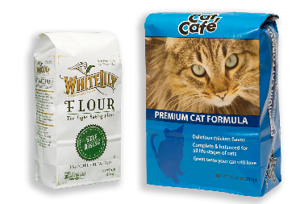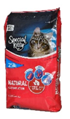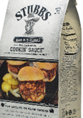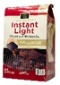
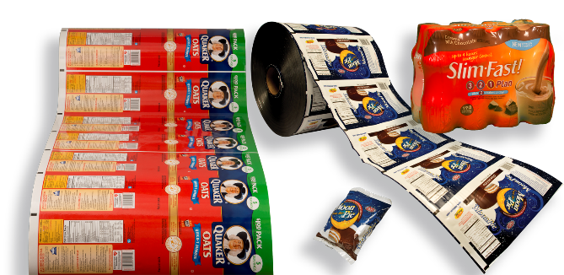

Plate Technology Time: Water-washable AWP™ plates are more efficient than solvent plates in job changeover.
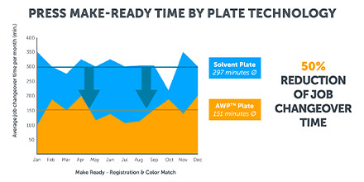

About Asahi Photoproducts
Asahi Photoproducts was founded in 1971 and is a subsidiary of the Asahi Kasei Corporation. Asahi Photoproducts is a leading pioneer in the development of photopolymer flexo printing plates. By creating high quality flexographic solutions and through continued innovation, the company aims at driving print forward in balance with the environment.
Follow Asahi Photoproducts at .
More information is available at www.asahi-photoproducts.com and at:
Monika Dürr  duomedia  monika.d@duomedia.com  +49 (0)6104 944895 | Dr. Dieter Niederstadt  Asahi Photoproducts Europe n.v. /s.a.  dieter.niederstadt@asahi-photoproducts.com  +49 (0)2301 946743

