Press Release
Asahi Photoproducts Announces New AFP™-Leggero Flexographic Plate for Corrugated Board Applications
Super-soft and smooth plate results in no board crush, fewer flute marks, good ink density, for the ultimate in post-print flexographic quality
Tokyo, Japan & Brussels, Belgium, March 26, 2020 – Asahi Photoproducts, a pioneer in flexographic photopolymer plate development, today announced the availability of a brand-new flexographic plate. Asahi AFP™-Leggero CleanPrint plates have been specifically designed for printing on lower quality low-liner corrugated board. This super-soft plate delivers kiss-touch printing without board crush, good ink density with reduced washboard effect, and is ideal for simple brown-box corrugated applications such as fruit trays and single-colour logo type printing.
“With the growing use of corrugated board packaging around the globe, brands and retailers increasingly seek ways to increase quality appearance and protect their goods at the same time,” said Dieter Niederstadt, Asahi Photoproducts’ Technical Marketing Manager. “Asahi’s AFP™-Leggero flexographic printing plates deliver both higher quality and better protection of the product by not damaging the corrugated box flute structure. This is a very new approach inside Asahi, not only to focus on print quality aspects, but also to add value for protection of the packaged goods. Our ‘Just Kiss. No Crush.’ tagline reinforces this quality and protective result delivered by Asahi AFP™-Leggero CleanPrint plates. In addition, as with all of our CleanPrint plates, the Leggero plates ensure less waste, fewer press stops for plate cleaning and consistent exceptional quality throughout the run, the hallmark of Asahi’s CleanPrint flexo plates. We expect packaging converters will be able to achieve up to 15% improvement in Overall Equipment Effectiveness (OEE) when they use these plates for corrugated post-print, delivering a solution in harmony with the environment.”
CleanPrint plates from Asahi Photoproducts have been specifically engineered to transfer all remaining ink to the printed substrate. The AFP™-Leggero CleanPrint effect is achieved because of the soft plate base material. The result is very clean printing. Another important benefit of Asahi’s CleanPrint plates, including AFP™-Leggero, is that they do not need to be cleaned as often as conventional digital solvent plates. Reduction of plate cleaning stops creates a significant productivity improvement as well as more consistent quality.
“With AFP™-Leggero’s soft-touch kiss printing,” Niederstadt added, “not only is the historical problem of board crush and washboarding virtually eliminated due to the softness of this plate, but there is also virtually no dot bridging and good ink laydown. That means that areas of solid colour as well as highlight areas are clean and crisp, as are fine lines and smaller type. This is the ideal plate for corrugated board post-print and will enable packaging converters to broaden the range of applications they can produce for customers, especially those that are not willing to sacrifice quality.”

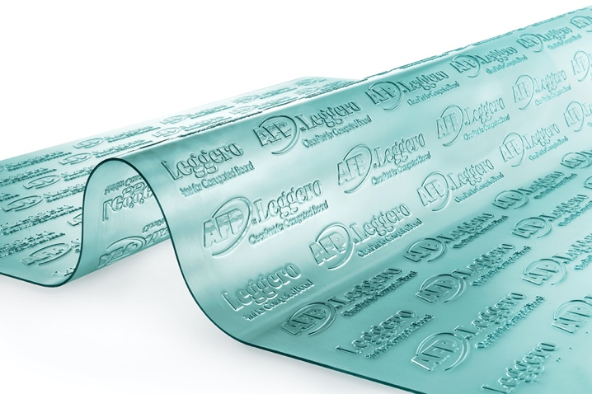
Caption: Soft base material ensures full ink transfer for CleanPrint results.
For more information about flexographic solutions from Asahi Photoproducts, visit www.asahi-photoproducts.com.
--ENDS—
About Asahi Photoproducts
Asahi Photoproducts was founded in 1971 and is a subsidiary of the Asahi Kasei Corporation. Asahi Photoproducts is a leading pioneer in the development of photopolymer flexo printing plates. By creating high quality flexographic solutions and through continued innovation, the company aims at driving print forward in harmony with the environment.
Follow Asahi Photoproducts at .
More information is available at www.asahi-photoproducts.com and at:
Monika Dürr  duomedia  monika.d@duomedia.com  +49(0)6104 944895 | Dr. Dieter Niederstadt  Asahi Photoproducts Europe n.v. /s.a.  dieter.niederstadt@asahi-photoproducts.com  +49(0)2301 946743


