Press Release

Asahi AWPTM-DEW 4260 PLF Delivers Higher Quality, Faster Processing, Sustainable Footprint and Easy Maintenance Concept
First water-wash processor of its kind with automated process from plate wash-out to UV finished plate
Tokyo, Japan & Brussels, Belgium, June 4, 2020 –Asahi Photoproducts, a pioneer in flexographic photopolymer plate development, today announced availability of it’s next-generation larger format water-wash flexographic plate processor, the AWPTM-DEW 4260 PLF. This is the first water-wash processor of its kind with an automated process from plate wash-out to the UV finished plate including plate processing, rinsing, drying and UV post exposure within one system.
“The market of larger volume users for AWPTM flexo plates and particularly for flexible packaging applications is growing,” said Dieter Niederstadt, Technical Marketing Manager. “For that reason, it was time for us to introduce a new member to our largest format processor family. Exclusively focusing on using the new AWPTM-DEW plate with this processor allows us to reduce the environmental footprint of the platemaking process by reducing the content of additives in the washout solution. It also allows us to speed-up the time for each plate coming out of the line dramatically.”
The system is designed to be able to use two standard formats at approx. 3-5 plates per hour, either 1200x 900 mm (48 x 36 inch) or 1067 x 1524 mm (42 x 60 inch), which gives both Asahi and its customers incredible flexibility in machine utilization. Plus, The AWPTM-DEW 4260 PLF is an automated combination of washer-dryer-light finishing, providing the opportunity for reduction of operator hands on requirements and potential associated errors. For customers already having a separate light finisher, the AWPTM-DEW 4260 PLF processor is available in a version without the light finisher function. This processor combination is the first incremental system of its kind and also features an improved UVA/UVC inline post exposure uniformity vs. offline systems with light finishing drawer.
AWPTM-DEW 4260 PLF: The Details
The AWPTM-DEW 4260 PLF processor is the successor development to Asahi’s 1116PD processor which has been used by many high-volume end users in the market. New features as compared to the older model include:
- Integrated plate punching system for pin bar
- Integrated air knife after plate rinsing unit to dry the plate
- Higher post-exposure uniformity with inline UVA and UVC light finishing
- Filter unit is located inside the machine with easy roll-out operator access
- New machine maintenance concept including low maintenance pumps and easy pipe layout
- Water safety tray located on the side frame without the need to clean leaked solution
- Asahi remote human machine interface (HMI) access and optional smart glass support system (future option)
- Optimized machine footprint at 6112 x 2070 x 1295 mm (smaller vs. separate units)

New Asahi maintenance concept
With the introduction of the new processor, Asahi has also realized the need to improve its AWPTM machine maintenance concept for our customers. As just-in-time production today is very important, the AWPTM-DEW 4260 PLF processor has a modem communication link on all machines to the processor’s human machine interface (HMI). This allows our technical support team to connect with the customer machine from any location for first level maintenance support. Our experience shows that 60% of the causes of all machine-related service issues can be traced with this support. In addition to tracing the cause of any problems, Asahi has also introduced a remote smart glass support concept as a future option on all systems. According to Alex Downes, Asahi Service Engineer, “The difference this functionality makes is unbelievable; pictures can explain so much more than words. A typical support interaction with a customer which took me hours of travel time in the past can now pin point the detailed problem in no time, allowing us to either fix the problem immediately or at least send the exact needed spare part to the customer. If we didn’t have the appropriate part with us on a traditional service call, that often required an additional visit, leading to more cost and potentially a longer down time. Now everything can be done quickly and in one step, often eliminating the need for any travel at all and getting the customer up and running quickly.” Niederstadt added, “Based on what we have seen in the start-up phase of this new service, we believe we can speed-up our service and reduce the amount of travel by half. This will better utilise our engineers and provide higher quality service for our customers.”
Caption: On-site customer smart glass remote support guided by Asahi Service Engineers
“Following the announcement of the AWPTM-DEW 4260 PLF processor at Labelexpo Europe in 2019, the first prototype machine was installed at a flexible packaging printer/converter,” Niederstadt added. “Now looking back over the last nine months of testing and more than 4.000 square meters of plate production, we are ready to bring this innovative processor into the market together with our AWPTM-DEW plate.” AWP™-DEW digital flexo plates are ideal for use with UV, EB, water-based and solvent-based inks and make a transition to Fixed Colour Palette printing easy, minimizing the need to use a larger number of spot colour inks. These durable plates also deliver improved plate lifetime on press.

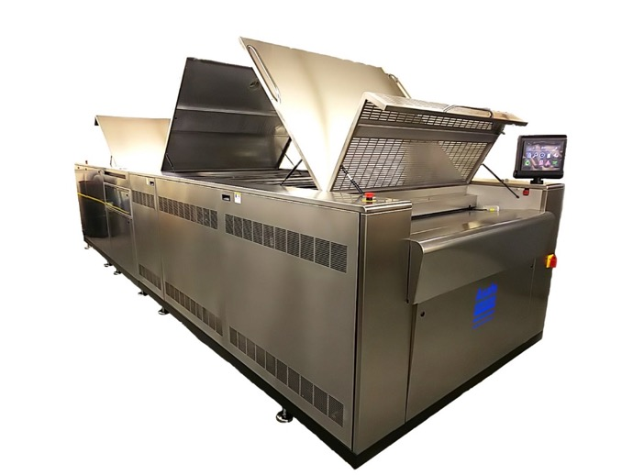
Caption: The AWP™-DEW 4260 PLF has a footprint of 6112 x 2070 x 1295 mm

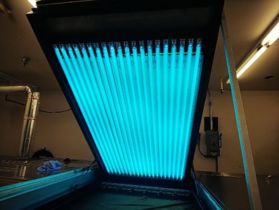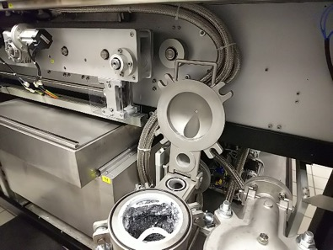
Inline-UV post-exposure ensures high plate uniformity Stainless steel machine components with easy roll-out filtration
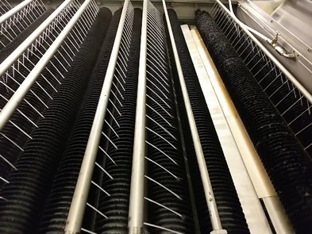
Round washout brushes with improved water supply

For more information about flexographic solutions from Asahi Photoproducts, visit www.asahi-photoproducts.com.
--ENDS—
About Asahi Photoproducts
Asahi Photoproducts was founded in 1971 and is a subsidiary of the Asahi Kasei Corporation. Asahi Photoproducts is a leading pioneer in the development of photopolymer flexo printing plates. By creating high quality flexographic solutions and through continued innovation, the company aims at driving print forward in harmony with the environment.
Follow Asahi Photoproducts at
More information is available at www.asahi-photoproducts.com and at:
Monika Dürr  duomedia  monika.d@duomedia.com  +49(0)6104 944895 | Dr. Dieter Niederstadt  Asahi Photoproducts Europe n.v. /s.a.  dieter.niederstadt@asahi-photoproducts.com  +49(0)2301 946743



