FOR IMMEDIATE RELEASE

Ricoh connectivity enhances client choice
and finishing flexibility

Ricoh Europe, London, 8 March 2016 – Ricoh is helping clients maximise their production capability by offering greater connectivity to finishing solutions through a new Ricoh interface unit.

“Smooth end-to-end production with minimum stoppages and downtime is what Print Service Providers are trying to achieve,” explains Benoit Chatelard, Vice President, Production Printing, Ricoh Europe. “They want to be able to produce and finish print as seamlessly as possible. Crucial to that is the connectivity of finishing systems, which facilitates fast job set-up and completion. That is why we are increasing our connectivity to third party solutions.”

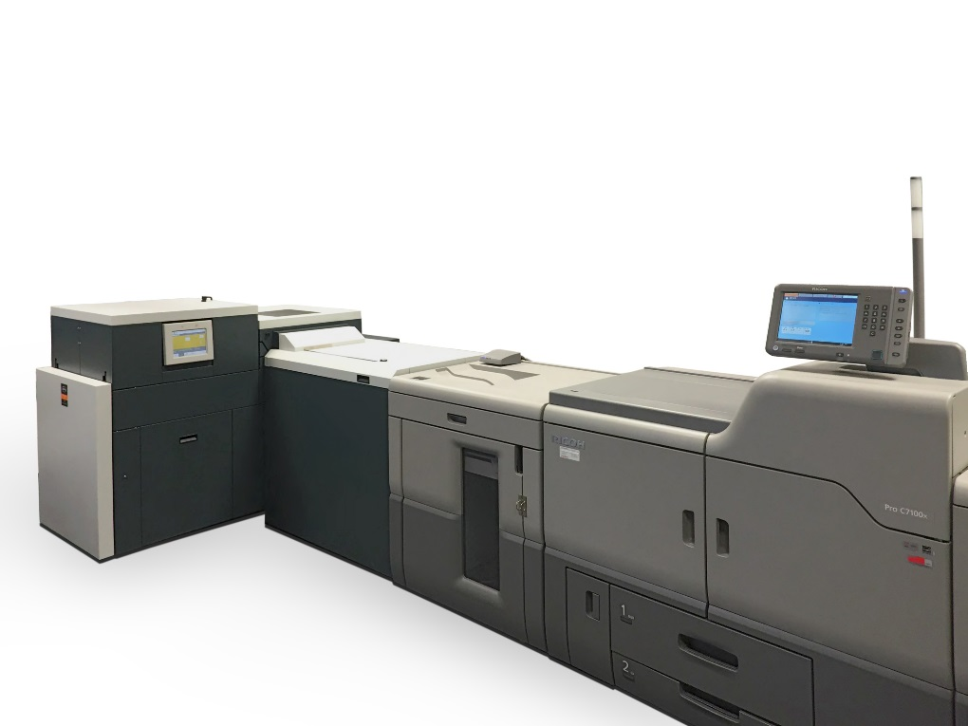

Booklet making connectivity
The Watkiss PowerSquare 224 booklet maker is the first third party finishing system to be configured to integrate inline, via the interface unit, with the Ricoh Pro™ C9100 series and Ricoh Pro™ C7100x series digital colour cut sheet production systems, and the Ricoh Pro™ 8100 series digital mono cut sheet production system. It has fully automated settings for different book sizes and pagination, including variable stitch leg length to support different book thicknesses. Its maximum book thickness of 10.4mm is double that of conventional booklet making machines. This makes it ideal for books with a high volume of pages or those produced on thicker stocks.

The small footprint system is easy to use with job parameters (paper size, book thickness and number of stitches) entered via a touchscreen. The PowerSquare automatically sets the stitch position, the wire draw length (the stitch leg length), the spine width required and the trim dimension. Job specifications can be quickly stored and recalled for efficient operation in the production of repeat jobs.

States Chatelard, “Connectivity to the Watkiss PowerSquare gives increased productivity to the Pro C9100 series, Pro C7100x and the Pro 8100, making a significant difference to the smooth, efficient operation of PSPs.”

Banner feeding enhancement
Also being seamlessly linked via the new Ricoh interface unit is a new high capacity banner feeding option, designed in conjunction with the leading media feed specialists, BDT, for the Pro C9100 and Pro C7100x colour cut sheet systems. The new retrofittable solution offers easy access, and has a 500 mm depth which is more than five times the capacity of the current Banner Feed Tray, and so can hold significantly more substrate which means fewer stoppages for refilling. In turn it speeds up throughput and increases production. It will be available in Europe from September 2016.

Adds Chatelard, “The very positive reaction to the banner functionality for the Pro C9100 and Pro C7100x series made it clear there is a strong appetite for this facility. We believe this step is a great solution for evolving busy production printing operations’ day-to-day workflow.”

He concludes: “We are committed to continuing to offer more choice, flexibility and productivity to PSPs. And we expect to announce a number of other finishing connectivity solutions in due course.”

-ends-

| Ricoh at drupa 2016 |
Ricoh will bring a range of products and services to drupa 2016 that will enable print service providers to accelerate their business transformation. Solutions on display will open new opportunities and routes to greater productivity and profitability for forward-thinking print professionals. Ricoh will also be bringing the ProTM VC60000 to the show. The world’s largest printing trade fair is scheduled for 31 May to 10 June at the Messe Duesseldorf, Germany, and Ricoh will again be located in Hall 8a.
| About Ricoh |
Ricoh is a global technology company specializing in office imaging equipment, production print solutions, document management systems and IT services.

Headquartered in Tokyo, Ricoh Group operates in about 200 countries and regions. In the financial year ending March 2015, Ricoh Group had worldwide sales of 2,231 billion yen (approx. 18.5 billion USD).

The majority of the company's revenue comes from products, solutions and services that improve the interaction between people and information. Ricoh also produces award-winning digital cameras and specialized industrial products. It is known for the quality of its technology, the exceptional standard of its customer service and sustainability initiatives.

Under its corporate tagline, imagine. change. Ricoh helps companies transform the way they work and harness the collective imagination of their employees.

For further information, please visit www.ricoh-europe.com

For further press information, please contact:
Ricoh Europe PLC
Jack Gibson
Tel: +44 (0) 20 3033 3632
E-mail: press@ricoh-europe.com
Ricoh at drupa: www.ricoh-europe.com/drupa2016
Homepage: www.ricoh-europe.com
Join us on Facebook: www.facebook.com/ricoheurope
Follow us on Twitter: www.twitter.com/ricoheurope
Visit the Ricoh media centre at: www.ricoh-europe.com/press

