Poligrafico Roggero & Tortia Picks Ricoh’s Pro™ VC60000
Ricoh Europe, London, 26 October 2017 - Poligrafico Roggero & Tortia (PRT), outsideTurin, is branching out from its traditional business and strengthening its ability to offer services for the transactional and direct mail market with the Ricoh Pro™ VC60000 continuous feed colour inkjet solution.
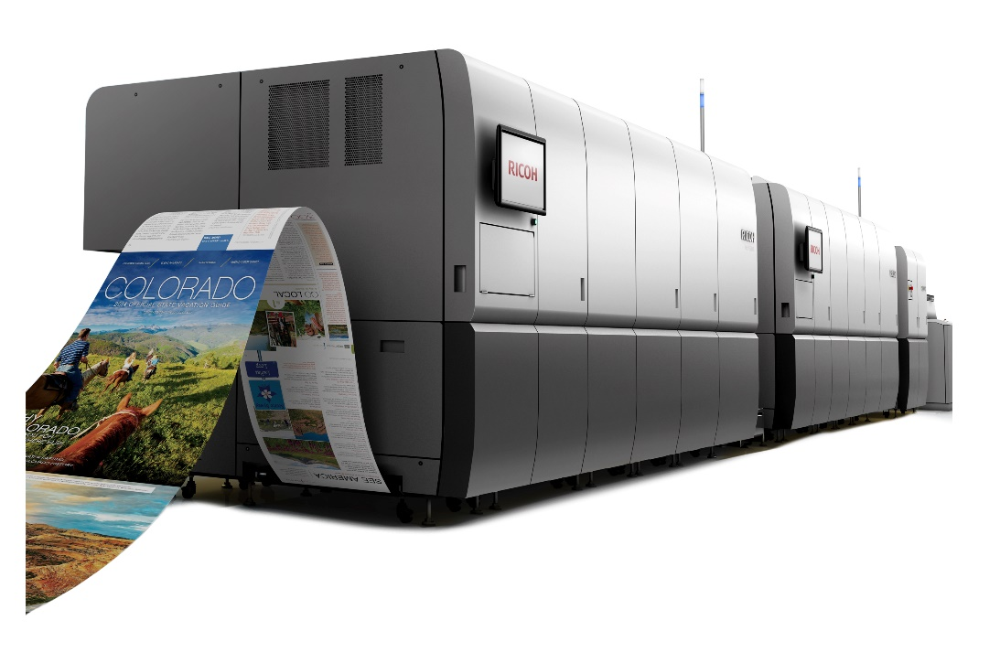

Ricoh Pro™ VC60000 continuous feed colour inkjet solution

Established in 1921, the graphic arts and printing company can now offer a full suite of output management services, from direct mail to transpromo and digital marketing.
Technology development has driven the investment explains PRT’s CEO Riccardo Pesce: “We keep a close eye on innovation and research. We handle all kinds of communication, on a multi-channel and one-to-one basis, offering competitive services to both companies that mail millions of documents and those that only send one at a time”.
Ricoh has been a major partner in this transformation process since 2007 when PRT installed the world’s first InfoPrint 5000 digital printing system to increase its production volumes. In 2013 it invested in the Ricoh InfoPrint 5000 AD3/AD4 full colour continuous feed solution. Now PRT has taken another step forward with the Ricoh Pro VC60000, with multi-drop ink, 1200 x 1200 dpi resolution and variable drop size at pixel level.

“Apart from being a highly productive solution,” says Pesce, “the Ricoh Pro VC60000 allows us to guarantee high output quality, with all the benefits of digital technology. The system is extremely flexible, particularly in terms of the media handled. All these aspects are fundamental and allow us to branch out from our traditional business and strengthen our services for the transactional and direct mail sectors, further expanding our communications offer”.
He continues: “Our services are developed to provide an end-to-end solution, meaning that customers generate the document using their own IT systems and we then take over, printing and mailing the document at the best postal rates to addresses both in Italy and in 14 countries around the world.”

Eef de Ridder, Director, Commercial Printing, of the Commercial and Industrial Printing Group, Ricoh Europe, comments, “We are delighted to have been able to partner PRT as it has grown and developed its services and solutions. We have supported it as it simplified its operations and increased its productivity. We are proud that its ambitious expansion plans will be facilitated by this latest Ricoh investment.”

-Ends-

|About Ricoh |
Ricoh is empowering digital workplaces using innovative technologies and services enabling individuals to work smarter. For more than 80 years, Ricoh has been driving innovation and is a leading provider of document management solutions, IT services, commercial and industrial printing, digital cameras, and industrial systems. Headquartered in Tokyo, Ricoh Group operates in approximately 200 countries and regions. In the financial year ended March 2017, Ricoh Group had worldwide sales of 2,028 billion yen (approx. 18.2 billion USD).

For further information, please visit www.ricoh-europe.com.

For further press information, please contact:
Ricoh Europe PLC
Jack Gibson
Tel: +44 (0) 20 3033 3766
E-mail: press@ricoh-europe.com
Homepage: www.ricoh-europe.com
Join us on Facebook: www.facebook.com/ricoheurope
Follow us on Twitter: www.twitter.com/ricoheurope

