Ricoh unveils the Ri 100 Direct to Garment printer

Ricoh Europe, London, 09 January 2018 – Ricoh continues to expand the possibilities for new and existing garment printing businesses with the launch of an entry level Direct to Garment (DTG) printer, the RICOH Ri 100.

Ideal for creative entrepreneurs starting a garment printing business or those wanting to add a new profitable product line to their existing printing business, the RICOH Ri 100 uniquely combines high quality output and ease of use at an affordable price level. It is best suited for low volume printing needs.
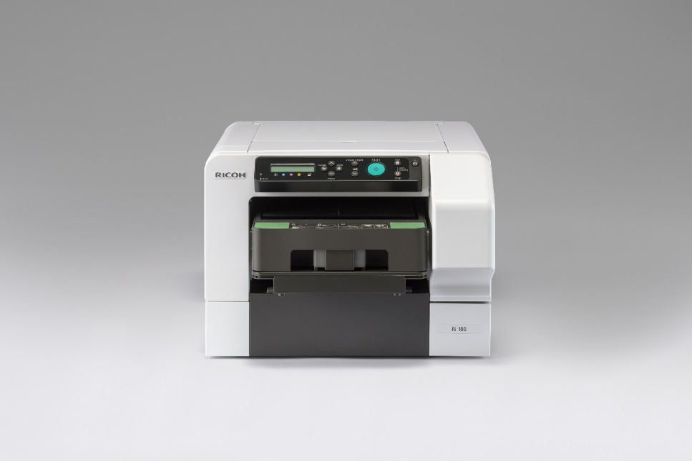

Ricoh’s new Ri 100 Direct to Garment (DTG) printer.

The latest solution further expands Ricoh’s DTG portfolio, which includes the recently launched RICOH Ri 3000 and Ri 6000 DTG printers. The Ri 100 enables operations to print on demand promotional and personalised items like T-shirts, cloth bags, cushion covers and sweatshirts. The Ri 100 can print on a wide range of materials from 100% cotton to blends with a minimum of 50% cotton.

The Ri 100 enables print providers to respond flexibly to the changing needs of the end user. It delivers dynamic offerings with quick, high quality digital printing and without the need for minimum order quantities. It is expected to become popular across a wide range of industries and for many activities, including fashion, universities, colleges & schools, corporate brands, SMBs, home decoration shops, tourism, youth groups, sports clubs and charity events.

The Ri 100 supports wireless printing from any application or workstation with a simple printer driver. Meanwhile, user-friendly automatic maintenance features support uptime. Additional design software can be used to enhance pictures and add text.

Graham Kennedy, Head of Commercial Inkjet Business, Commercial and Industrial Printing Group, Ricoh Europe, says: “We are delighted to build on the success of the Ri 3000 and Ri 6000 with this compact entry level option. Its affordability and ease of use will attract a new audience to garment decoration and allow operations to expand their range of services fully supported by the highly knowledgeable and responsive Ricoh team. It has never been easier to start Direct to Garment printing with a complete solution from one vendor.”

The system includes the stackable, Ricoh Rh 100 Finisher as an option. This space-saving solution eliminates the need for a separate heat press.

The Ri 100 Direct to Garment printer also incorporates versatile Ricoh piezo-electric inkjet technology to deliver crisp high quality prints. The integrated variable drop size technology enables the printing of detailed designs and photographs with smooth gradations at 1200 x 1200 dpi resolution.

The Ricoh Ri 100 will be available in the UK, Netherlands and Spain from April. It will be available in the rest of EMEA later in the spring.

To learn more about the Ricoh DTG printers please visit www.ricoh-europe.com.

-Ends-

|About Ricoh |
Ricoh is empowering digital workplaces using innovative technologies and services enabling individuals to work smarter. For more than 80 years, Ricoh has been driving innovation and is a leading provider of document management solutions, IT services, commercial and industrial printing, digital cameras, and industrial systems. Headquartered in Tokyo, Ricoh Group operates in approximately 200 countries and regions. In the financial year ended March 2017, Ricoh Group had worldwide sales of 2,028 billion yen (approx. 18.2 billion USD).

For further information, please visit www.ricoh-europe.com.

For further press information, please contact:
Ricoh Europe PLC
Jack Gibson
Tel: +44 (0) 20 3033 3766
E-mail: press@ricoh-europe.com
Homepage: www.ricoh-europe.com
Join us on Facebook: www.facebook.com/ricoheurope
Follow us on Twitter: www.twitter.com/ricoheurope

