Ricoh presents broadest portfolio at FESPA 2018
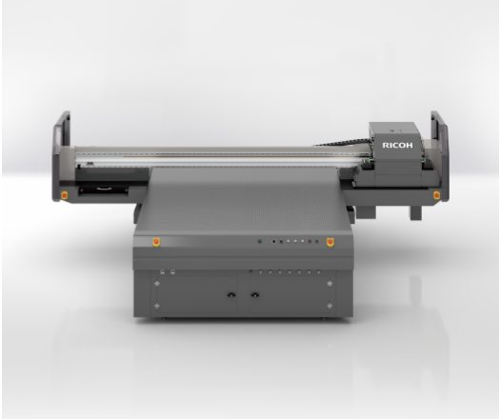
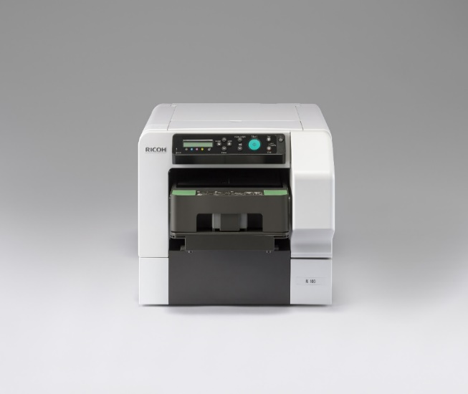
Ricoh Europe, London, 08 February 2018 – Ricoh will be using FESPA to highlight how its latest wave of innovations can help print providers profitably expand their services.

Ricoh’s FESPA line up will include flatbed, large format, direct-to-garment, sheet fed and inkjet printhead technologies

On its 224sqm Hall 3.1 A50 stand, at Messe Berlin, from May 15 to 18, Ricoh will explore with print and communications businesses how to open new worlds of opportunity in the vibrant Sign and Display sector.

In five distinct areas, it will demonstrate the latest in flatbed, large format, direct-to-garment, sheet fed and inkjet printhead technologies.

An applications and software studio area, featuring a wide range of print examples from a host of Ricoh systems, will highlight further possibilities. It will also enable visitors to explore a broad spectrum of creative opportunities.

Graham Kennedy, Head of Commercial Ink Jet Business, Commercial and Industrial Printing Group, Ricoh Europe, comments: “We’re excited to present systems from across our continuously-expanding portfolio. From flatbed for decor and innovative cost-effective garment printing to large format and our own widely adopted technology inkjet print heads – we have solutions to address diverse challenges. Our specialists will be on hand to help visitors identify revenue earning opportunities and talk through seamless integration that supports efficient and streamlined workflow.”

Ricoh is located near the seminar and club FESPA areas as well as the main entrance. Visitors are encouraged to explore Ricoh’s extensive cost-effective portfolio and discover how it can help them expand their business and opportunities.

For more information visit www.ricoh-europe.com.

-Ends-

|About Ricoh |
Ricoh is empowering digital workplaces using innovative technologies and services enabling individuals to work smarter. For more than 80 years, Ricoh has been driving innovation and is a leading provider of document management solutions, IT services, commercial and industrial printing, digital cameras, and industrial systems. Headquartered in Tokyo, Ricoh Group operates in approximately 200 countries and regions. In the financial year ended March 2017, Ricoh Group had worldwide sales of 2,028 billion yen (approx. 18.2 billion USD).

For further information, please visit www.ricoh-europe.com.

For further press information, please contact:
Ricoh Europe PLC
Jack Gibson
Tel: +44 (0) 20 3033 3766
E-mail: press@ricoh-europe.com
Homepage: www.ricoh-europe.com
Join us on Facebook: www.facebook.com/ricoheurope
Follow us on Twitter: www.twitter.com/ricoheurope

