Ricoh announces first IPN partnership

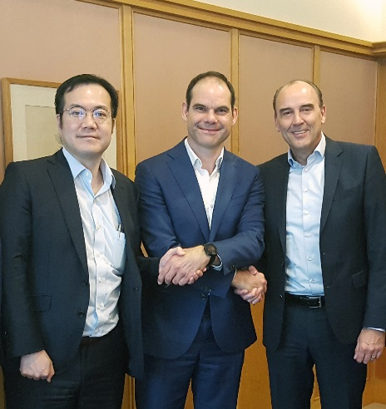
Ricoh Europe, London, 19 July 2018 – Ricoh has agreed a worldwide partnership with the IPN (International Printers Network) that will support the development of collaborative relationships and enable mutually beneficial knowledge sharing.

L-R Keith Miyazaki, General Manager of Commercial Printing Business Centres, Ricoh Company Ltd, Jeroen Beckers, General Manager IPN, Eef de Ridder, Vice President, Commercial Printing of the Commercial & Industrial Printing Group, Ricoh Europe.

IPN, established 25 years ago, is a unique global network of entrepreneurs, C-level executives and business owners. Based on personal relationships, it promotes the exchange of real life peer-2-peer experience, knowledge and innovation, in a non-competitive environment.

A recent review and a renewed strategy to maintain relevance to its members has led IPN to develop the Business Partner concept. This encourages a closer relationship with vendors to the mutual benefit of both vendors and members alike. It offers support with brand awareness,
building relationships, knowledge, sales, efficiency and marketing.

“This partnership will enable Ricoh to engage with IPN members and develop mutually collaborative relationships,” says Keith Miyazaki, General Manager of Commercial Printing Business Centres, Ricoh Company Limited. “We can share our roadmap and gather honest and insightful feedback from vendor agnostic members worldwide. Their regional perspective will also enable us to ensure our developments competently address the needs of the US, Europe and Asia Pacific markets. We look forward as well to actively participating in the general and technical meetings, as well as the expo, where we can share knowledge and also learn from the other members.”

Jeroen Beckers IPN General Manager adds: “The value of the network is rooted in the open approach of its membership and we are delighted that Ricoh has become our first Business Partner. We, along with our stakeholders, look forward to learning more about its market outlook, research and development programme, planned product evolution and ongoing portfolio enhancements, while at the same time sharing our updates and experiences.”

For more information visit www.ricoh-europe.com.

-ENDS-

| About IPN |
Established 25 years ago, the IPN started its activities as a network for entrepreneurs in the printing and graphic arts industry. Today the IPN covers the customer journey, but also includes all digital means of communications, such as social media.
The IPN is a peer-2-peer network of entrepreneurs. Membership is vested in C-level executives, often the owners themselves, who then attend IPN meetings to exchange knowledge, experience and innovations and to develop mutual business. All this is done based on relationships that are built over multiple IPN events.
It is a unique network that has achieved its global reach whilst still maintaining a size that facilitates the building of true personal relationships. This leads to an environment where the exchange of real life experience, knowledge and innovation between entrepreneurs, can be achieved based on mutual trust in a non competitive environment.
Recently the IPN has reviewed and renewed its strategy in order to maintain its relevance to its members, other partners and the industry at large. This has led to the development of the new concept of Business Partners. For further information, please visit www.ipnglobal.com.

|About Ricoh |
Ricoh is empowering digital workplaces using innovative technologies and services enabling individuals to work smarter. For more than 80 years, Ricoh has been driving innovation and is a leading provider of document management solutions, IT services, commercial and industrial printing, digital cameras, and industrial systems.
Headquartered in Tokyo, Ricoh Group operates in approximately 200 countries and regions. In the financial year ended March 2018, Ricoh Group had worldwide sales of 2,063 billion yen (approx. 19.4 billion USD).
For further information, please visit www.ricoh-europe.com.

###
© 2018 RICOH COMPANY, LTD. All rights reserved. All referenced product names
are the trademarks of their respective companies.
For further press information, please contact:
Ricoh Europe PLC
Jack Gibson
Tel: +44 (0) 20 3033 3766
E-mail: press@ricoh-europe.com
Homepage: www.ricoh-europe.com
Join us on Facebook: www.facebook.com/ricoheurope
Follow us on Twitter: www.twitter.com/ricoheurope

