Leading commercial print service provider invests in The Netherlands’ first Ricoh Pro™ T7210

Ricoh Europe, London, 18 September 2018 – Leading Dutch commercial print service provider Magneet Communicatiecentrum has chosen to extend its service delivery and speed up production with The Netherlands’ first Ricoh Pro T7210 UV flatbed printer.
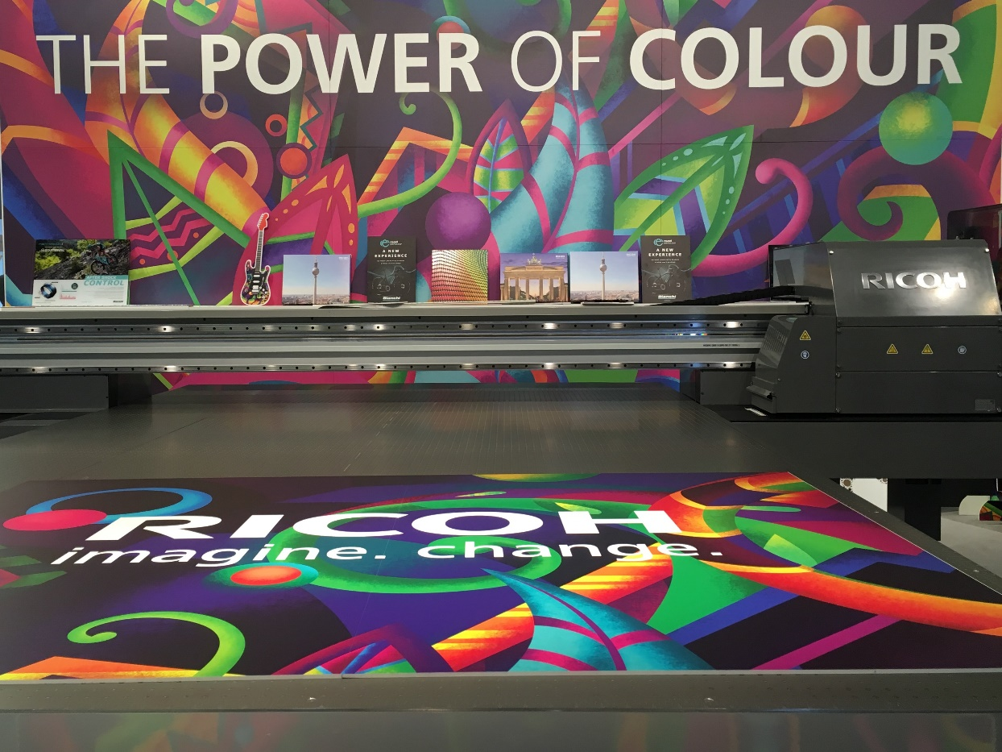
Magneet Communicatiecentrum has chosen The Netherlands’ first Ricoh Pro T7210 UV flatbed printer

The operation already runs two Ricoh Pro™ C9110 heavy duty digital colour sheetfed presses, a Ricoh Pro™ 907EX and a Ricoh Pro™ L4160 large format printer.

It has added the Ricoh Pro T7210 to help it deliver a variety of applications that are currently being outsourced. The result is a faster job delivery time and greater production flexibility. It also allows Magneet to work more closely with its clients and offer advice on topics including material types and different production possibilities.

"I believe the Ricoh Pro T7210 will deliver a wide range of production capabilities. At the moment we are testing to see what the different possibilities are,” says Mathieu Levens, director of Magneet. "We chose Ricoh because we already work with various Ricoh's production systems and are very satisfied with them. Moreover, we are convinced that Ricoh will do everything it can to ensure Magneet is a success."

Ricoh Pro T7210 versatility
The Ricoh Pro T7210 is optimised for the industrial printing of decoration. It can run at speeds of up to 100 sqm per hour on a wide range of material from glass and wood to aluminium and composites. With a maximum print size of 2.1 metres x 3.2 metres, the system can print on one plate or on several pre-cut plates to increase productivity.

"The Ricoh Pro T7210 features inkjet technology and print heads that provide excellent inkjet performance and reliability," comments Graham Kennedy, Head of Commercial Inkjet Business, Commercial & Industrial Printing Group, Ricoh Europe. "With this new system we are responding to the demand from commercial and industrial print professionals and manufacturers for more personalisation, greater flexibility for smaller production runs and extensive material versatility."

For more information visit www.ricoh-europe.com.

-Ends-

|About Ricoh |
Ricoh is empowering digital workplaces using innovative technologies and services enabling individuals to work smarter. For more than 80 years, Ricoh has been driving innovation and is a leading provider of document management solutions, IT services, commercial and industrial printing, digital cameras, and industrial systems.
Headquartered in Tokyo, Ricoh Group operates in approximately 200 countries and regions. In the financial year ended March 2018, Ricoh Group had worldwide sales of 2,063 billion yen (approx. 19.4 billion USD).
For further information, please visit www.ricoh-europe.com.

###
© 2018 RICOH COMPANY, LTD. All rights reserved. All referenced product names
are the trademarks of their respective companies.

For further press information, please contact:
Ricoh Europe PLC
Jack Gibson
Tel: +44 (0) 20 3033 3766
E-mail: media@ricoh-europe.com
Homepage: www.ricoh-europe.com
Join us on Facebook: www.facebook.com/ricoheurope
Follow us on Twitter: www.twitter.com/ricoheurope

