Ricoh stages second Interact Europe to discuss latest Ricoh workflow technologies

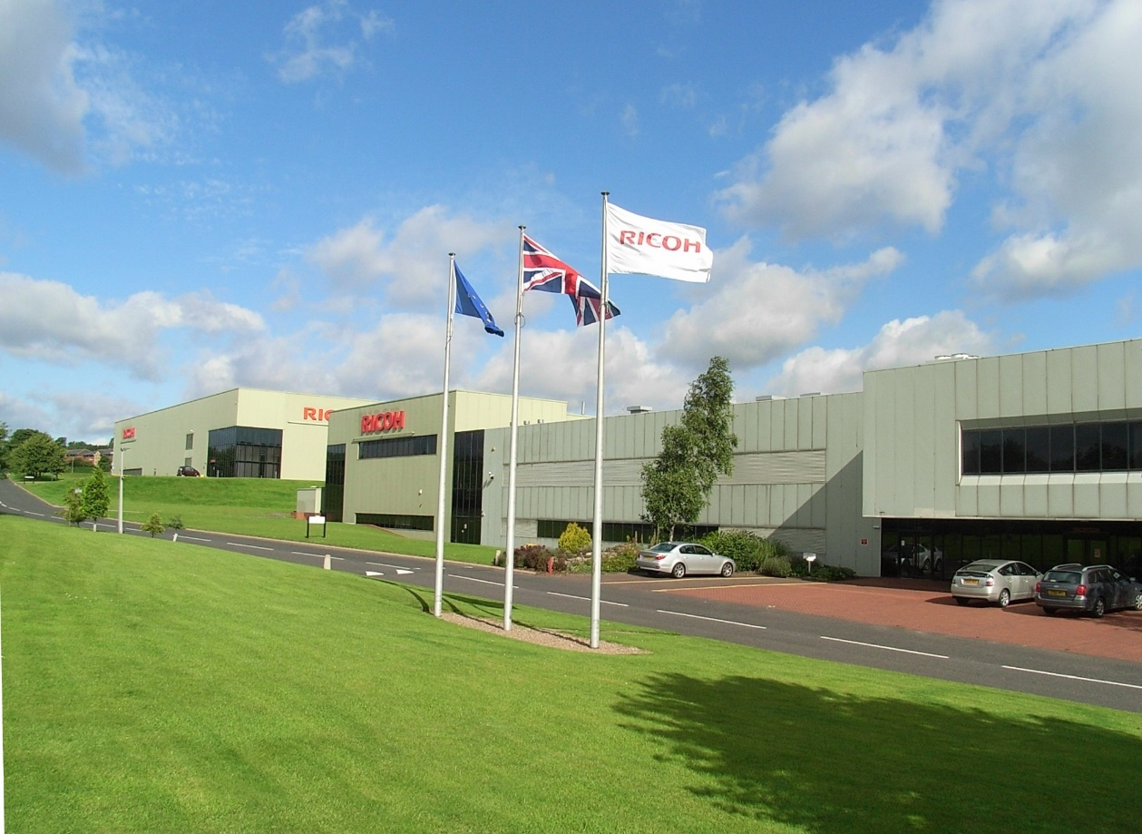
Ricoh Europe, London, 31 October 2018 – European Ricoh ProcessDirector (RPD) users are again being invited to participate in detailed and far-reaching discussions on the latest technology breakthroughs, best practices and trends during Ricoh’s second Interact Europe. The three day event at Ricoh’s European Customer Experience Centre (CEC) in Telford, England runs from November 27 to 29.
Ricoh's European Customer Experience Centre in Telford, England will host the second Interact Europe

Interact Europe was created to provide practical guidance and encourage valuable user feedback. This year’s event will provide a broad range of training and interactive sessions designed to help users take full advantage of their primary production workflow tool. They will also have the opportunity to network with Ricoh experts and industry thought leaders.

Eef de Ridder, Vice President, Commercial Printing, Commercial and Industrial Printing Group, Ricoh Europe, comments: “Ricoh ProcessDirector users from across Europe found last year’s event highly informative. They were able to return to their operations with new insight and knowledge that enhanced their efficiency and productivity. Through networking they gained a broader understanding and during our collaborative sessions they were able to add their valuable input. We look forward to another mutually rewarding event this year where the latest updates, created following astute user feedback, will be among the key topics discussed.”

As well as a look at what’s new, including the latest in PDF processing, this year’s carefully selected sessions include the top 10 highlights of RPD, a review of workflows for complex print scenarios, workflow basics from the experts and a “Did you know RPD could...?” session.

There will also be technical advice on planning an RPD upgrade, making RPD data work for you and web service integration as well as a cloud solutions update.

A Deep Dive session will look at tracking document production and last year’s popular workflow challenge will again encourage attendees to suggest problems they would like RPD to solve. At the end of the event one of these solutions will be presented.

An Ask The Expert panel and a tour of the CEC complete the highly educational agenda.

For more information about Ricoh please visit www.ricoh-europe.com.

-Ends-

|About Ricoh |
Ricoh is empowering digital workplaces using innovative technologies and services enabling individuals to work smarter. For more than 80 years, Ricoh has been driving innovation and is a leading provider of document management solutions, IT services, commercial and industrial printing, digital cameras, and industrial systems.
Headquartered in Tokyo, Ricoh Group operates in approximately 200 countries and regions. In the financial year ended March 2018, Ricoh Group had worldwide sales of 2,063 billion yen (approx. 19.4 billion USD).
For further information, please visit www.ricoh-europe.com.
For further press information, please contact:
Ricoh Europe PLC
Jack Gibson
Tel: +44 (0) 20 3033 3766
E-mail: press@ricoh-europe.com
Homepage: www.ricoh-europe.com
Join us on Facebook: www.facebook.com/ricoheurope
Follow us on Twitter: www.twitter.com/ricoheurope

