Melter orders Germany’s first Ricoh Pro™ VC70000

Ricoh Europe, London, 12 June 2019 – Direct mail specialist Melter has ordered Germany’s first Ricoh Pro VC70000 colour high speed inkjet press.
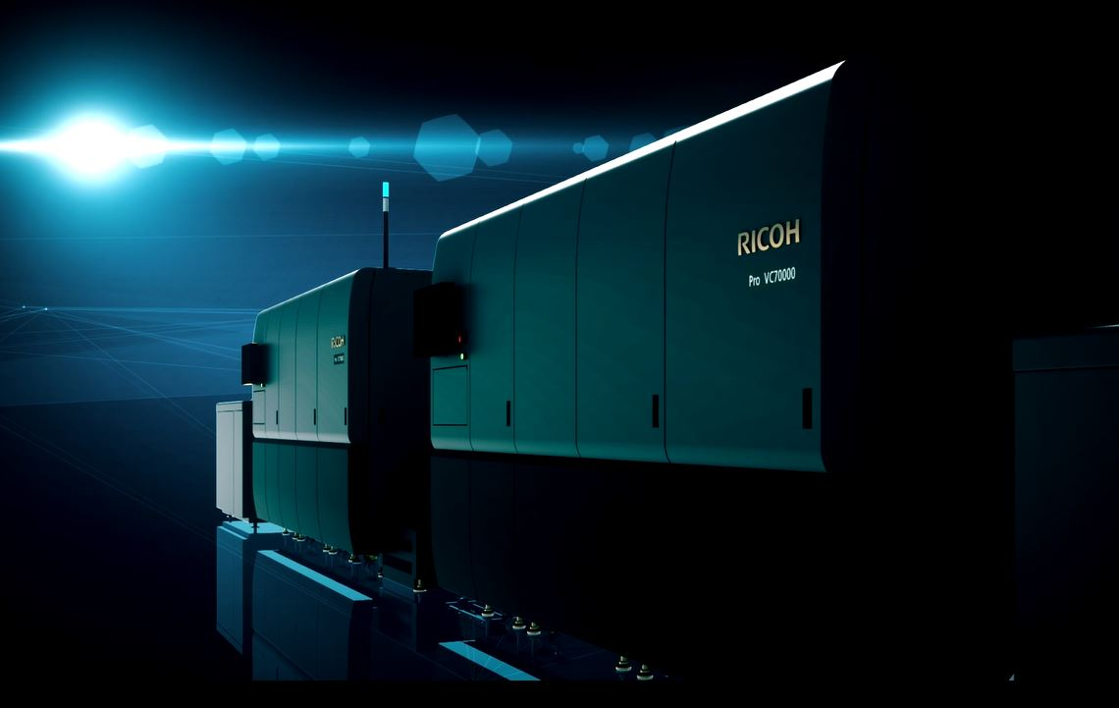
Melter invests in Germany’s first Ricoh Pro VC70000 colour high speed inkjet press

The award-winning Pro VC70000 will join two Ricoh Pro™ C9200 colour sheetfed presses. Melter has made the strategic investment to help it consistently drive digitisation in the production environment and meet increasing demand for high quality, fast turnaround, personalised print.

"As one of Europe’s leading service providers for direct marketing we are always on the lookout for new, pioneering technologies for our customers which not only differentiate us from the competition, but also, and above all, meet the ever-increasing market and customer requirements,” says Daniel Melter, Managing Director, Melter Group.

"We are very pleased to have found a partner with Ricoh who supports us with powerful technology and great service expertise. The Pro VC70000 impresses with excellent print quality, productivity and high profitability. Thanks to this platform, we are able to offer our customers new and very creative print products with excellent impact and great added value."

The Ricoh Pro VC70000 high speed inkjet colour printing platform enables flexible, efficient and high quality digital printing, thanks to its new Ricoh ink technology, innovative and patented dryer and exceptional media versatility that includes offset coated stocks.

Eef de Ridder, Vice President, Commercial Printing Group, Ricoh Europe, says: “We are delighted that Melter has chosen to expand its production capabilities with our latest technology platform that delivers unparalleled quality at class leading speeds. The decision follows Zalsman’s confirmation of its successful adoption of the Pro VC70000 and further underpins how our solutions portfolio can support dynamic operations as they embrace growth.”

For more information visit www.ricoh-europe.com.

-Ends-

| About Ricoh |
Ricoh is empowering digital workplaces using innovative technologies and services enabling individuals to work smarter. For more than 80 years, Ricoh has been driving innovation and is a leading provider of document management solutions, IT services, commercial and industrial printing, digital cameras, and industrial systems.
Headquartered in Tokyo, Ricoh Group operates in approximately 200 countries and regions. In the financial year ended March 2019, Ricoh Group had worldwide sales of 2,013 billion yen (approx. 18.1 billion USD).

For further information, please visit www.ricoh-europe.com.

###

© 2019 RICOH COMPANY, LTD. All rights reserved. All referenced product names
are the trademarks of their respective companies.

For further press information, please contact:
Ricoh Europe PLC
Jack Gibson
Tel: +44 (0) 20 3033 3766
E-mail: media@ricoh-europe.com
Homepage: www.ricoh-europe.com
Join us on Facebook: www.facebook.com/ricoheurope
Follow us on Twitter: www.twitter.com/ricoheurope

