Dataform Media focuses on individualisation with Europe’s first Ricoh Pro™ VC60000 with extended gamut ink
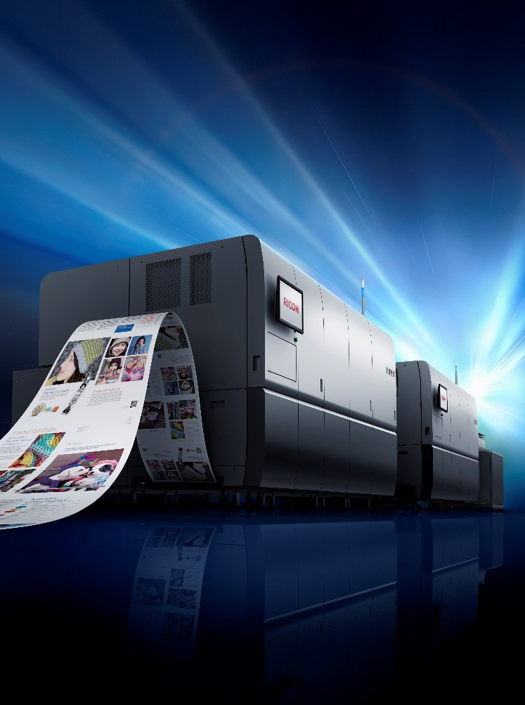
Ricoh Europe, London, 30 July 2019 – Austrian print service provider Dataform Media has chosen to drive individualisation, runs of one, and win new business, with Europe’s first order of a Ricoh Pro VC60000 continuous feed press with extended gamut ink.

Dataform invest in Europe’s first Ricoh Pro VC60000 continuous feed press with extended gamut inks

Dataform Media, part of Dataform, was founded in 1972. It produces forms and mail products from simple letters to complex applications including documents for banks and insurance companies and tickets with security printing. It chose the Pro VC60000 that features new Ricoh ink technology designed to print directly on common wood-free offset papers, matt-coated and coated printing papers. It aims to use it to print educational books among other applications.

The flexible and economical press delivers high colour stability and an improved colour gamut with more vivid colours and a richer black. This combination increases the different types of applications that can be supported. It also has a faster printing speed up to 150 m/min, enabling higher production volumes (including offset to digital page migration) and decreased time to market for promotions.

Stefan Achter, Managing Director of Dataform Media, comments: "We offer optimal products with all-round optimal service. Our investment in the Ricoh Pro VC60000 extended gamut press will support this. We look forward to it helping us further enhance how we support our clients with exciting new capabilities including individualisation and runs of one."

“We are delighted that Dataform Media has identified the powerful impact our newly developed inks have on the smooth and fast production of high quality digital print,” says Eef de Ridder, Vice President, Commercial Printing Group, Ricoh Europe. “As well as enhancing its capabilities it can also seek new business opportunities confident in its ability to deliver consistently reliable fast turnaround results.”

Installation of Dataform Media’s new Pro VC60000 press will start next month (August).

For more information please visit www.ricoh-europe.com.

-Ends-

| About Ricoh |
Ricoh is empowering digital workplaces using innovative technologies and services enabling individuals to work smarter. For more than 80 years, Ricoh has been driving innovation and is a leading provider of document management solutions, IT services, communication services, commercial and industrial printing, digital cameras, and industrial systems.
Headquartered in Tokyo, Ricoh Group operates in approximately 200 countries and regions. In the financial year ended March 2019, Ricoh Group had worldwide sales of 2,013 billion yen (approx. 18.1 billion USD).

For further information, please visit www.ricoh-europe.com.

###

© 2019 RICOH COMPANY, LTD. All rights reserved. All referenced product names are the trademarks of their respective companies.

For further information, please visit www.ricoh-europe.com

For further information, please contact:
Ricoh Europe PLC
Jack Gibson
Tel: +44 (0) 203 033 3766
E-mail: media@ricoh-europe.com
Homepage: www.ricoh-europe.com
Join us on Facebook: www.facebook.com/ricoheurope
Follow us on Twitter: www.twitter.com/ricoheurope
Visit the Ricoh media centre at: www.ricoh-europe.com/press

