Blog Post
By Kristian Ekvall
R&D & Technical Sales



Celebrating 42 Years of Waterless Offset Printing

As Labelexpo celebrates its 40th anniversary, we at Toray are also taking the opportunity to celebrate 42 years of waterless offset printing, sharing the story of how and why waterless offset printing came to be as well as where we see it going in the future.

After about five years of R&D, waterless offset printing was first introduced to the market at drupa 1977 and commercialized by Toray in 1978. The first waterless offset plates were TAP-type positive plates. Because the first plate was based on a positive working format, where about 95% of production is positive-working, the product was first marketed in Japan. Press, ink, and paper manufacturers collaborated with Toray to support the product, and the initial market acceptance there was very good.

Although waterless offset was first demonstrated in North America at Print 1980, it still had a positive-working base. But by 1982, Toray had developed a negative-working (TAN) type plate, allowing a market opportunity in North America where 95% of the market was negative-working. However, acceptance in North America was somewhat slow, partly due to conservative marketing efforts and the absence of a reliable supply of waterless offset inks in that geography. In recent years, however, waterless offset has begun to be perceived as a more viable option around the world.

Waterless offset printing is a green alternative printing system that runs on standard offset presses. The key to waterless printing is a plate that uses an ink-resistant silicone rubber coating to eliminate the need for achieving ink/water balance as required with conventional dampening solution.

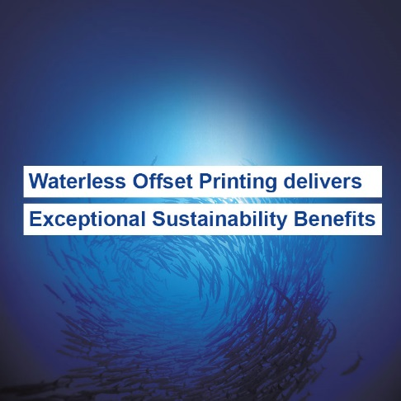

Waterless offset printing eliminates many of the problems conventional offset printers (and the environment) face. There is no water used in the printing process, thus preserving a precious resource. And since there is no need to establish ink/water balance, presses run up to color much faster. That means easier operation with less makeready waste, faster time to market, and the ability to economically produce the shorter runs that are common today.

Now waterless offset printing has expanded into a wide range of other applications, including labels and security applications such as passports, identification cards, event tickets, bank notes and more. As environmental regulations have grown stricter around the world, a growing number of commercial printers are looking into conversion to waterless offset to be able to meet more stringent environmental requirements. It is particularly applicable when printing on non-absorbent substrates such as plastics and metal, both high growth and high margin applications for waterless offset printers.

Toray continues to be a leader in this area, bringing many innovations in terms of both plates and processors that help offset printers deliver higher quality, reduce waste – and what is increasingly important – significantly reduce their environmental footprint. Also important is the ability for adopters of waterless offset printing to enter new markets and generate new revenue streams, especially with applications on non-porous substrates and for those demanding very high quality, such as labels and security documents.

At Toray, we view our work in making offset printing more sustainable as a corollary to the work that Labelexpo has been doing for 40 years – helping to bring responsible technologies to the market that make label printing more competitive, sustainable and profitable. We look forward to continuing our relationship with the organizers of Labelexpo events around the world as we join them in the important venues they host for the industry.



For more information, please visit our website: www.toraywaterless.com.

Yours sincerely,
Kristian

Press contacts:
DUOMEDIA
Monika Dürr
Tel. +49 6104 944 895
Email: monika.d@duomedia.com
www.duomedia.com

TORAY
IMPRIMA - Graphics Division
Toray Textiles Central Europe s.r.o.
Prumyslová 4
79640 Prostějov
Czech Republic
Tel.: +420 (582) 303 800
Email: imprima@ttce.toray.cz
www.imprima.toray

