Blog Post
By Barbora Krupičková
Marketing & Sales Department

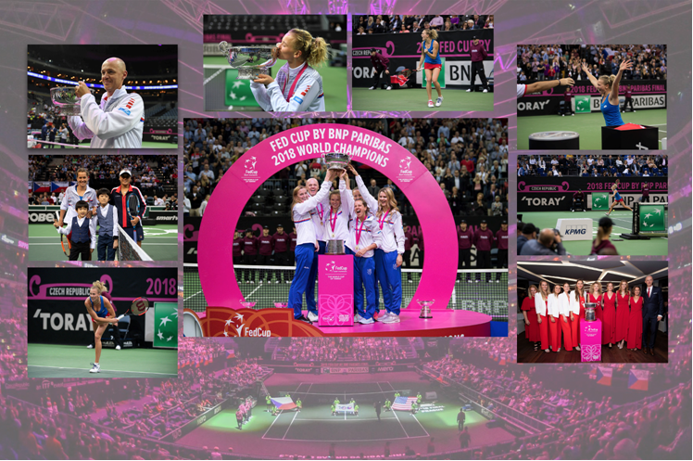
Toray sponsor of the FED CUP FINAL in Czech Republic in November 2018

Prostějov/Czech Republic, November 28th, 2018 – At IMPRIMA, as part of the Toray group, we are extremely proud to have been the international partner of the prestigious 2018 Fed Cup by BNP Paribas Final that took place from 10-11 November in the Prague’s O2 Arena.

Toray has been supporting tennis for decades. This year, and for the 35th time in a row, the company was part of the title sponsors of the WTA’s Toray Pan Pacific Open, a women's tournament held annually in Tokyo.
Last August, our IMPRIMA division also partnered up with the ITF World Junior Tennis Finals, a major team event for players under 14, that took place in Prostějov.

You will wonder: What is the connection between Toray and the world of tennis?

As a company, Toray is keen on investing in research and innovation, and a continuous strive to improve is part of our DNA. We do not believe that competition is our enemy; it has helped us to grow, stay ahead of innovation, and to perform better every day. Today, we still have our roots and headquarters in Japan, but we are globally active in 27 countries, and count 250 subsidiaries and partner companies throughout Europe, Asia, and North and South America. Facing competition has never been an obstacle; instead, it has always helped us stay at the top of our game.

Here are the most exciting photos of the competition:
www.duomedia.com/news-detail/toray-textiles-central-europe-sro/15527/toray-sponsor-of-the-fed-cup-final-in-czech-republic-in-november-2018/English

Yours sincerely,
Barbora

Press contacts:
DUOMEDIA
Monika Dürr
Tel. +49 6104 944 895
Email: monika.d@duomedia.com
www.duomedia.com

TORAY
IMPRIMA - Graphics Division
Toray Textiles Central Europe s.r.o.
Prumyslová 4
79640 Prostějov
Czech Republic
Tel.: +420 (582) 303 800
Email: imprima@ttce.toray.cz
www.imprima.toray

