Blog Post
By Barbora Krupičková
Marketing & Sales Department

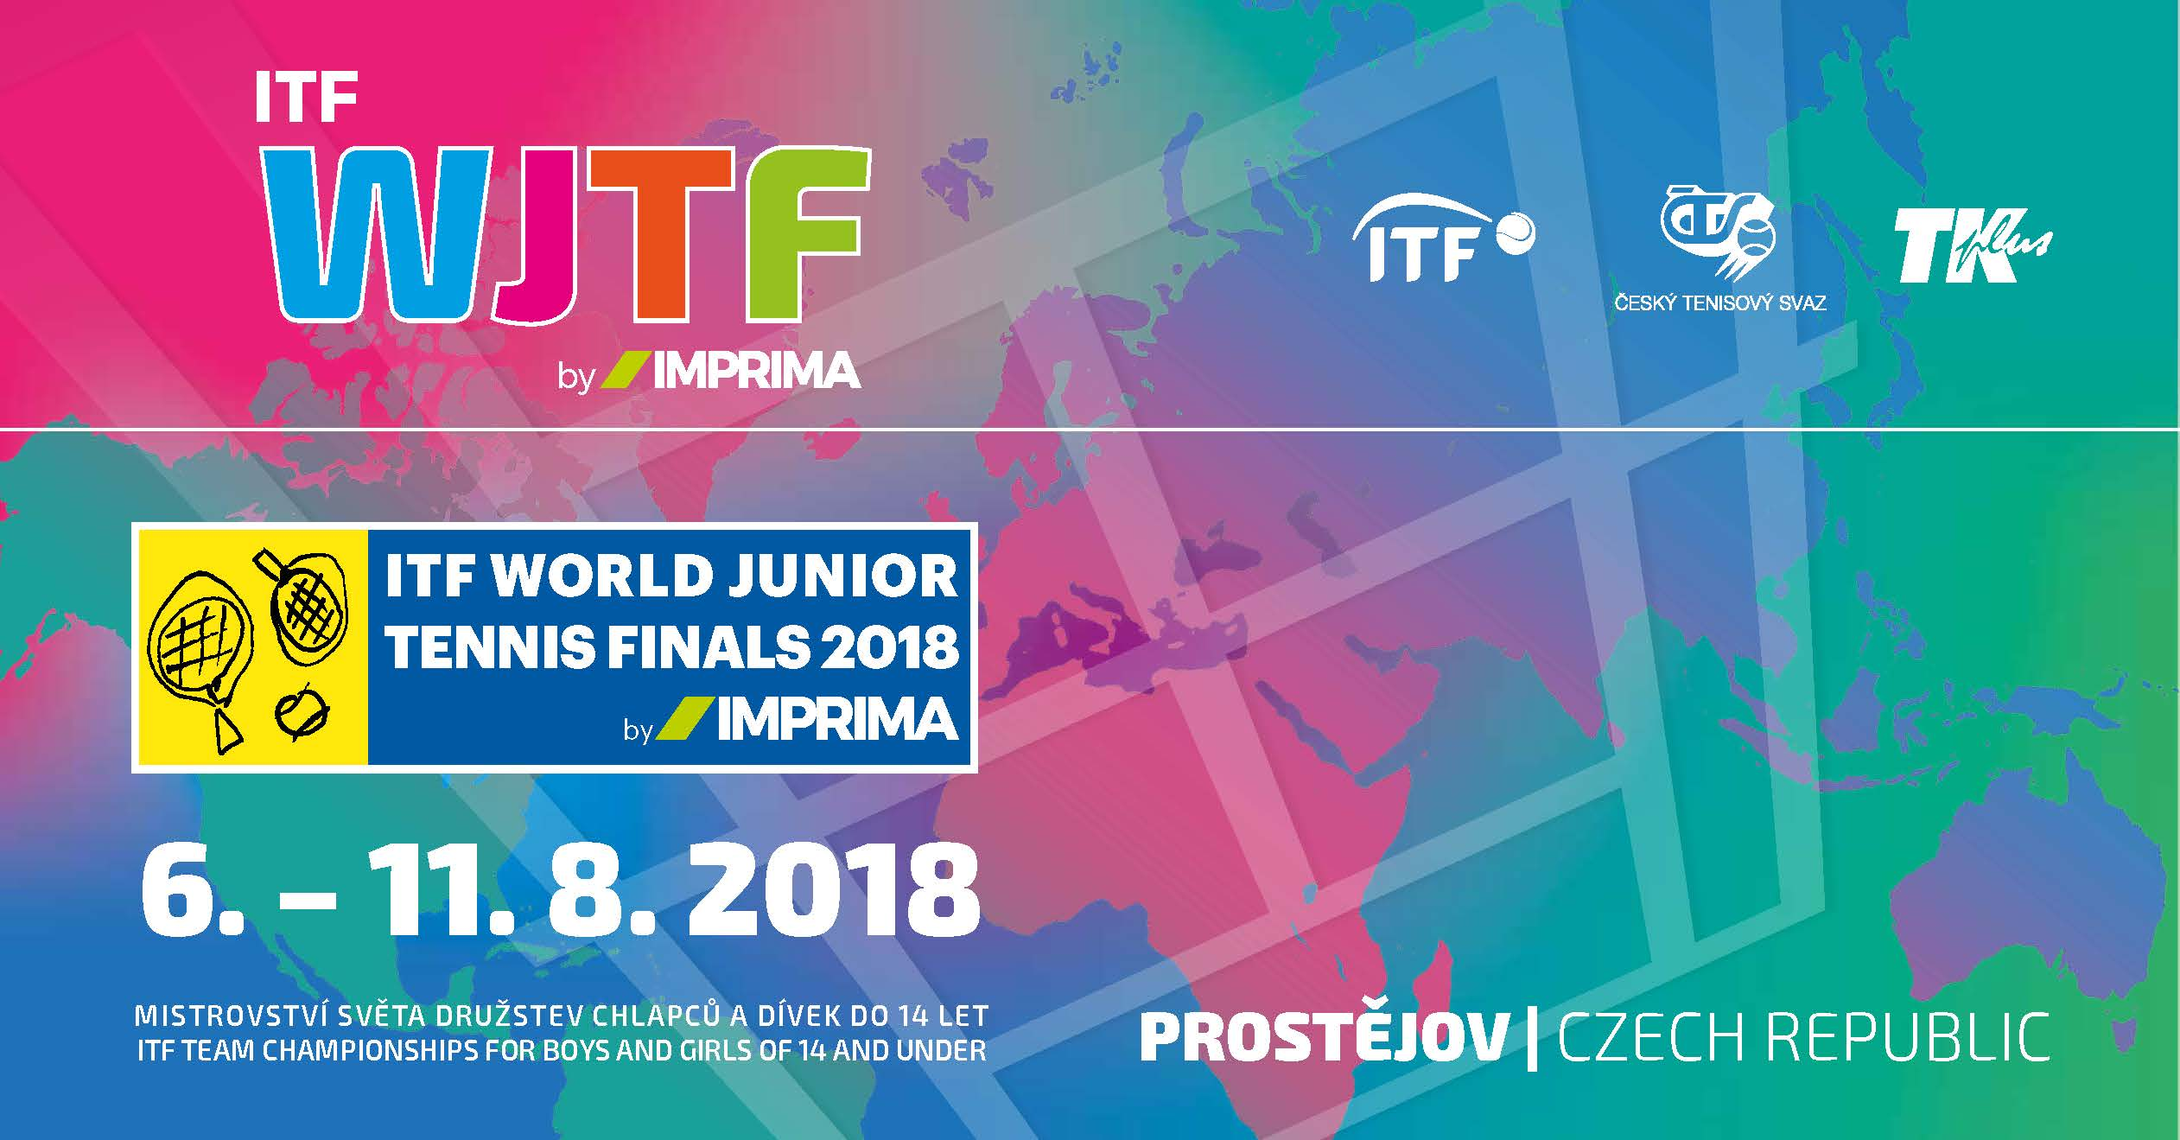
International Tennis Federation Returns to Prostĕjov, Czech Republic for World Junior Tennis Finals 2018
Prostějov/Czech Republic, July 19th, 2018 – Toray, headquartered in Prostějov, Czech Republic, joins the city in welcoming the International Tennis Federation (ITF) back for the 2018 World Cup Junior Tennis Finals for boys and girls under 14. This is the world’s most prestigious ITF youth event and attracts the best national teams for boys and girls in this category. It is a world-class youth event that first came to Prostějov in 1999 after holding the event in Japan for eight years. The ITF has trusted the Prostějov tennis courts since then as an ideal location for the final World Cup tournament.

After challenging worldwide qualifying teams from more than 130 countries from Europe, Asia / Oceania, South America, North America / Central America, the Caribbean and Africa, 16 girls’ teams and 16 boys’ teams will compete in the final tournament. The Girls and Boys of the Czech Republic, as representatives of the hosting country, will start the World Cup competition.

This World Junior event has been the launching pad for a number of leading players who went on to make tennis history. This includes Rafael Nadal, Novak Djokovic, Kei Nishikori, Tomas Berdych, Dinara Safin, Richard Gasquet, Jo-Wilfried Tsong, Kim Clijsters, and more.

IMPRIMA, the Toray Graphic Division in Prostějov, has become the Title Partner of this prestigious tennis finale, which will take place from 6th to 11th August 2018 in the premises of the Tennis Club in Prostějov. We will be watching the competitions, cheering on the teams, and looking for the next tennis champions to emerge from this prestigious event, making even more tennis history. It is important to our company to support events like this that give young people an opportunity to pursue their dreams. And it is especially exciting that ITF has chosen to continue to conduct the event in our city.

We hope you will join us to wish all tennis players many successes and strengths in this ITF World Junior Tennis Finals 2018 by IMPRIMA tournament. To learn more about the event, visit:

English site: www.itftennis.com/juniors/team-competitions/itf-world-junior-tennis
Czech site: www.tkplus.cz/?akce=20

Press contacts:
DUOMEDIA
Monika Dürr
Tel. +49 6104 944 895
Email: monika.d@duomedia.com
www.duomedia.com

TORAY
IMPRIMA - Graphics Division
Toray Textiles Central Europe s.r.o.
Prumyslová 4
79640 Prostějov
Czech Republic
Tel.: +420 (582) 303 800
Email: imprima@ttce.toray.cz
www.imprima.toray

