Blog Post
By Kristian Ekvall
R&D & Technical Sales


Why Waterless Offset Printing Delivers Exceptional Sustainability Benefits

Waterless offset printing was first introduced at drupa 1977 and brought to market in Japan by Toray in 1978. Toray has continued to be a leader in this area, bringing many innovations in terms of both plates and processors that help offset printers deliver higher quality, reduce waste – and what is increasingly important – significantly reduce their environmental footprint.

Many improvements have been made in conventional offset presses over the years, but they still require water, fountain solution, and in most cases, the use of 1,000 to 1200 liters of IPA alcohol per month. In fact, this conventional B1 offset press running two shifts per day will consume around 200 liters of fresh water every day of operation.

Fresh water is used by the offset press, and some of the resulting contaminated water goes down the drain. In addition, more water is used in dampening (fountain) solution, which must be disposed of as a hazardous chemical when it is changed. Because it can be both an art and a science to get the ink/water balance just right, conventional offset printers will often have more makeready waste as well, contributing further to a negative environmental impact.

This is important, since fresh water is critical to supporting human life, and in many parts of the planet –in Europe and particularly in the Mediterranean regions – fresh water is becoming a scarce resource.

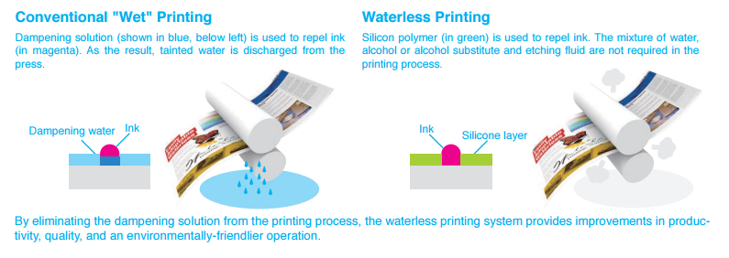

As mentioned, IPA alcohol continues to be used especially those conventional offset printers who produce applications on non-absorbent materials. Beyond the impact in the printing plant, IPA alcohol contributes even more to a negative environmental impact, from the energy and resources required to manufacture it, to the cost, energy consumption and CO₂ emissions associated with transporting thousands and thousands of liters each year to the various printing plants that use it.

Waterless offset printing is a green alternative printing system that runs on standard offset presses. The key to waterless printing is a plate that uses an ink-resistant silicone rubber coating to eliminate the need for achieving ink/water balance as required with conventional dampening solution.

Waterless offset printing, then, eliminates many of the problems conventional offset printers (and the environment) face. There is no water used in the printing process, thus preserving a precious resource. And since there is no need to establish ink/water balance, presses run up to color much faster. That means less makeready waste, faster time to market, and the ability to economically produce the shorter runs that are common today.

In addition, waterless offset printing delivers very high quality print, especially when printing on with non-absorbent substrates such as plastics and metal, high growth and high margin applications for waterless offset printers. It is ideal for security applications such as passports, identification cards, event tickets, bank notes and more. These applications can be difficult to print at the right quality and with the necessary security features using conventional offset printing. It is also ideal for metal decorating applications, another high-growth application opportunity.

Combine the higher margins that these specialized applications deliver with the reduced waste of these more expensive substrates offered by waterless printing and it is a win/win – for the offset printer and for the customer.

Also of note, as the number of newspaper titles and the subscription volumes for newspapers have declined, newspaper printing itself has become more of a service than a profit center. Waterless offset printing allows newspaper printers to increase press utilization and deliver more profit to their bottom line by producing high quality commercial printing.

Most offset printers should be able to easily convert to waterless printing with minimal investment and training. It requires:

• Thermal CTP, 830nM
• An offset press with a temperature-control system for the inking unit – standard in most modern offset presses – proper functioning of the silicone coating of waterless offset plates requires a consistent temperature
• Dedicated waterless UV/Oxidative inks
• A Toray or approved waterless plate processor
• Training for press operators delivered by Toray accredited professionals to ensure the right level of operator skills.

That’s it. The return on investment can be achieved quickly, especially when a printing company is producing high margin applications on expensive substrates, such as plastics, security papers, metal and more.

As the world becomes more aware of and concerned about the climate emergency, commercial printers can do their part by reducing their overall environmental footprint. And converting to waterless offset printing is a good way to make a substantial reduction in their environmental footprint – for the benefit of their own bottom line; for their customers, especially those that are increasingly looking for sustainable printing; and for the planet.

For more information about waterless printing, visit www.toraywaterless.com. We stand ready to work with you to convert your conventional offset operation to waterless offset. Once you have taken this step, you will never look back and will wonder why you didn’t take this important step sooner.

For more information, please visit our website: www.toraywaterless.com.

Yours sincerely,
Kristian

Press contacts:
DUOMEDIA
Monika Dürr
Tel. +49 6104 944 895
Email: monika.d@duomedia.com
www.duomedia.com

TORAY
IMPRIMA - Graphics Division
Toray Textiles Central Europe s.r.o.
Prumyslová 4
79640 Prostějov
Czech Republic
Tel.: +420 (582) 303 800
Email: imprima@ttce.toray.cz
www.imprima.toray

