Press release
Toray Partner Marks3zet Reinforces Value of Waterless Offset Printing for Business Growth

IMPRIMA SD Plates and excellent Toray Support Key to Customer Success, according to new Marks3zet MD

Prostějov/Czech Republic, March 20, 2018 - Toray Graphics in the Czech Republic, a leading manufacturer of waterless offset plate technology, today reported that its long-term partner, dealer Marks3zet, continues to benefit from supplying Toray waterless offset products and services to its customers. Marks3zet was the first dealer in Europe to promote and sell waterless offset printing and continues to have success with this technology from the 1980s to today.

“I took on this role at Marks3zet in October of 2017,” said Ralf Schmidt, Managing Director of Marks3zet. “Having been an offset printer myself and in the industry for more than 30 years, I have a deep understanding of the issues printing companies face every day, and that helps in my ability to articulate to them the business benefits of switching to waterless offset printing. Toray is one of our most important partners. In fact, we collaborated with Toray in the early days of waterless offset printing, a very innovative technology at that time, and we are still working together closely to promote the benefits waterless printing offers.”

Mr. Schmidt points out that while the printing industry as a whole has been under pressure from digital alternatives over the past two decades, labels, packaging and a number of specialized applications continue to drive growth for printing and packaging companies. “Waterless printing helps drive this growth,” he added, “and eliminates a lot of issues that occur with water-based printing, especially with UV inks which are growing in popularity. Waterless offset delivers good density and a very sharp dot for extremely high quality printing. It’s also more environmentally sound, increasingly important in today’s world.”

Mr. Schmidt specifically highlights Toray’s new IMPRIMA SD plates. “These plates are very high resolution,” he commented, “and can be utilized to consistently print images with a resolution of less than 10 microns. This is ideal for growing niche applications such as security printing for identity documents, high value event tickets, tax stamps and more. This provides our customers with many new opportunities to serve their customers and to grow their revenues. Toray provides us with exceptional products, services and support that make it easy to bring to our customers what they need to increase their profitability. It’s a great partnership, and we look forward to working closely together far into the future.”

Why Waterless Offset?
Not to be confused with dry offset printing, waterless offset is an attractive alternative to the flexographic printing process for short and medium run applications because of the lower print form preparation cost. In addition, the Toray's IMPRIMA line of waterless offset printing plates provides superior printing results on a wide variety of paper stock and non-absorbent substrates such as foils and synthetic materials. Waterless offset printing not only reduces water of substrate, but also eliminates the need for toxic chemicals in the printing process.

For more information, please visit our web site: www.imprima.toray


Captions:

DSCN1354
Marks3zet visiting TTCE
From left to right
Gerd Carl - Business Development Manager / Technical Sales
Michael Jotzo - Technical Sales
Ralf Schmidt - Managing Director of Marks3zet
Hans-Heinrich Benecke - Technical Sales & Project Management
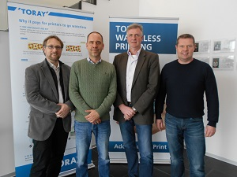
DSCN1356
Marks3zet visiting TTCE
From left to right Gerd Carl, Michael Jotzo, Hans-Heinrich Benecke, Ralf Schmidt

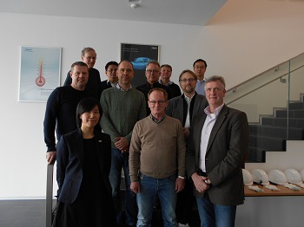
DSCN1358
Marks3zet together with Toray consultants and Sales team
From left to right Ralf Schmidt, Akari Nakano, Tore Harms, Takayuki Kamei, Michael Jotzo, Rinus Hoebeke, Joachim Hans Koch, Kristian Ekvall, Gerd Carl, Mitsunori Hayashi, Hans-Heinrich Beneke


Ralf Schmidt
Ralf Schmidt, Managing Director of Marks3zet since October 2017.

About Toray
Toray Industries Inc., the leading manufacturer of waterless printing plates worldwide, was founded in 1926 and has a global presence with factories and sales offices in Asia, Europe, Middle East, South and North America. The main businesses of Toray are fabrics and textiles, plastics and chemicals, IT-related products, environmental and engineering solutions, carbon fiber composite materials, life science and others. Many of the products are developed from its proprietary polymer technology base and are commonly
used by the electronics, packaging, textile, automotive and aviation industries. Recent annual sales approached € 15 billion.

Toray Graphics, a subsidiary of Toray Textiles Central Europe (TTCE), is based in the Czech Republic and features a state-of-the-art manufacturing line for waterless printing plates. Located in Prostějov, in the heart of Europe, the facility consolidates all business operations, including sales, customer service, marketing, production and R&D, for faster, more efficient support of Toray’s independent network of dealers and distributors in the European market.

DUOMEDIA
Monika Dürr
Tel. +49 6104 944 895
Email: monika.d@duomedia.com
www.duomedia.com

TORAY
IMPRIMA - Graphics Division
Toray Textiles Central Europe s.r.o.
Prumyslová 4
79640 Prostějov
Czech Republic
Tel.: +420 (582) 303 800
Email: imprima@ttce.toray.cz
www.imprima.toray

