Press release
Codimag Celebrates 40 Years in Business and 20 Years Partnering with Toray to Bring Waterless Offset Printing to Narrow Web Printers

Prostějov/Czech Republic, July 13th, 2018 - Toray Graphics in the Czech Republic, a leading manufacturer of waterless offset plate technology, today congratulated Codimag on celebrating its 40th year in business, manufacturing a range of offset and letterpress presses for the narrow web market. Headquartered in France, the company has partnered with Toray for the past two decades, one of the first offset press manufacturers to adopt waterless offset printing technology. The company currently has an installed base of more than 400 presses worldwide. Codimag has installed more than 200 narrow web waterless offset presses to date, according to Benoît Demol, the CEO of this family-owned business.
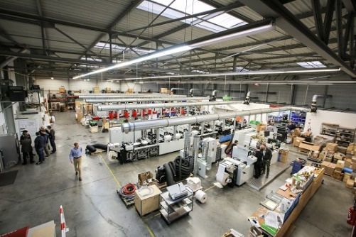
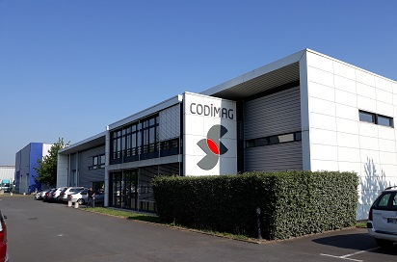

“When we first started working with Toray,” Demol explains, “introducing waterless offset printing to the narrow web market was truly an innovation. In 2007, we introduced our Aniflo technology, an anilox solution that creates the most competitive narrow web press for short to medium – and even longer – runs, another important innovation for this market.”

Demol, who has been the company’s CEO for the past three years, is a tireless supporter of waterless offset technology. “The key benefit of waterless offset printing is its quality,” he says. “We wanted to avoid the instability and waste associated with the ink/water balance in wet offset. As run lengths in the narrow web market have continued to become shorter, we are now seeing true results of the strategic choice we made in the late 1990s to partner with Toray to bring waterless offset printing to our customers. Our latest presses are completely designed for waterless offset printing, and we are selling only Aniflo presses these days. The technology takes time and waste out of the printing process, making it the ideal choice for today’s shorter runs, cost considerations and high-quality expectations.”

Codimag is particularly pleased with the advances Toray has brought to the market with its IMPRIMA family of waterless offset printing plates, especially IMPRIMA MC, a digital thermal non-ablative waterless printing plate especially designed for waterless printers who are looking for a water washable plate for short-run applications. He continues: “We think all the innovations we have brought to this market over the years, including our new Viva 340 press introduced during Labelexpo Europe 2017 in Brussels, deliver the best printing quality for our market. When people hear ‘short run,’ they immediately think of digital printing. While inkjet quality has improved considerably, it still cannot deliver the same level of quality and productivity delivered by waterless offset printing. And while flexography has dominated, it is simply cost prohibitive for shorter runs, largely because the cost of flexographic plates is so high. The only process with the quality and productivity demanded by today’s market is waterless offset. Wet offset has issues with ink/water balance, and we have chosen to avoid these by promoting waterless offset technology.”

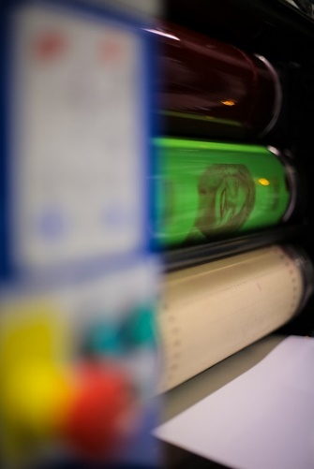

Another factor that can negatively impact the quality, cost and productivity of wet offset, according to Demol, is the use of chemistry in platemaking. “Waterless offset has fewer variables,” he says. “Plates are faster to make and more environmentally sustainable. Not only do we not use chemistry in the platemaking process, but we also avoid the issues that are caused when chemistry is not properly maintained, which can result in poor printing quality and excessive waste. We have chosen to avoid chemistry in order to avoid these issues at their roots, and that is why I am so happy working with Toray and its IMPRIMA plates.”

In 2017, Codimag attended Labelexpo Shanghai for the first time. “Our demonstrations there really caught the interest of attendees,” Demol explains. “We had attendees bring us their own files, and we were able to print them in less than 30 minutes, with the entire process unfolding before their eyes – prepress, plate imaging, mounting plates on press, and less than five minutes to get to a production speed of 75 meters per minute. It’s helping us gain traction in China, where we already have three presses installed and a fourth coming soon to Beijing Sunrise, a company that won the L9 World Label Award last year.”

Codimag presses can be found in Australia, South Africa, China, Thailand, Korea and Latin America, although the bulk of the installs are in Central Europe. “We see great expansion opportunity in Eastern Europe,” Demol states. “Companies in these countries often have older presses, but they now have the money to invest in new technology, and they are very interested in investing in disruptive technology, such as Aniflo for waterless offset. We also have several presses installed in Latin America, another geography that is very interesting for us. Especially in these smaller markets, we see more companies interested in finding a way to produce labels more economically with higher quality and in-line finishing, which we can help them do. And, of course, the Chinese market is very interesting to us, and we see lots of opportunity to expand there as well.”

A good deal of Codimag’s success can be attributed to the relationship with Toray, according to Demol. “I am really happy with the direction Toray is going with its IMPRIMA line of plates,” he says. “They truly listen to our common customers, and that feedback drives a lot of their development strategy. And sometimes Toray refers us to customers who are not in the narrow web market but want to enter it and are great fans of waterless offset. It’s truly a symbiotic relationship that brings value to our respect companies, and, importantly, our customers.”

In addition, Demol appreciates Toray’s efforts to educate the market on the value of waterless offset. “There is still bad information out there about waterless offset printing,” he reports. “This is left over from many years ago, and we really need a strong effort to educate the market on the benefits of today’s waterless offset printing. We have very few press issues with waterless offset. You have to consider that, while we are a small company, two of the world’s largest offset press manufacturers also use waterless offset. If it didn’t work as advertised, they certainly wouldn’t be using it!”
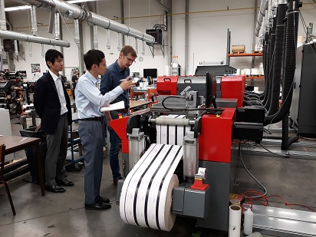
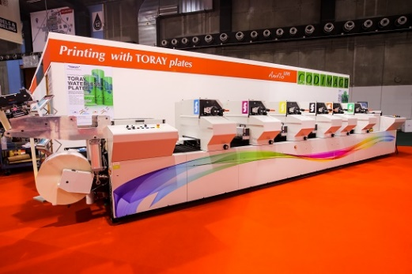

Demol is also looking forward to visiting Toray’s new R&D Centre in the Czech Republic. “It will help us deliver even better customer support,” he says, “and provide a direct channel into the Toray R&D process for customer feedback. Access to these resources will help us put into the mind of customers that waterless offset printing is a brilliant technology with so many advantages, and world-class support. We truly believe it is the future of offset printing.

For more information please visit our website www.imprima.toray.
For more information on Codimag visit www.codimag.com.

About Codimag
For 40 years, Codimag has designed, manufactured and sold printing presses with high added-value at its facilities in Bondoufle, France. Today, it is the world leader in intermittent waterless offset label printing. Codimag offers solutions tailored to label printers’ needs with a high level of innovation, both in terms in technology and application, making its presses productive and cost-effective for many different markets. With a worldwide network of agents, Codimag is able to take its technologies around the world, and support its customers in a profitable, long-term relationship.

About Toray
Toray Industries Inc., the leading manufacturer of waterless printing plates worldwide, was founded in 1926 and has a global presence with factories and sales offices in Asia, Europe, Middle East, South and North America. The main businesses of Toray are fabrics and textiles, plastics and chemicals, IT-related products, environmental and engineering solutions, carbon fiber composite materials, life science and others. Many of the products are developed from its proprietary polymer technology base and are commonly used by the electronics, packaging, textile, automotive and aviation industries. Recent annual sales approached € 15 billion.

Toray Graphics, a subsidiary of Toray Textiles Central Europe (TTCE), is based in the Czech Republic and features a state-of-the-art manufacturing line for waterless printing plates. Located in Prostějov, in the heart of Europe, the facility consolidates all business operations, including sales, customer service, marketing, production and R&D, for faster, more efficient support of Toray’s independent network of dealers and distributors in the European market.

DUOMEDIA
Monika Dürr
Tel. +49 6104 944 895
Email: monika.d@duomedia.com
www.duomedia.com

TORAY
IMPRIMA - Graphics Division
Toray Textiles Central Europe s.r.o.
Prumyslová 4
79640 Prostějov
Czech Republic
Tel.: +420 (582) 303 800
Email: imprima@ttce.toray.cz
www.imprima.toray

