Press release
Jura Security Printing Turns to Toray for Highest Quality Security Printing with Waterless Offset

Prostějov/Czech Republic, November 15, 2018 - Toray Graphics in the Czech Republic, a leading manufacturer of waterless offset plate technology, today reported that Jura Security Printing, with headquarters in Budapest and Vienna, has successfully been using Toray IMPRIMA waterless offset printing plates to help its customers achieve the extremely high quality requirements of the security printing market. Jura Security Printing, a family-owned business established in 1988, serves international markets with a talented staff of 60 people. In addition to providing waterless offset printing plates to its customers, the company also offers graphic security software, hardware, document design, banknote protection, personalization and training. Across all of its services, the company has about 120 customers in Europe, the Americas and Asia.

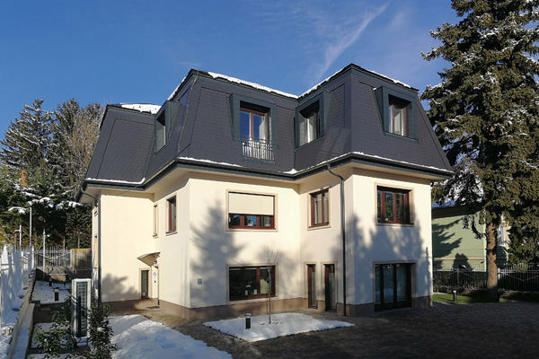
New offices in Budapest

“Our first foray into waterless printing was in the 2008/2009 timeframe,” says Mr. Árpád Papp, Technical Director. “One of our clients was looking for a very high quality security printing solution for card production, and we found that waterless printing was the only way to go. We were able to achieve 6,400 dpi quality for them, and they got the project. We have never looked back, and today we are serving more than 25 customers around the globe who use waterless plates.”

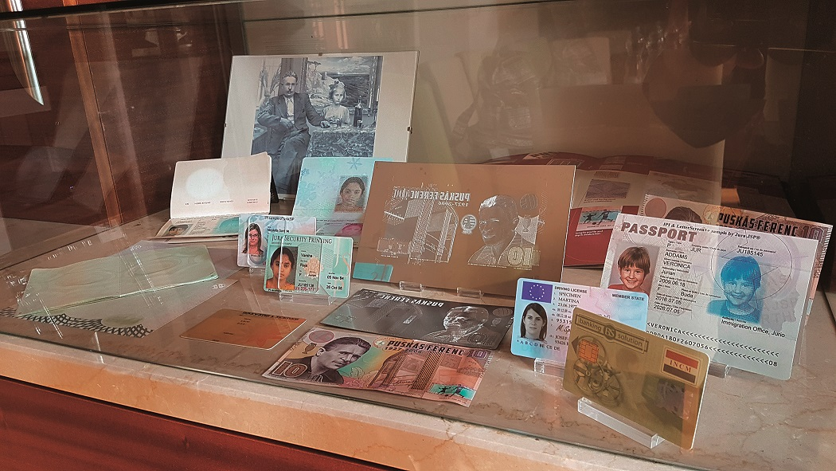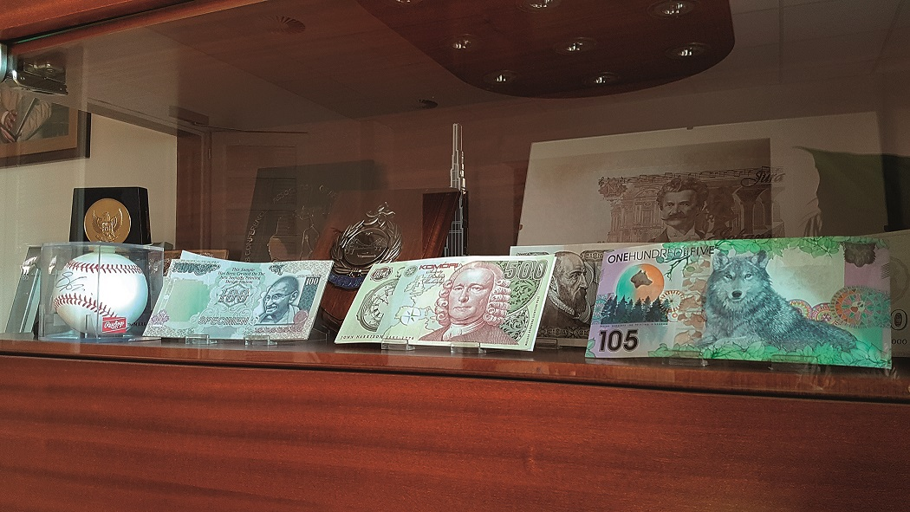
Printed sample

Jura Security Printing also helps its security printing customers with document design and workflow for a variety of secure documents, including high end security features for ID cards of all types, event tickets, banknotes, tax stamps and more. “Over the last decade,” Papp continues, “we have been very pleased with the continuing improvement in quality and functionality we have seen with the Toray IMPRIMA waterless offset plates. Our customers who have made the switch to the waterless offset process are reaping the quality and environmental benefits, and this is helping their businesses to grow. We look forward to a continuing relationship with Toray, as we both work to spread the word about waterless offset printing.”


Jura logo

For more information please visit our website www.imprima.toray.
For more information on Jura Security Printing visit www.jura.hu.

About Jura Security Printing
Jura Security Printing specializes in developing and supplying graphic security software, hardware, design, banknote protection, personalization and training. Jura provides complete prepress solutions, including the production of high quality plates for waterless offset printing, and has been meeting the demands of high security printing worldwide for more than two decades.

About Toray
Toray Industries Inc., the leading manufacturer of waterless printing plates worldwide, was founded in 1926 and has a global presence with factories and sales offices in Asia, Europe, Middle East, South and North America. The main businesses of Toray are fabrics and textiles, plastics and chemicals, IT-related products, environmental and engineering solutions, carbon fiber composite materials, life science and others. Many of the products are developed from its proprietary polymer technology base and are commonly used by the electronics, packaging, textile, automotive and aviation industries. Recent annual sales approached € 15 billion.

Toray Graphics, a subsidiary of Toray Textiles Central Europe (TTCE), is based in the Czech Republic and features a state-of-the-art manufacturing line for waterless printing plates. Located in Prostějov, in the heart of Europe, the facility consolidates all business operations, including sales, customer service, marketing, production and R&D, for faster, more efficient support of Toray’s independent network of dealers and distributors in the European market.

DUOMEDIA
Monika Dürr
Tel. +49 6104 944 895
Email: monika.d@duomedia.com
www.duomedia.com

TORAY
IMPRIMA - Graphics Division
Toray Textiles Central Europe s.r.o.
Prumyslová 4
79640 Prostějov
Czech Republic
Tel.: +420 (582) 303 800
Email: imprima@ttce.toray.cz
www.imprima.toray

