Press release
LabelPlus Delivers High Quality Short Run Labels with Waterless Offset Printing and Toray IMPRIMA Printing Plates

Dutch company transformed from continuous forms printing to labels as market evolved

Prostějov/Czech Republic, September 12, 2019 – Toray Graphics in the Czech Republic, a leading manufacturer of waterless offset plate technology, today reported that LabelPlus, located in The Netherlands, has carved out a new business over the last few years producing very high quality, high value labels, primarily on plastic substrates, using Codimag waterless offset presses with Toray IMPRIMA plates. The company, founded 30 years ago as a continuous forms printer serving the trade, began its transformation in 2007 as laser printing was having a significant impact on the forms business, and has been able to build a thriving business using a blend of digital printing, wet offset and waterless offset printing.

“We have optimized our two Codimag VIVA340 presses for shorter runs, and use our Codimag VIVA420 Aniflo for longer runs,” said Bertjan Lempsink, Owner. “We process some 25,000 jobs per year, and we count on an efficient workflow. With waterless offset printing and Toray plates, we have been able to optimize that aspect of our business, even to the point of effectively competing with flexography. For example, we produce high value labels printed on a plastic material for a jewelry company. They use a lot of black with knockout type, and a 5th color for a metallic finish. This is a complicated job that could not be effectively produced with digital printing or wet offset. And they are produced in small quantities – 6,000, 12,000, or up to 40,000 labels. I believe that keeping current customers happy is the most important thing, even more important than acquiring new ones. And being able to produce these high-value labels efficiently, with minimal waste, is one of the things that makes waterless offset printing so valuable in my business. In addition, the colors are more brilliant, and the contrast is better than other printing technologies we or our competitors are using.”

Toray and Codimag will be collaborating at Labelexpo Europe in September to demonstrate the benefits of waterless offset printing. Toray will be located in Hall 11, Booth number D02, at the show, while Codimag will be located just across the aisle in Booth number C10. Codimag will be running live waterless offset printing demonstrations on its VIVA 420 intermittent (semi-rotary) press using Toray IMPRIMA LJ plates on a variety of different substrates. Toray’s presence at the show will feature the full array of waterless offset printing plates for label production.

About Waterless Offset Printing
Waterless printing is an alternative printing system that runs on standard offset presses. The key to waterless printing is a plate that uses an ink-resistant silicone coating to eliminate the need for dampening solution. It is easy for conventional wet offset press operations to switch to waterless offset for higher quality and a smaller environmental footprint.

There are four key environmental benefits of waterless printing:

- Water sustainability—an increasingly pressing need everywhere
- No tainted water discharge—no fountain solution, no waste water management
- Reduced solution and chemical in plate processing—minimized VOCs
- Sound ecology beyond FSC, ISO or wind power

Waterless offset printing also delivers better quality than conventional offset and eliminates the constant adjustments required to maintain ink/water balance on a conventional press.

For more information, contact your Toray representative or visit www.imprima.toray.
www.iprima.toray

Images and captions:

Mr. Bertjan Lempsink, Director & Owner


Karim Adams, Production Manager

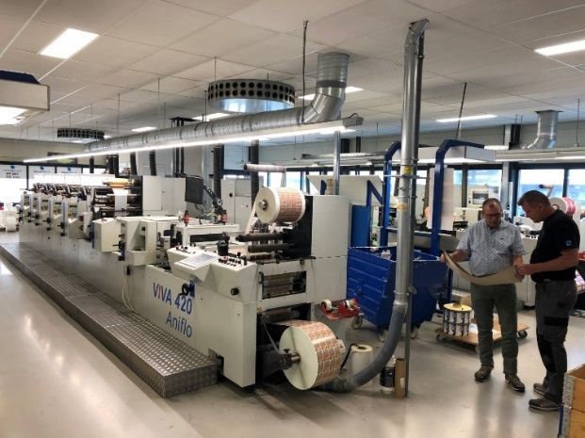
LabelPrint press using IMPRIMA plates

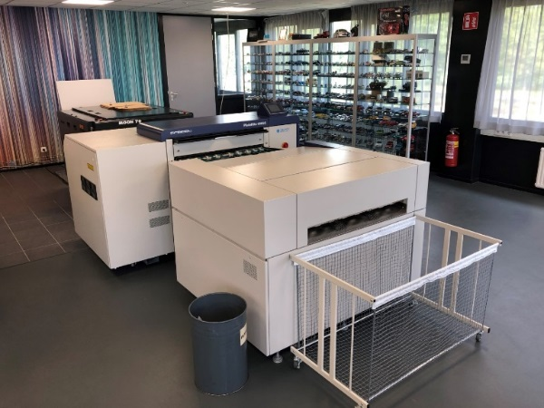
CTP Imager and Processor used to produce Toray IMPRIMA plates at LabelPlus

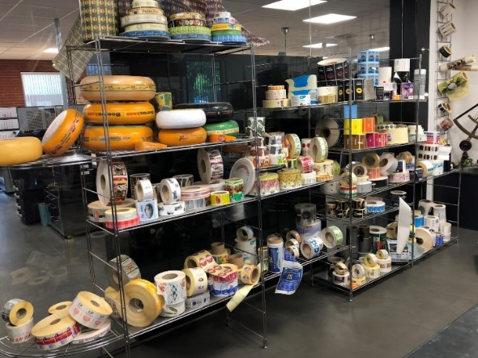
LabelPlus show room with label samples
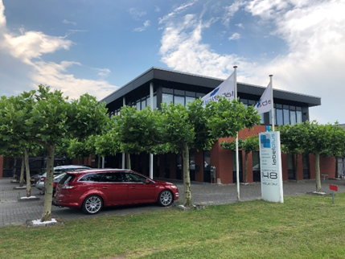
Manfacturing plant of LabelPlus in Enschede

About Toray
Toray Industries Inc., the leading manufacturer of waterless printing plates worldwide, was founded in 1926 and has a global presence with factories and sales offices in Asia, Europe, Middle East, South and North America. The main businesses of Toray are fabrics and textiles, plastics and chemicals, IT-related products, environmental and engineering solutions, carbon fiber composite materials, life science and others. Many of the products are developed from its proprietary polymer technology base and are commonly used by the electronics, packaging, textile, automotive and aviation industries. Recent annual sales approached € 15 billion.

Toray Graphics, a subsidiary of Toray Textiles Central Europe (TTCE), is based in the Czech Republic and features a state-of-the-art manufacturing line for waterless printing plates. Located in Prostějov, in the heart of Europe, the facility consolidates all business operations, including sales, customer service, marketing, production and R&D, for faster, more efficient support of Toray’s independent network of dealers and distributors in the European market.

DUOMEDIA
Monika Dürr
Tel. +49 6104 944 895
Email: monika.d@duomedia.com
www.duomedia.com

TORAY
IMPRIMA - Graphics Division
Toray Textiles Central Europe s.r.o.
Prumyslová 4
79640 Prostějov
Czech Republic
Tel.: +420 (582) 303 800
Email: imprima@ttce.toray.cz
www.imprima.toray

