Press release
Gulf News Waterless Offset Printing to Conserve Water, Expand Product Offerings

Koenig & Bauer Cortina press and Toray waterless offset plates a winning combination for the addition of high-quality commercial print services

Prostějov/Czech Republic, March 24, 2020 - Toray, the leader in innovative solutions for waterless offset printing, today reported that Gulf News, the largest circulated English-language newspaper in the United Arab Emirates, has been using now for a couple of years the Koenig & Bauer Cortina waterless offset press with 12 towers, of which four are heatset, and is using the Toray IMPRIMA WA waterless offset plates. The company, with their facility in Dubai, has increased press utilization by adding commercial work serving the retail and magazine markets, including its own flagship weekly magazine, The Friday. It also converted from tabloid to Berliner format in conjunction with the installation of the new press, a format that is increasingly popular in the international newspaper industry. The company’s state-of-the-art printing plant, located about 40 km from the city center, was opened in 2012 and employs about 100 production staff. Overall corporate employment, including editorial staff, is at 800.

“We are very proud of our highly automated, state-of-the-art plant here in Dubai,” said Robert Renyold, Production Manager. “Not only is the facility completely climate controlled, but automation is everywhere, from our print room to paper storage and reel handling, mostly done with robots. Being located in the desert, water is a scarce resource, and implementing waterless offset printing in our new facility was an important decision, for us and for the planet.”

Renyold, who has been with the company for 15 years and recently took over responsibility for managing the Cortina press, adds that other decision criteria were the reduced waste, lower emissions and overall lower environmental footprint achieved with Cortina waterless offset printing using Toray IMPRIMA plates.

Quality was another important factor. “This configuration gives us a very high level of quality,” Renyold notes. “With the Toray IMPRIMA plates, we are able to produce a very fine dot, and dot gain is very low. We also use a 150-line screen. Together, that delivers exceptional quality.”

Renyold points out that this elevated quality level has enabled the company to produce gain in revenue thanks to the ability to produce very high-quality commercial work, which he says they were not able to do before.

“We also value our relationship with Toray,” Renyold states. “We had the task of converting from conventional offset to waterless offset, while at the same time adding commercial applications. So, a fair amount of change was required. Toray worked very closely with us during the implementation process from the inception, helping us produce the best possible quality plates on our Kodak Generation plate setter and marks-3Zet waterless plate processor. It was an extremely smooth implementation with their help, and the fact that our climate requires us to have a completely climate-controlled facility also made implement much easier, with very consistent humidity levels in our paper stock. To achieve the high quality we aimed at with our new waterless offset platform, we needed the consumables – including plates, inks and paper – to be very stable and work well together. Toray worked with us to ensure we achieved that. They also visit us regularly to oversee our operation, and when we need help or support, they are right there to help us. Toray is truly a valued partner for Gulf News. As a side note, we share our enthusiasm for supporting the tennis sport. We continue as the Official Newspaper supporting both the WTA Tour and the ATP 500 World Tour, while Toray has been a supporter of the International Tennis Foundation (ITF) World Cup Junior Tennis Finals for boys and girls under 14.”

For more information about waterless offset printing and products and services from Toray, visit our website: www.toraywaterless.com.

Images and captions:

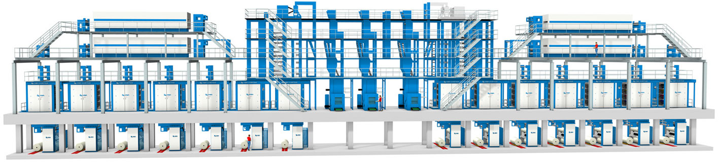
Innovative newspaper technology in the desert:
the impressive KBA Cortina line at Gulf News using Toray IMPRIMA waterless offset plates.

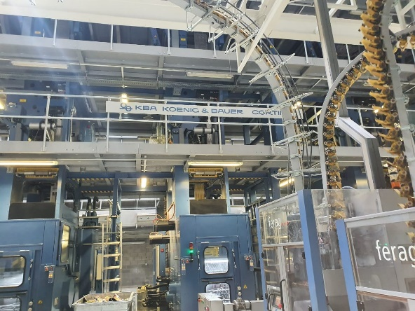
Cortina 1: The Cortina Press installed at Gulf News features 12 towers, of which 4 are heatset.

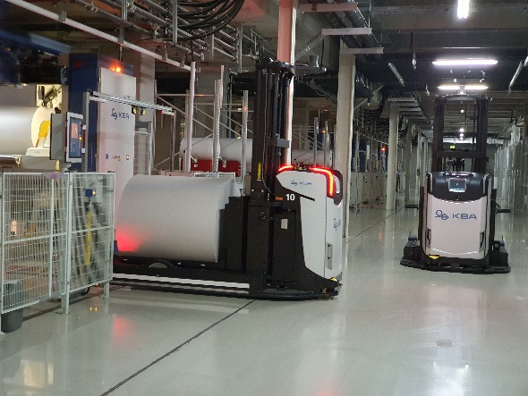
Reel handling: Robotics are used throughout the plant to improve efficiency, including reel handling.

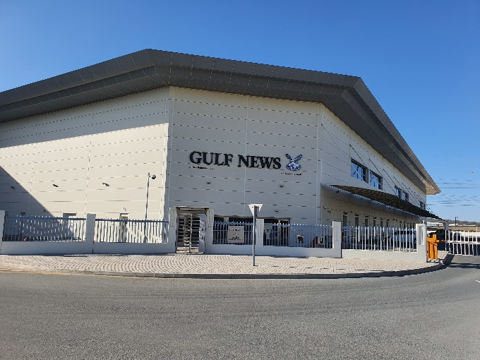
Gulf News Building: Al Nisr Publishing’s new, high-tech printing plant in the middle of the Dubai desert.



Mr. Renyold: Robert Renyold, Production Manager at Gulf News in Dubai.

About Gulf News
Gulf News, the leading English-language newspaper of the Gulf, is published by Al Nisr Publishing LLC, a multimedia organization with activities spanning the media universe, including newspapers and magazines, digital media, contract publishing, commercial printing, niche publications, direct marketing and distribution.

About Toray

Toray Industries Inc., the leading manufacturer of waterless printing plates worldwide, was founded in 1926 and has a global presence with factories and sales offices in Asia, Europe, Middle East, South and North America. The main businesses of Toray are fabrics and textiles, plastics and chemicals, IT-related products, environmental and engineering solutions, carbon fiber composite materials, life science and others. Many of the products are developed from its proprietary polymer technology base and are commonly used by the electronics, packaging, textile, automotive and aviation industries. Recent annual sales approached € 15 billion.

Toray Graphics, a subsidiary of Toray Textiles Central Europe (TTCE), is based in the Czech Republic and features a state-of-the-art manufacturing line for waterless printing plates. Located in Prostějov, in the heart of Europe, the facility consolidates all business operations, including sales, customer service, marketing, production and R&D, for faster, more efficient support of Toray’s independent network of dealers and distributors in the European market.

Press contacts:
DUOMEDIA
Monika Dürr
Tel. +49 6104 944 895
Email: monika.d@duomedia.com
www.duomedia.com

TORAY
IMPRIMA - Graphics Division
Toray Textiles Central Europe s.r.o.
Prumyslová 4
79640 Prostějov
Czech Republic
Tel.: +420 (582) 303 800
Email: imprima@ttce.toray.cz
www.imprima.toray

