PRESS RELEASE
UNITED CAPS Partners with trio-technik to Streamline Manufacturing Process in Schwerin Plant, Strengthening Market Leadership Position
AirMove transport system delivers increased productivity, helps ensure a high quality standard
Wiltz, Luxembourg, 16 October 2018 – UNITED CAPS, an international manufacturer of caps and closures, today announced it has installed four trio-technik AirMove transport systems in its Schwerin plant, which primarily serves the German beverage market. The 10,000 m² facility occupies two production halls, employs 58 people, and produces several billion 28mm and 38mm closures per year for still and carbonated water, juices and milk. Trio-technik will be demonstrating the system using caps and closures from UNITED CAPS at the 26th Fakuma international trade fair for plastics processing, scheduled for 16 to 20 October 2018 in Friedrichshafen, Germany.
“We are pleased to be partnering with trio-technik to demonstrate its innovative AirMove transport system at this important show,” said Olivier Jaillot, Chief Manufacturing Officer for UNITED CAPS. “We implemented this system at the beginning of the year and have been extremely pleased with its performance. At Fakuma, we will be providing trio-technik with red PROSPARK and blue SPARK closures for use in their demonstrations.”
Jaillot explains that after the quality control, which includes the visual check by cameras, the caps must be raised to a height of 1.9 meters for a packing in containers. “If we were to use a conventional conveyor belt system, it would take more space and use more energy. With the trio-technik AirMove system, we only need about one-third of the space a conveyor belt system would require, and we use 20% less energy.”
The trio-technik AirMove system uses special steel pipes that are designed for frictionless movement of parts in order to prevent damage during transport. “Other systems we looked at use plastic tubing,” Jaillot says, “and we could see they would cause erosion of plastic on our caps during transport. We also love the fact that the system is basically maintenance-free since the blower motor is the only moving part in the system, which is a key contributor to our ability to maintain the high level of quality and reliability our customers expect from us. It’s been a great decision for us, and we believe visitors to the trio-technik stand at Fakuma will be as impressed as we have been.”
Trio-technik worked closely with Thoralf Niehusen, Plant Director of the Schwerin location, and the UNITED CAPS R&D Center during the selection and implementation process.
Jaillot explains that the partnership with trio-technik is a good example of UNITED CAPS’ market driven approach based on Relate. Perform. Sustain.
- Relate – We know the brand owner requirements regarding our caps and relate to partners like trio-technik. We gained insights that help us to optimise the quality of our product.
- Perform – The trio-technik partnership is one way we have worked to provide a high quality product that assures the productivity requested by the brand owners.
- Sustain – The trio-technik technology contributes to the UNITED CAPS target to reduce the overall energy consumption
In addition to SPARK and PROSPARK closures, the Schwerin plant also manufacturers PROGLASS and PROSTILL. The trio-technik AirMove system is used to transport all of the caps manufactured in the Schwerin plant through the quality control process.
“Our thanks go to the UNITED CAPS team for their collaboration with us, both in the installation in their Schwerin plant, and for their generosity in providing us with SPARK and PROSPARK caps for use in our Fakuma demonstration, stated Tobias Esau, Project Manager, of trio-technik. “Like UNITED CAPS, we seek to be more than a supplier, and partnerships like the one we have with UNITED CAPS help both of our companies deliver better customer service.”
For more information about UNITED CAPS’ beverages range, please visit the dedicated microsite www.unitedcaps-innovations.com/beverages.
For more information about products and services from UNITED CAPS, please visit www.unitedcaps.com.

Images:
1/ Schwerin plant building
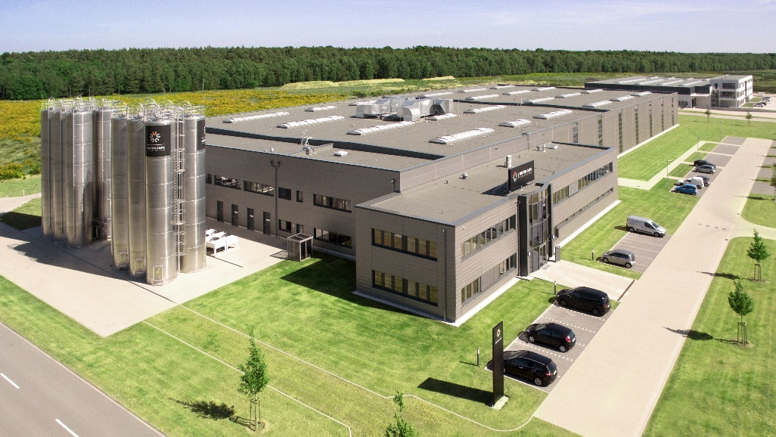
UNITED CAPS’ ultra-modern plant in Schwerin, newly built in 2014, is specialised in large production runs and mainly produces closures for beverage industry.

2/ UC_pr18008_02
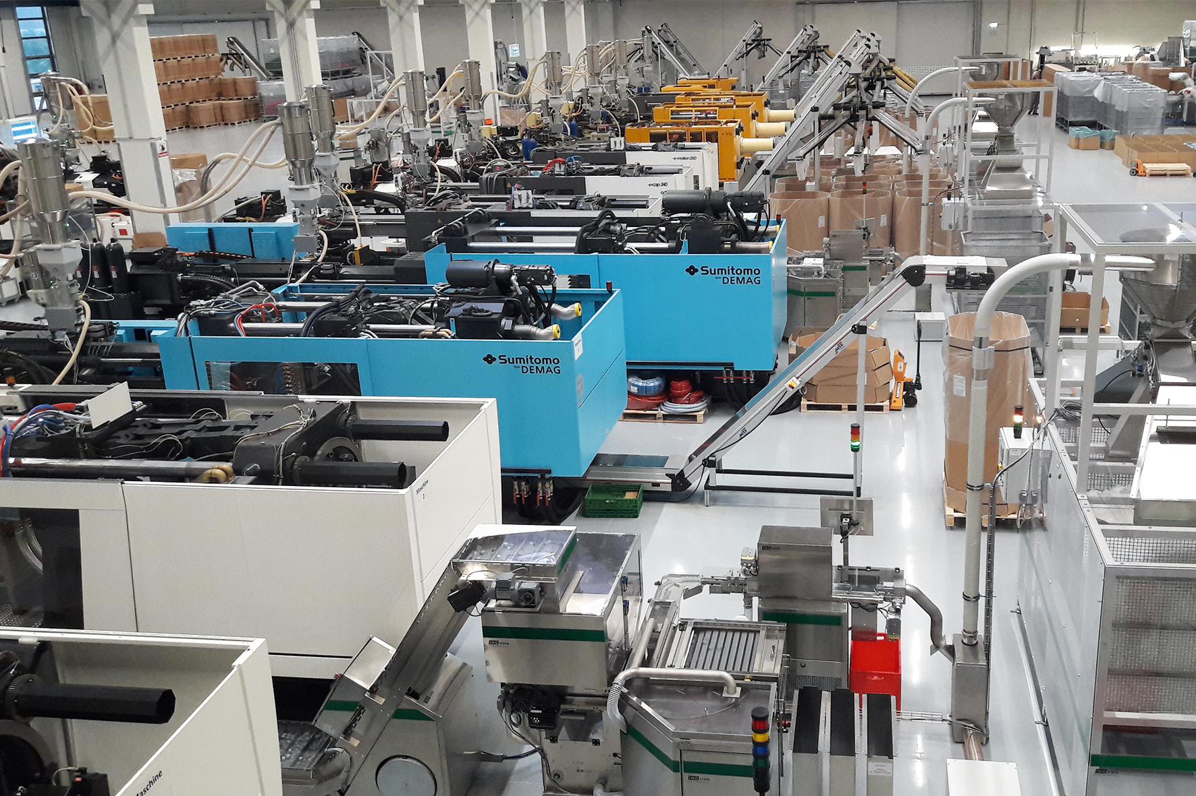
Thanks to the trio-technik AirMove transport system (on the right on the picture) installed beginning of January 2018, UNITED CAPS only needs about one-third of the space a conveyor belt system would require.

3/ UC_pr18008_03
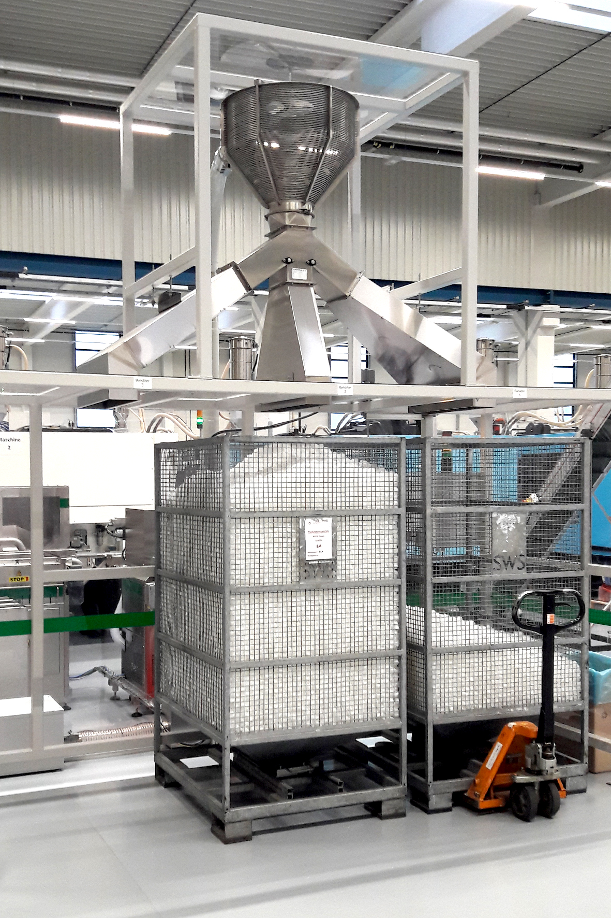
Opposite of plastic pipes used in conventional conveyor belt system, the trio-technik AirMove system use steel pipes, which are designed for frictionless movement of parts in order to prevent damage on closures during transport.

4/ UC_pr18008_Headshot of Olivier Jaillot, Chief Manufacturing Officer, UNITED CAPS

Olivier Jaillot explains that UNITED CAPS has chosen to implement trio-technik’s AirMove system because this system is basically maintenance-free since the blower motor is the only moving part in the system, which is a key contributor to UNITED CAPS’ ability to maintain the high level of quality and reliability the customers expect from UNITED CAPS.

5/ UC_pr18008_Headshot of Tobias Esau

Tobias Esau, from trio-technik is happy about the collaboration with UNITED CAPS, as both companies deliver better customer service.

6/ UC_pr18008_Beverages photomount
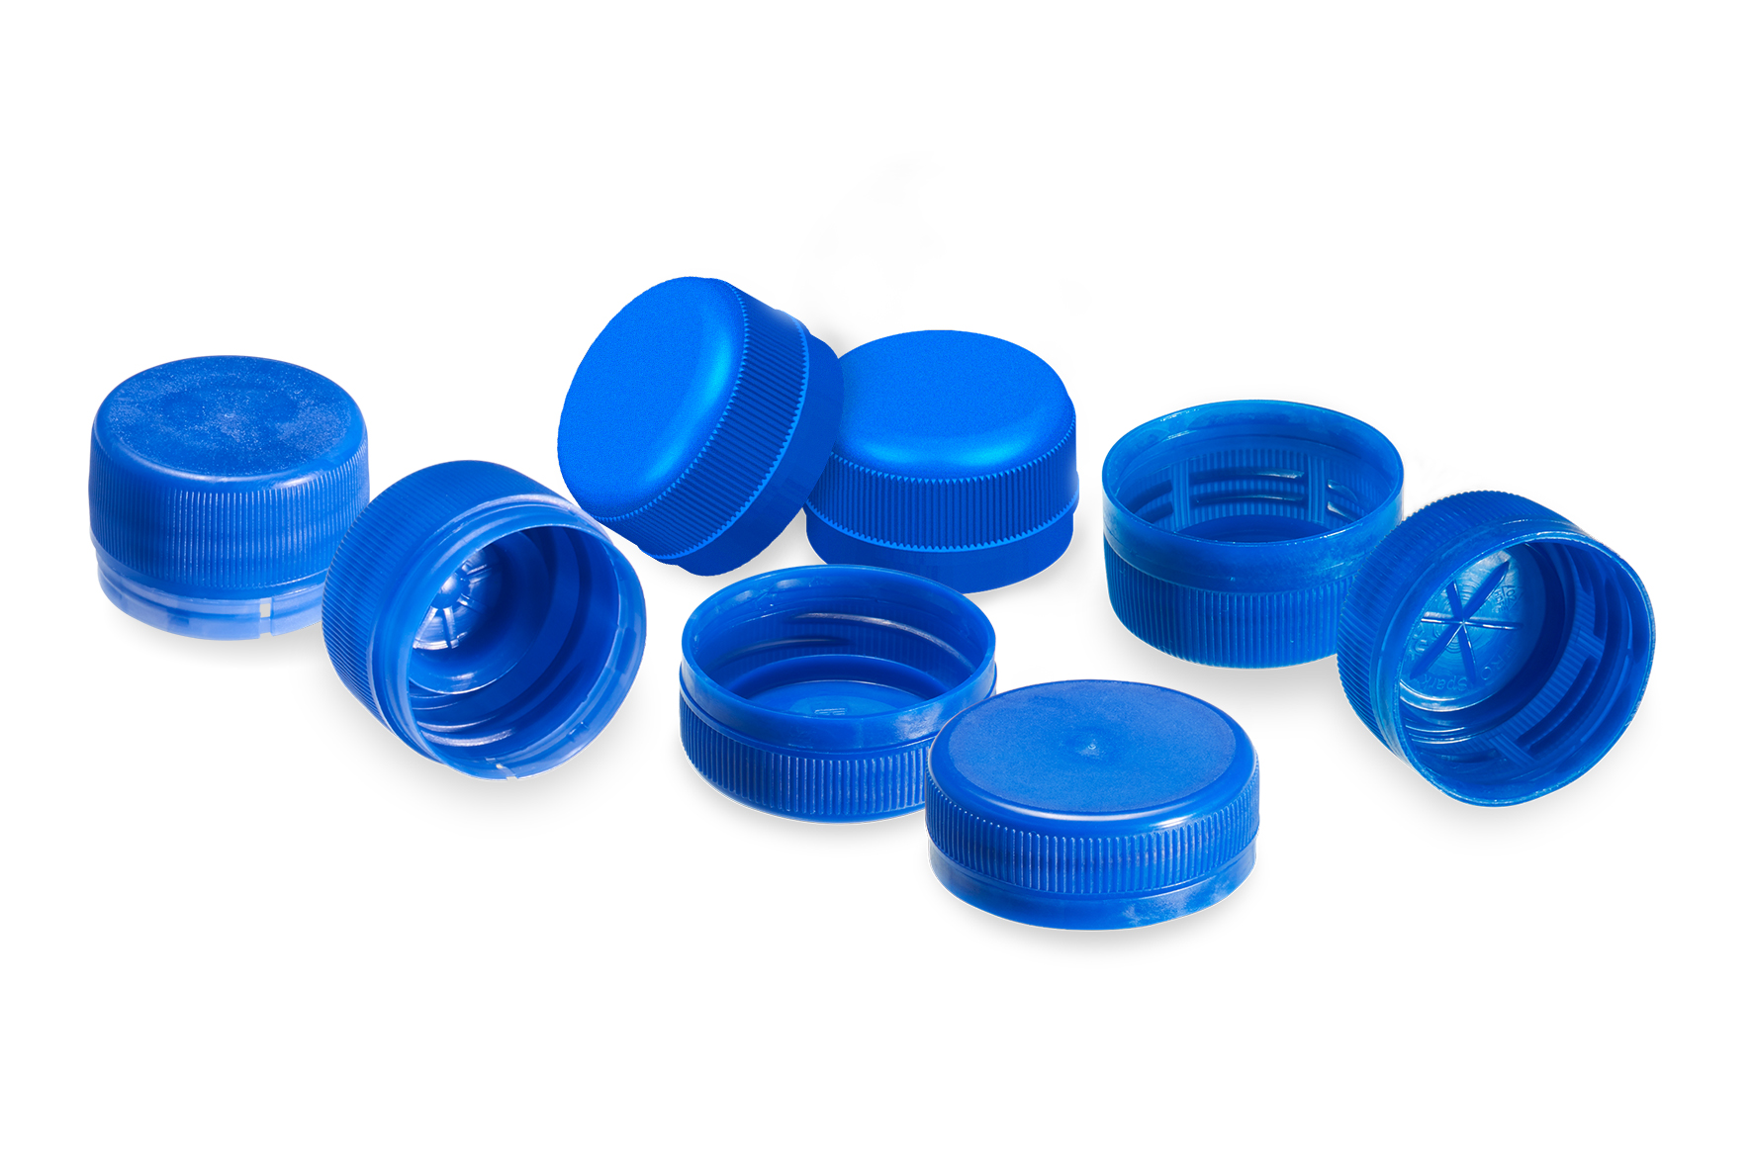
UNITED CAPS’ Schwerin plant primarily serves the German beverage market, by producing closures for PET bottles such as PROSPARK (for full beverage range, from still waters to high carbonated soft drinks), SPARK (for still waters to high carbonated soft drinks), PROSTILL (for still drinks pressurized / non pressurized) ; and by producing closures for glass bottles such as PROGLASS (for carbonated beverages and still drinks).

ABOUT UNITED CAPS
UNITED CAPS is a global industry reference for the design and production of highly-performant plastic caps and closures. Extensive innovative capabilities and a broad portfolio of advanced standard and bespoke solutions make UNITED CAPS a preferred partner to the world’s leading companies. We support our customers’ value chain by safeguarding product integrity, assuring safety and consumer health, and ultimately protecting brand reputation. A highly dynamic and flexible, family-based group, UNITED CAPS offers end-to-end solutions to serve a wide range of applications and markets around the world. The company is headquartered in Luxembourg and has manufacturing facilities in Belgium, France, Germany, Hungary, Ireland, Luxembourg and Spain. Employing more than 500 people, UNITED CAPS’s turnover amounts to 137 million Euros (as at end 2017).
www.unitedcaps.com


PRESS CONTACT
Monika Dürr
duomedia
monika.d@duomedia.com
+49 (0)6104 944895

