PRESS RELEASE
UNITED CAPS Unveils Expanded Edible Oils and Vinegars Portfolio
Expanded portfolio has “Everything You Need, Nothing You Don’t”
Wiltz, Luxembourg, 18 June 2020 – UNITED CAPS, an international manufacturer of caps and closures, today reported following the acquisition of Spanish firm Embalatap, the company has completed a period of consolidation and integration, resulting in an enhanced portfolio of caps and closures for edible oils and vinegars.
“The UNITED CAPS new Edible Oils and Vinegars line of products features big innovation packed with small details that make them a portfolio built for life in the kitchen,” said Benoit Henckes, CEO of UNITED CAPS. “They include differentiated design, smart security and affordable sustainability, and are true to our principle of ‘Less is More,’ reducing the need for range complexity. Our team has worked hard to ensure we bring the most comprehensive portfolio of caps and closures for edible oils and vinegars to our customers, with not only outstanding performance in the kitchen, but outstanding performance on the production line as well.”
Caps and closures in the Edible Oils and Vinegars portfolio are available in a wide variety of colours for on-shelf standout and a premium look with optional tamper evident and tear-off membrane security features. The portfolio contains closures that flip, click, switch and flow. It offers a powerful variety exemplified by a range with maximum and minimum pour options. The Edible Oils portfolio includes:
- A new UNITED CAPS 26 Family of user-friendly, lightweight closures designed to enable brands to maximise weight saving potential without impacting the end customer experience. These caps are the lightest products in our Edible Oils portfolio, weighing in at less than one gram.
- A new UNITED CAPS 29 CLICK TE cap with a premium look, tear-off membrane and tamper evident (TE) band flip top closure suitable for use with PET and glass bottles for both Edible Oils and Vinegars.
- The ingenious 29 DOUBLEFLOW caps continue to be a popular offering within the Edible Oils portfolio, offering a variety of pouring options and exceptional control thanks to its innovative droplet shape. It is lightweight and attractive and keeps the bottle dry with spill-free performance. DOUBLEFLOW weighs just three grams and is optimized to perform reliably on the production line with no line modification.
- A product developed especially for large containers (2 to 5 litres), the 42 SUN snap-on closure is also available with an ergonomic “Porter” handle for ease of use.
In addition to the 29 CLICK TE cap described above, the enhanced UNITED CAPS portfolio for vinegars includes:
- 29 VINJET, a best-selling product in Southern Europe with vintage appeal for vinegar, sauces and dressings. Caps for white and red vinegar have one hole for pouring, while caps for sauces, dressings and balsamic vinegar feature four holes.
- The UNITED CAPS 36 PRO2P is an exceptionally easy-to-use product for glass and PET Edible Oil and Vinegar bottles. This snap-on two-piece closure features an anti-drop system and unique pouring shape for exceptional control and a content-preserving tear-off membrane.
“We are pleased to be bringing this enhanced portfolio to the market,” Henckes added. “We have applied our expertise built up over 80 years of working with plastics to offer customers a comprehensive selection designed to meet just about every possible need in the growing market for caps and closures for Edible Oils and Vinegars.”
For more information about products and services from UNITED CAPS, please visit www.unitedcaps.com

Images & Captions:
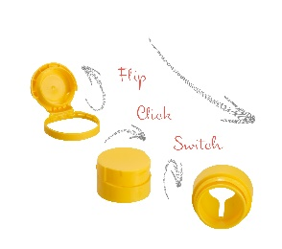
- UC_pr20001_1: Lift-Tear-Pour-Click: Caps and closures in the Edible Oils and Vinegars portfolio are available in a wide variety of colours for on-shelf standout and a premium look with optional tamper evident and tear-off membrane security features. The portfolio contains closures that flip, click, switch and flow.

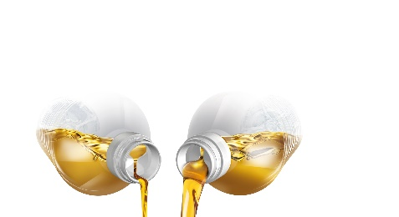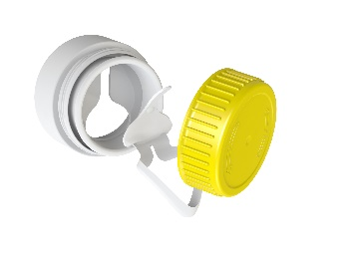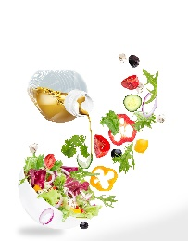
- UC_pr20001_2: The ingenious 29 DOUBLEFLOW caps continue to be a popular offering within the Edible Oils portfolio, offering a variety of pouring options and exceptional control thanks to its innovative droplet shape.
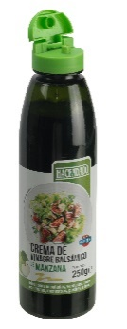
- UC_pr20001_3: 29 VINJET, a best-selling product in Southern Europe with vintage appeal for vinegar, sauces and dressings.

ABOUT UNITED CAPS
UNITED CAPS is a global industry reference for the design and production of high performance plastic caps and closures. Extensive innovative capabilities and a broad portfolio of advanced standard and bespoke solutions make UNITED CAPS a preferred partner for the world’s leading companies. We support our customers’ value chain by safeguarding product integrity, assuring safety and consumer health, and ultimately protecting brand reputation. As a highly dynamic and flexible family-based group, UNITED CAPS offer end-to-end solutions to serve a wide range of applications and markets around the world. The company is headquartered in Luxembourg and has manufacturing facilities in Belgium, France, Germany, Hungary, Ireland, Luxembourg, Malaysia and Spain. Employing almost 650 people, UNITED CAPS’s turnover amounts to 158 million Euros (as at end 2019).

www.unitedcaps.com



PRESS CONTACT
Monika Dürr
duomedia
monika.d@duomedia.com
+49 (0)6104 944895

