Contact
Trendelina Kryeziu
Marketing & Communications Manager
M: +49 711 9816 389
Trendelina.kryeziu@flintgrp.com

Novotecno enjoys major benefits from next generation rotec® sleeves
By deploying the latest rotec® Blue Light Sleeves from XSYS on its wide web flexo presses, the Spanish fresh produce packaging specialist has been able to reduce downtime and running costs. The next-generation, thin-walled sleeve features a longer-lasting construction that improves efficiencies and productivity in flexo printing production.

Ahaus, Germany. 12 May 2021. Headquartered in Badalona, in Spain, Novotecno S.A. – Grupo Giró is an international innovation leader in packaging systems and products for the fresh fruit and vegetable industry. The company produces tubular nets, labels and films, as well as manufacturing specialised weighing and bagging machinery for the horticultural sector.

The Giró brand is known worldwide for the excellent quality, high reliability and great modularity of its machinery, which allows packers to achieve the best productivity in the market and to respond quickly to new demands from customers.

Working with XSYS regional agent LR Flexo, Novotecno has been relying on rotec® Blue Light plate-mounting sleeves for all flexographic printing at the factory in Badalona for more than 10 years. It was the first converter to upgrade to the new long-lasting construction, thin-walled sleeves, and the improvement has been impressive.

“On average, we were ordering approximately 50 rotec® Blue Light Sleeves of this size each year, because they became damaged so quickly. Since switching to the new construction in July 2019, lifetime has doubled, so that amounts to a substantial saving for us,” said Daniel Moreno, Production Manager at Novotecno.

Continuous innovation from XSYS
The long-lasting construction rotec® Blue Light Sleeves is the third generation of this thin-walled, plate carrier technology from XSYS Sleeves. Introduced to the market in 2020, the new sleeve offers improved overall stability compared to the original Blue Light Sleeve from the early 1990s. The development builds on the thin-wall technology of the second-generation sleeve from 2016, but is less likely to crack and more cut resistant. It also has a smoother surface than competitive products.

Available in lengths between 250 and 2600mm, the new thin-walled sleeve is offered in a thickness of 0.9 – 1.7mm. It can be combined with various adapters for plate-mounting off press and offers easy and reliable handling of all flexo plate types.

“With the new construction of the thin Blue Lights, the product is more robust. Soon after we started using them, it became clear that the surface is much more resistant and doesn’t crack after a few cuts.” commented Daniel Moreno.
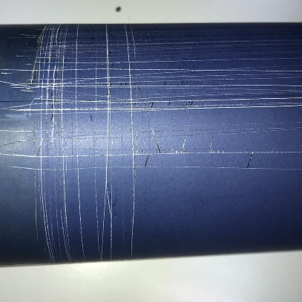
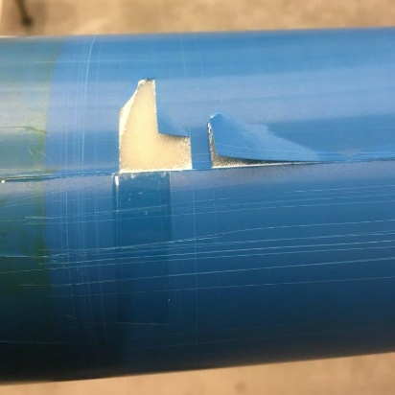

Original thin Blue Light New Construction Blue Light

Preferred partner for sleeves
The XSYS rotec® product development team is constantly driving innovation to meet the needs of customers and stay ahead of trends. The evolution of the sleeve technology goes hand in hand with the partnerships that have been created over many years.

“Having represented rotec® Sleeves & Adapters for more than 20 years, I am impressed by how easily the rotec® team understood the situation and proposed a new solution for our common customer,” said Lluis Rebled, owner of LR Flexo. “Our partnership with Novotecno is a real success story and it is a clear example of how we work together with customers to help them succeed.”

Commenting on why Novotecno chooses XSYS Sleeves as their supplier, Moreno concluded, “The product quality is excellent, and we know we can rely on XSYS if there are any issues. When we had a specific problem, XSYS and the agent LR Flexo took it seriously and solved it for us quickly. This is the relationship and cooperation we expect with our partners, therefore rotec® is our preferred brand for sleeves.”

For more information about the new XSYS division of the Flint Group, please visit www.xsysglobal.com or contact info@xsysglobal.com.

ABOUT XSYS
Formed in January 2021 as a new division of Flint Group, combining Flint Group Flexographic and Xeikon Prepress into a single division, XSYS has been designed to bring more brilliance into the packaging industry – into the lives of its customers and colleagues – using brilliant products and services for brilliant print results and business success. It combines under one umbrella such well-known flexographic and letterpress brands as nyloflex®, Xpress, nyloprint®, nylosolv®, rotec®, FlexoExpert, ThermoFlexX, Catena, TFxX and Woodpecker, to provide a complete flexographic and letterpress prepress solution.

Headquartered in Stuttgart, Germany, XSYS operates from more than 37 locations around the world and remains one of the largest global suppliers offering both flexographic and letterpress prepress solutions, including plates, sleeves, processors, workflow solutions and expert professional services designed to help these industries move forward with increasing innovation, improved productivity and profitability and a reduced environmental footprint.
ABOUT FLINT GROUP
Flint Group is dedicated to serving the global printing and packaging industry. The company develops, manufactures and markets an extensive portfolio of printing consumables and printing equipment, including: a vast range of conventional and energy curable inks and coatings for most offset, flexographic and gravure applications; pressroom chemicals, printing blankets and sleeves for offset printing; photopolymer printing plates and sleeves, plate-making equipment and flexographic sleeve systems; pigments and additives for use in inks and other colourant applications; Flint Group also designs, develops and delivers web-fed digital colour presses for labels and packaging applications, document printing, as well as commercial printing as well as platemaking equipment for the newspaper industry and computer-to-plate (CtP) solutions for the commercial printing market; With a strong customer focus, unmatched service and support, and superior products, Flint Group strives to provide exceptional value, consistent quality and continuous innovation to customers around the world. Headquartered in Luxembourg, Flint Group employs some 6200 people. Revenues for 2020 were € 1.7 billion. On a worldwide basis, the company is the number one or number two supplier in every major market segment it serves. For more information, please visit www.flintgrp.com
.

