Press Release

Japanese Printing Company Nabe Process Co., Ltd., Improves Efficiency with Asahi Photoproducts AWP™ Flexographic Plates
Overall number of press stops for plate cleaning or quality adjustment significantly reduced
Tokyo, Japan & Brussels, Belgium, December 06, 2021. Asahi Photoproducts, a pioneer in flexographic photopolymer plate development, today reported that Nabe Process Co., Ltd., a major Japanese printing company, has tested Asahi’s AWP™ CleanPrint water-washable flexographic plates against conventional solvent-based plates to measure differences in quality and productivity between the two. The AWP™ plates, which were made with CrystalCleanConnect, demonstrated a significant improvement in print quality and productivity compared to the conventional solvent-developed flexographic plate. CrystalCleanConnect is a brand-new offering jointly developed by Asahi Photoproducts and ESKO that automates the platemaking process, reducing steps from 17 to 1 and dramatically reducing potential for error.
According to Nabe Process Co., the test was conducted using actual customer work, and all times and steps were carefully documented. It was notable that the Asahi AWP™ plates had excellent ink transfer, which contributed to the overall improved quality and fewer press stops for plate cleaning and other quality issues.
The design chosen by Nabe Process Co., Ltd. for this test contains fine highlights. To obtain the required quality with solvent-based plates, the press had to be stopped several times during the run to prevent such things as ink filling. This was not the case with the Asahi AWP™ water-washable plates which offer CleanPrint technology, originally developed by Asahi in order to improve the ink transfer from the plate surface to the printed material.
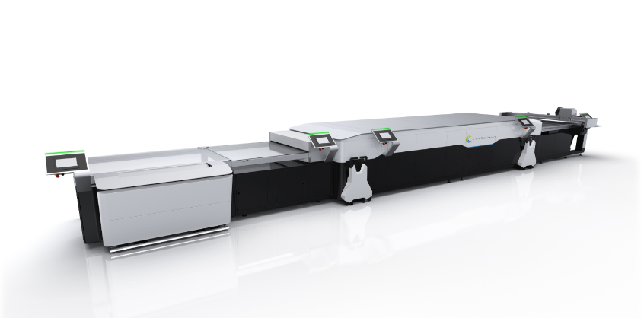
Mr. Yasuo Naka, General Manager of Flexography Division, Nabe Process Co., Ltd., commented “From this result, we were able to confirm that we can deliver more stable and higher quality printed products to our customers using Asahi's AWP™ water-washable plates. With the conventional solvent plate, we also had more difficulty in the printing process due to misregistration during printing. With the Asahi AWP™ plates, however, that problem is resolved and productivity is dramatically improved.We are very happy with the performance of the AWP™ plates as a result. In addition, in the spring of 2021, we installed CrystalCleanConnect, a fully automatic plate-making device jointly developed by Asahi and ESKO. That has added to our overall quality and productivity, geting plates to press much faster, with less operator engagement time and with less opportunity for error. Based on these results, we are converting all of our flexographic plates to Asahi AWP™ water-washable CleanPrint plates, and we know our customers will be even more delighted than ever with the quality they receive from us."

Caption: CrystalCleanConnect, a world-first fully automated flexographic platemaking solution jointly developed by Asahi Photoproducts and ESKO

Mr. Yuzo Fujiki, Chief Technology Officer, Printing Solution Project, of Asahi Kasei Corporation, commented, “We were pleased to work with Nabe Process on this project to validate the excellent plate performance of our AWP™ water-washable plates in terms of both print quality and productivity. And we are thrilled that Nabe Process has chosen to create even more efficiency by installing the first CrystalCleanConnect system in the world, the industry's first fully automatic water-washable plate-making device, developed in collaboration with ESKO. As we continue to work with forward-thinking companies like Nabe Process, we will also be working toward continouos improvement of print quality as well as keeping sustainability top of mind.”
Asahi's CleanPrint flexographic printing plate has excellent ink transfer from the plate surface to the substrate, resulting in less ink remaining on the plate surface during and after printing compared with conventional solvent-based plates, dramatically reducing the number of press stops required for plate cleaning. In additon, the plate making process is water-based, using non-VOC based chemicals. And with the CrystalCleanConnect solution, which delivers ready-to-mount plates with the push of a button, platemaking time and labor is also dramatically reduced, resulting in a more efficient and cost-effective flexographic printing operation.
For more information about Asahi AWP™ CleanPrint water-washable flexograhic plates, CrystalCleanConnect and other products and services from Asahi Photoproducts, visit www.asahi-photoproducts.com.
—ENDS—

About Asahi Photoproducts
Asahi Photoproducts was founded in 1973 and is a subsidiary of the Asahi Kasei Corporation. Asahi Photoproducts is a leading pioneer in the development of photopolymer flexo printing plates. By creating high quality flexographic solutions and through continued innovation, the company aims at driving print forward in harmony with the environment.
Follow Asahi Photoproducts at .
More information is available at www.asahi-photoproducts.com and at:
Monika Dürr  duomedia  monika.d@duomedia.com  +49(0)6104 944895 | Dr. Dieter Niederstadt  Asahi Photoproducts Europe n.v. /s.a.  dieter.niederstadt@asahi-photoproducts.com  +49(0)2301 946743

