Shanghai Huichang Flexo Technology Co., Ltd., a repro house in Shanghai, China, installs AWP™ CleanPrint water-wash flexographic platemaking system
Excellent plate quality with a reduced carbon footprint, increasingly important as demand for sustainable solutions continues to grow in China
Tokyo, Japan & Brussels, Belgium, April 26, 2022. Asahi Photoproducts, a pioneer in flexographic photopolymer plate development and a subsidiary of Asahi Kasei, reported today that Shanghai Huichang Flexo Technology Co., Ltd., a repro house located in Shanghai, China, has recently installed Asahi's AWP™ CleanPrint water-wash platemaking system, a processor capable of producing flexographic plates up to 1067x1524 mm (42x60 inches). The AWP™ water-wash processor works with an eco-balanced plate that doesn’t use VOC-based washout solvents in the platemaking process and emits less carbon dioxide than alternative systems. In addition, the high plate accuracy and excellent ink transfer properties of the AWP™-DEW CleanPrint water-wash flexo plate delivers improved quality and printing efficiency for flexographic printing companies.
Shanghai Huichang Flexo Technology Co., Ltd. is a newly established company that was founded in 2021. The company was looking to introduce an efficient and eco-balanced plate to support long-term business development in China, in harmony with the environment. The company opted for the Asahi Kasei AWP™ CleanPrint water-wash platemaking processor that was installed on their site in August 2021. Huichang Flexo has been operating the system for several months and is satisfied with its ability to deliver excellent plate quality with a reduced carbon footprint, an increasingly important benefit as demand for sustainable solutions continues to grow in China.
In addition, the AWP™ water-wash system features Asahi Kasei's proprietary CleanPrint technology. This feature enhances ink transfer from the plate surface to the printed substrate and reduces ink filling and other printing issues that flexographic printers experience in their operations. Huichang Flexo’s new high-quality platemaking with CleanPrint technology provides the ideal solution for flexographic printers wishing to increase quality and productivity in balance with the environment.

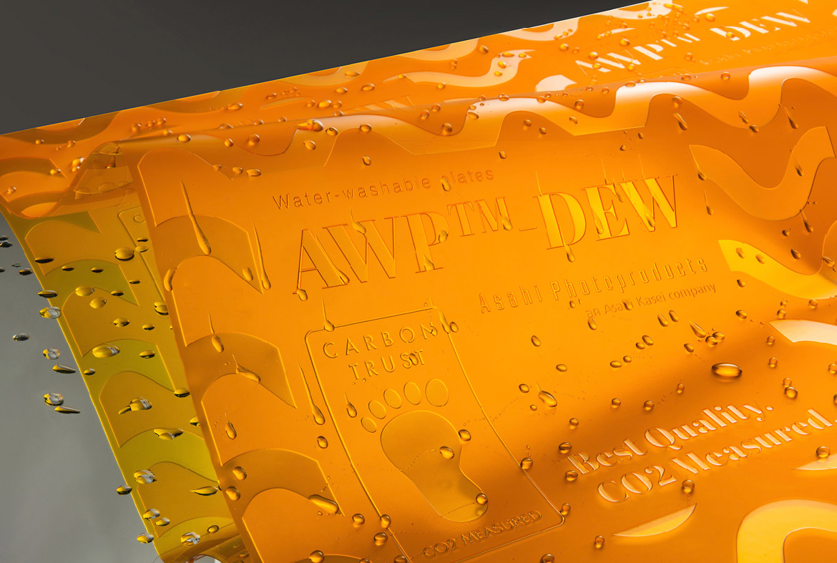
Caption: AWP™-DEW CleanPrint water-wash flexo plate: Huichang Flexo has been satisfied with its ability to deliver excellent plate quality with a reduced carbon footprint.

"We introduced platemaking equipment to the Chinese market, including the Asahi Kasei's AWP™ CleanPrint water-wash platemaking system, to provide flexo printing companies with high-quality plates in balance with the environment. In China, environmental regulations are becoming more strict, and many companies need to take urgent action to be compliant. To assist them, we introduced a platemaking system that can produce water-wash plates up to 1067x1524 mm with a water-wash solution. These plates deliver high-quality print in harmony with the environment for companies that print on various substrates, including paper and flexible packaging material, and we highly recommend them," said Mr.Pinghui Ren, President of Shanghai Huichang Flexo Technology Co., Ltd.
"Asahi Kasei's AWP™ CleanPrint water-wash platemaking system has proven highly effective for the production of high-definition applications around the world. In the future, flexographic printing, which has a low environmental impact, will primarily be used for flexible packaging in China because of the easy conversion of packaging from gravure to flexo printing. We are very excited to support this transition in China with our AWP™ platemaking solution and its many benefits, such as the improvement of printing efficiency and the low environmental impact,” added Mr. Toshiki Sugawara, Sales Representative for Asahi Kasei Electronic Materials (Changshu) Co., Ltd.
For more information on Asahi Photoproducts AWP™ water-wash platemaking systems and CleanPrint plates for the flexo market, please visit www.asahi-photoproducts.com

--End--

About Shanghai Huichang Flexo Technology Co.,Ltd.
Shanghai Huichang Flexo Technology Co., Ltd. is a new repro house established in 2021 in Shanghai, China. In addition to the AWP™ CleanPrint water-wash platemaking system, the company has introduced the latest plate imaging equipment such as ESKO's Crystal XPS. They offer to their print customers solutions that achieve excellent quality in harmony with the environment.

About Asahi Photoproducts
Asahi Photoproducts was founded in 1973 and is a subsidiary of the Asahi Kasei Corporation. Asahi Photoproducts is a leading pioneer in the development of photopolymer flexo printing plates. By creating high quality flexographic solutions and through continued innovation, the company aims at driving print forward in harmony with the environment

Monika Dürr  duomedia  monika.d@duomedia.com  +49(0)6104 944895 | Dr. Dieter Niederstadt  Asahi Photoproducts Europe n.v./s.a.  dieter.niederstadt@asahi-photoproducts.com  +49(0)2301 946743



