Case Study

Nabe Process Corporation Validates CrystalCleanConnect Benefits
Automated flexographic platemaking system helps company transition to a more sustainable solution

Tokyo, Japan & Brussels, Belgium, August 16, 2022. Nabe Process Corporation, the first company worldwide to install CrystalCleanConnect, was established in 1964 in Takamatsu Prefecture, Japan.
When it first entered the flexo market, Nabe Process was using solvent-based photopolymer plates and processors. In 2020, however, the company began looking for a more sustainable solution that could take the company to new levels of quality, cost and cycle time, and create a better ambient work environment for its employees.
Transitioning to a More Sustainable Solution
“When we learned about AWP™ CleanPrint water-washable plates from Asahi Photoproducts, we were intrigued,” said Mr. Yasuo Naka, Flexo Division Manager, Nabe Process Co., Ltd. “With water wash versus a solvent washout, platemaking time is significantly reduced, helping us to increase throughput in our plant.”
He also found that AWP™ CleanPrint water-washable plates offered other value, adding, “These plates demonstrated a significant improvement in print quality and productivity compared to the conventional solvent-processed flexographic plates. This includes cost savings and faster cycle time due to make-ready time reduction, fewer press stops for plate cleaning, and reduced substrate waste. The AWP™ plates feature high dimensional plate accuracy and stable print repeatability. Plus, since no VOC-based washout solvents are used, there is no odor; and the platemaking and press rooms are comfortable with a perfect ambient environment for the staff.”
He added, "We expect our customers to be even more satisfied with the quality we deliver and with our turnaround times. We will be using CrystalCleanConnect and AWP™ plates for more products in the future".
CrystalCleanConnect: The Details
CrystalCleanConnect is the first automated platemaking line from plate imaging to a ready-to-mount plate, replacing a VOC-based solvent processing solution using water wash technology in balance with the environment.
CrystalCleanConnect is comprised of several highly integrated components that deliver a complete system:
- Esko´s automated software hub, that integrates the process from end to end.
- Esko´s plate handling robot. The operator simply places the plate material on the loading table. The plate handling robot loads AWP™ CleanPrint water-wash plate material on the CDI Crystal XPS and retrieves press-ready plates at the end of the process.
- Esko’s CDI Crystal XPS. The integrated imager and exposure unit delivers full control over plate floor and printing dots with simultaneous main and back UV LED exposure for an extremely consistent and high-quality plate image.
- Asahi’s CCC inline plate processor, dryer and light finisher. Asahi AWP™-DEW water-washable plates do not need plate drying when processed via an inline air-knife, removing the water from the plate surface. The result is a significant reduction in plate production time, since the drying process, especially with solvent-based platemaking, can take as much as two hours.
- Kongsberg inline cutting table, a unique integration for the industry. Using efficient file nesting results in at least a 10% savings in waste plate material.
CrystalCleanConnect is the first automated platemaking solution to improve the ambient operator work environment by eliminating VOC based washout solutions from the plate making process and to improve operator safety by eliminating hazardous operator touch points from 12 to 1. It is also an industry-first with integration of plate cutting into the automated workflow. The first plate is available, including cutting, 70 minutes after the start.
For more information about CrystalCleanConnect, download our free white paper here.
—ENDS—
About Asahi Photoproducts
Asahi Photoproducts was founded in 1973 and is a subsidiary of the Asahi Kasei Corporation. Asahi Photoproducts is a leading pioneer in the development of photopolymer flexo printing plates. By creating high quality flexographic solutions and through continued innovation, the company aims at driving print forward in harmony with the environment.
Follow Asahi Photoproducts at .
More information is available at www.asahi-photoproducts.com and at:
Monika Dürr  duomedia  monika.d@duomedia.com  +49(0)6104 944895 | Dr. Dieter Niederstadt  Asahi Photoproducts Europe n.v. /s.a.  dieter.niederstadt@asahi-photoproducts.com  +49(0)2301 946743


Image & caption:
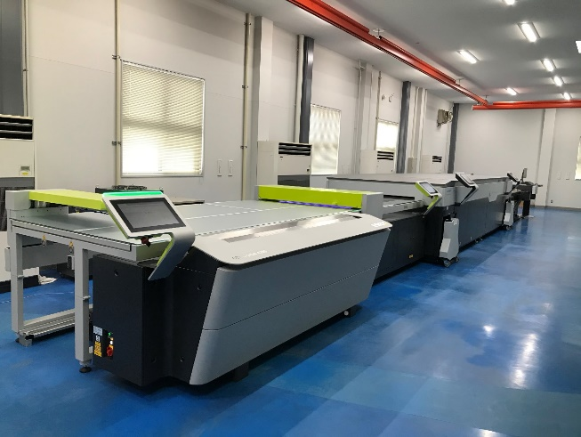
CrystalCleanConnect, a world-first fully automated flexographic platemaking solution jointly developed by Asahi Photoproducts and ESKO

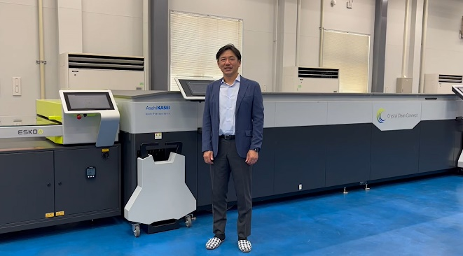
Mr. Yasuo Naka, Flexo Division Manager, Nabe Process Co., Ltd. in front of the CrystalCleanConnect installed in March 2021.

