Press Release

German Packaging Converter Arwed Löseke Brings Plate Production In-house as a More Sustainable Business Solution
Fifth generation family owned business invests in water-wash plate technology for faster plate availability and reduction of its CO₂ footprint
Tokyo, Japan & Brussels, Belgium, August 24, 2022. Asahi Photoproducts, a pioneer in flexographic photopolymer plate development, today reported that German packaging converter Arwed Löseke Paper Processing and Printing GmbH, has recently upgraded its printing operation with a BOBST M6 LED hybrid flexographic printing press utilizing Asahi AWP™-DEW CleanPrint water-washable printing plates and UV inks. Löseke is a fifth-generation family owned business with a large machine park, including a 10-colour rotogravure and a 10-colour CI flexo printing press. The company was founded in Hildesheim in 1883, has about 250 employees, and is currently managed by managing director and owner, Ariane Löseke.
In addition to the new Bobst M6 inline flexo press, they also acquired an Asahi AWP™ 4835P water-wash plate processor and an ESKO CDI XPS plate imaging system in order to bring flexo plate making in-house. In addition to eliminating the use of solvent-wash printing plates, the company is also able to offer customers more flexibility and faster turn times with no sacrifice in quality, including new applications such as adhesive labels.
“Our company is paving the way and investing in future-proofing our business,” said Ms. Löseke. “We now offer a wide range of products from foils, bags, flexible packaging and adhesive labels to dust filtration bags made of paper. This, combined with expert industry knowledge and working hand in hand with our customers to truly address their business needs, is clearly a unique selling proposition for the company. In order to add the necessary expertise to get up to speed quickly with adhesive labels, an application enabled by our adoption of Asahi AWP™ CleanPrint water-washable plates, we are delighted to have industry expert Anke Hoefer join our sales team. A satisfied customer is the focus of our approach and our efforts in all areas, and Anke is a valuable enabler in that regard with her expertise in both adhesive labels and flexible packaging.”
Sebastian Spitzer, who holds a Bachelor Professional in Print (CCI) and is responsible for technical administration, notes, “Another benefit of this new configuration, and a key reason for choosing the Asahi AWP™-DEW plates, is the improvement in print quality. The AWP™-DEW is a specially engineered plate, which also minimizes print smearing.”
Ariane Löseke also comments that it is important for both the company and its customers to reduce their CO₂ footprint. By implementing its new extended gamut 7-color LED hybrid flexographic printing press with AWP™ CleanPrint water-washable plates and fixed colour palette capability, the company not only reduces long job change over times but is also able to reduce the inventory of spot colour inks for the printing press. Sebastian Spitzer added, “Replacing spot colors with the extended color space is a process that is subject to constant optimization. We are very happy to have found a partner in Asahi who will accompany us on this path and actively support us.”
In addition, Löseke invested in new flexo platemaking equipment, with the goal to bring platemaking in-house. This process was outsourced in the past, and the technological transformation has enabled them to produce plates just-in-time for the job and generate less waste in the press room due to virtual elimination of the need for press stops for plate cleaning.
“We were impressed with the quality and productivity we saw during our search for the best solutions,” Sebastian Spitzer says, “as well as the fact that Asahi has a joint development partnership with ESKO, another recognized industry leader. As we gain more experience with the technology, we hope to be able to transfer some of our work from other technologies, such as rotogravure, to this more sustainable flexographic process.”
Bringing flexo platemaking in house enables better control over delivery times and plate quality for Arwed Löseke. “Even if we do need to replace a plate during the print run,” Spitzer says, “we can produce a new one in less than an hour, much more quickly than can be done with outsourced solvent-based platemaking. We have communicated all of these value propositions to our customers, and they are very appreciative of the types of investments we are making on their behalf.”
Ms. Löseke concludes, “The biggest advantage of these investments for me as the company owner is the sustainability of the AWP™-DEW water-wash plates. In addition, solvent-based systems require more space since they require extraction systems to deal with VOCs. This makes it virtually impossible and very costly to relocate the system. With our new Asahi system, we have this extra flexibility in case we need to move the equipment.”
“We are pleased to welcome Arwed Löseke as an Asahi customer,” said Martin Schreil, Sales Representative DACH, for Asahi Photoproducts. “It is always a pleasure to work with forward-thinking companies who are looking to future-proof their businesses with sustainability as a key driver. We believe our partnership is a good step in that direction, and we look forward to continuing to work together.”
For more information about flexographic solutions from Asahi Photoproducts that are in harmony with the environment, visit www.asahi-photoproducts.com.
—ENDS—

About Asahi Photoproducts
Asahi Photoproducts was founded in 1973 and is a subsidiary of the Asahi Kasei Corporation. Asahi Photoproducts is a leading pioneer in the development of photopolymer flexo printing plates. By creating high-quality flexographic solutions and through continued innovation, the company aims at driving print forward in harmony with the environment.
Follow Asahi Photoproducts at .
More information is available at www.asahi-photoproducts.com and at:
Monika Dürr  duomedia  monika.d@duomedia.com  +49(0)6104 944895 | Dr. Dieter Niederstadt  Asahi Photoproducts Europe n.v. /s.a.  dieter.niederstadt@asahi-photoproducts.com  +49(0)2301 946743


Images and captions:
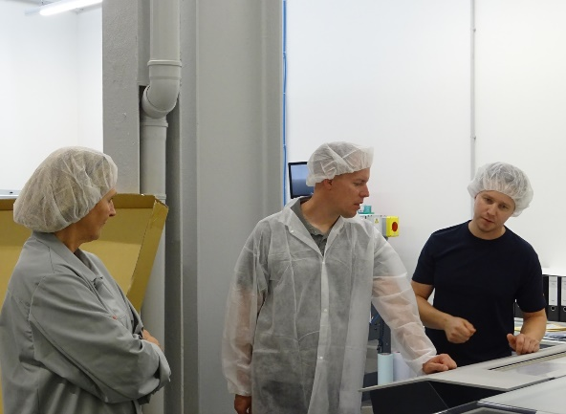
Caption: Timo Kreuteler of Wigo Chemie GmbH, Anke Hoefer of Arwed Löseke and Sebastian Spitzer, Technical Administsration, consult about platemaking best practices

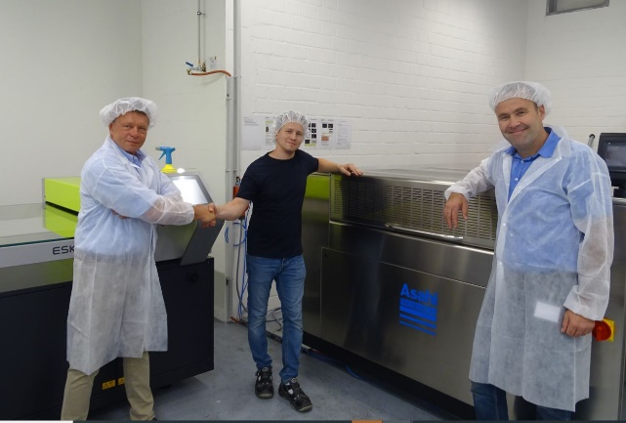
Caption: Ulrich Schulze and Martin Schreil of Asahi congratulate Sebastian Spitzer, Technical Administration at Arwed Löseke (center)

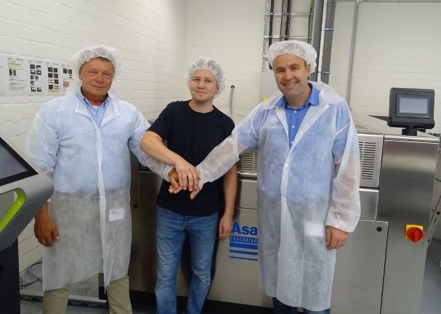
Caption: Arwed Löseke’s transition into Asahi’s CleanPrint water-washable plate making technology created a team with Arwed Löseke’s best results at heart

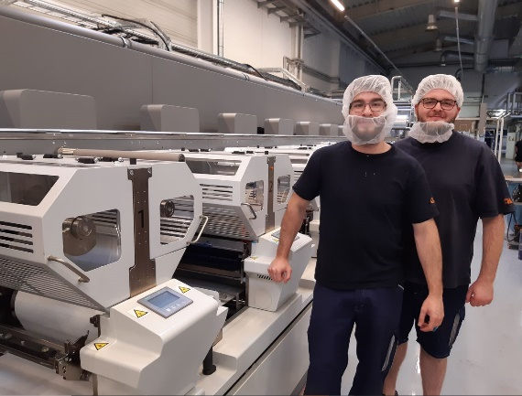
Caption: Asahi’s CleanPrint water-wash flexo plates are the perfect companion for Arwed Löseke’s Bobst MC LED hybrid flexo press, say machine operators Heinrich and Caygece

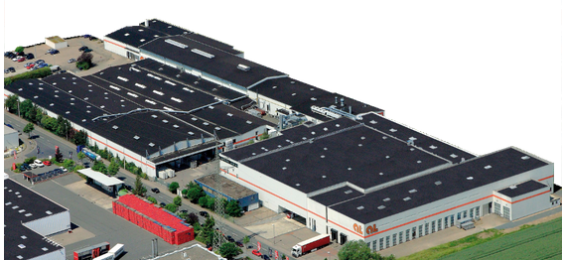
Caption: Aerial view of Arwed Löseke’s printing and converting plant

