Press Release

Asahi Photoproducts to Showcase Innovation, Improved Sustainability, Progress toward Carbon Neutrality for Flexographic Platemaking at LabelExpo Americas 2022
Elimination of solvents, reduction of waste, faster time to press key to reduction of carbon footprint for flexographic printers/converters
Tokyo, Japan & Brussels, Belgium, September 1, 2022. Asahi Photoproducts, a pioneer in flexographic photopolymer plate development, today reported it will be showcasing industry leading sustainability for flexographic platemaking at LabelExpo Americas 2022. At the show, which is scheduled for 13-15 September at the Donald E. Stephens Convention Center in Chicago, Asahi Kasei will be located at Booth 845. The company will feature its AWP™-DEW CleanPrint flexographic plates which are well down the path toward achieving Carbon Neutrality.
“In addition to displaying our complete line of CleanPrint plates suitable for high quality label printing,” said Yuji Suzuki, Technical Advisor, “we will also be unveiling our new water recycling unit, a breakthrough in sustainability and water conservation for flexo plate production.”
The new water recycling unit is targeted for larger Asahi plate processing systems. It features an innovative filtering system that recycles up to 75% of the water used in plate processing, with only the remaining 25%, in the form of a slurry or sludge, to be disposed of. Forty percent of the additive used in the water wash remains in the filtered water, reducing the amount of additive required for processing subsequent plates. “Fresh water is one of the earth’s most precious resources,” Yuji Suzuki added. “We chose to develop water-washable plates to eliminate the need for polluting solvents. But at the same time, we wanted to find a way to minimize the use of that water. This recycling unit does just that.”
On a Path to Carbon Neutrality
Asahi Photoproducts is also pleased to announce that it is well down the path toward achieving Carbon Neutral status for its AWP™-DEW CleanPrint water-wash plates in partnership with The Carbon Trust, expected to be achieved soon. “Sustainability is a key focus for our parent company, Asahi Kasei,” Dieter Niederstadt, Technical Marketing Manager noted, “and we have their full support in pursuing our carbon neutrality objectives. We look forward to discussing these efforts with visitors to our booth at LabelExpo Americas 2022 and explaining the importance of the type of accountability working with The Carbon Trust enables. It is one thing to claim that your solutions are green; it’s quite another to be able to back that up by accountable data including certification by a prestigious organization like The Carbon Trust.”
CleanPrint Technology Delivers Improved Productivity, Quality, Profitability
Asahi AWP™ CleanPrint water-washable flexographic plates are processed without VOC-based washout solvents and deliver a faster time to press than VOC solvent-based plates. Asahi´s CleanPrint water-washable flexographic photopolymer plate technology’s ability to deliver high quality print performance is a result of its engineered photopolymer chemistry design. The water-wash technology also features a low surface energy plate resulting in fewer press stops for plate cleaning for significantly improved press efficiency and reducing press waste. All of these elements make them the most sustainable flexographic plates in the industry. In addition, AWP™-DEW CleanPrint plates deliver extremely high-quality print due to their precise registration and ability to deliver perfect printing balance between highlights and solids and full support for fixed color palette printing.
For more information about flexographic solutions from Asahi Photoproducts that are in harmony with the environment, visit www.asahi-photoproducts.com.
Note to Journalists: To schedule a one-on-one meeting with Asahi experts at LabelExpo Americas 2022, contact monika.d@duomedia.com.
—ENDS—

Image and caption
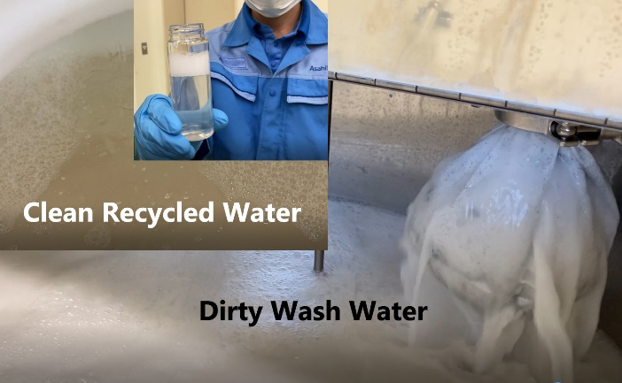
Asahi’s new water recycling unit features an innovative filtering system that recycles up to 75% of the water used in plate processing.

About Asahi Photoproducts
Asahi Photoproducts was founded in 1973 and is a subsidiary of the Asahi Kasei Corporation. Asahi Photoproducts is a leading pioneer in the development of photopolymer flexo printing plates. By creating high quality flexographic solutions and through continued innovation, the company aims at driving print forward in harmony with the environment.
Follow Asahi Photoproducts at .
More information is available at www.asahi-photoproducts.com and at:
Monika Dürr  duomedia  monika.d@duomedia.com  +49(0)6104 944895 | Dr. Dieter Niederstadt  Asahi Photoproducts Europe n.v. /s.a.  dieter.niederstadt@asahi-photoproducts.com  +49(0)2301 946743


