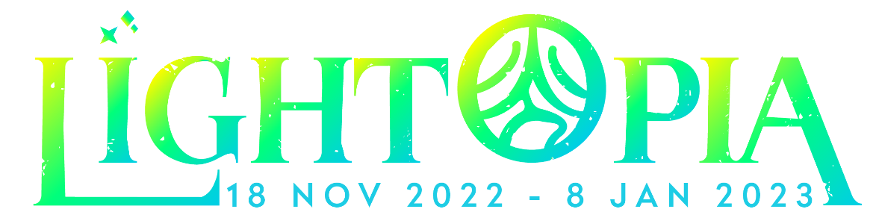

Lightopia Festival Brussels Debut
at Castle of Grand-Bigard
Europe’s largest lantern and light festival coming to
Brussels this winter

This winter, the castle of Grand-Bigard, the spectacular historic castle near Brussels, will host Lightopia Festival, a multi-award-winning lantern and light festival. Lightopia Festival will make its debut on the European continent this November and will continue until New Year's 2023.

Lightopia Festival is a multi-award-winning lantern and light festival that combines traditional handcrafted lanterns with modern design and technology such as water shows, 3D projections, and artistic installations to create an interactive and immersive experience. Finding its inspiration in the thousand-year-old traditions of the Chinese New Year with their lantern festivals and fireworks to scare away evil spirits and welcome the new year, Lightopia Brussels will be the first of its kind.

The castle of Grand-Bigard, a 17th-century landmark adorned with beautiful gardens, magical woodland and Renaissance style architecture, will be the perfect host for Lightopia Brussels.

Lightopia Brussels will be the first of its kind and the biggest light show on the European continent, bringing never-before-seen, bespoke light installations to transform the castle of Grand-Bigard into a magical Christmas fairyland for families, couples and friends to enjoy during the holiday season.

The 1.8 km-long light and lanterns trail, filled with thousands of installations using over 1,000,000 light bulbs, will showcase an interactive Tree of Life protected by the Manneken Pis Fairy that will dazzle guests with colourful illuminations. Visitors will walk through an enchanted light trail and discover the Fairy Gate, Golden Christmas Tree, Spell Tunnel, Dream Catcher, Magical Safari, Belgium Fairy Flowers, Enchanted Mini-City, Wizardly Lights, Love Land, and much more.

A stunning water show featuring a 40-meter wide and 15-meter-tall water screen will rise in front of the castle, turning it into a never-before-seen fairy tale dreamworld that will delight the audience.

Lightopia Brussels not only brings you a visual feast, but visitors will also be able to enjoy Christmas dinner in the dazzling scenery of the castle greenhouse. They can get mulled wine and hot chocolate to go as they explore the multi-sensory event.

Xavier Pelgrims, owner of the Grand-Bigard castle, says: “Originating from the United-Kingdom, this event is coming to the continent for the first time. At night, a fabulous lightshow will illuminate the castle and the park with hundreds of multi-coloured and interactive lights, a real enchantment for everyone.”

Ian Xiang, Founder of Lightopia, adds: “We are thrilled to bring Lightopia Festival to Brussels in the beautiful scenery of the Grand-Bigard castle. Lightopia has already brought happiness and lifelong memories to thousands of families. At Lightopia Brussels, we will share our passion for light and creativity, bring joy to our audiences and offer them an unforgettable experience that families and friends can enjoy together.”

Lightopia Brussels at the Grand-Bigard castle will be open to the public during selected days from 18 November 2022 to 8 January 2023. There will also be a Fantasy Playground for younger audience members with Twinkling Dining Café, where food and refreshment will be available for all taste buds to enjoy.

Tickets
 | Off-peak day | Peak day
Adults | € 18,50 | € 22,50
Senior (65+), disabled persons | € 16,50 | € 20,50
Children aged between 4 and 16 | € 14,50 | € 17,50
Group (min. 20 persons) | € 16,50 | € 20,50
Family ticket (2 adults and 2 children) | € 60,00 | € 70,00
Children under 4 years | Free entrance
Parking | € 5,00 per car
For a limited period of time, visitors will receive 20% off early bird tickets when they register on the waiting list here.
For further information and ticket bookings, please visit Lightopiabrussels.be.

Contact:
Sylvia Tielemans
contact@kasteelgrootbijgaarden.be
+32(0)474 50 38 30

Kasteel van Groot-Bijgaarden
Isidoor van Beverenstraat 5 – 1702 Groot-Bijgaarden
www.kasteelgrootbijgaarden.be

