Press Release

Asahi Photoproducts Takes Its Sustainability Message to Labelexpo India
Elimination of solvents, reduction of waste, faster time to press key to increased sustainability for flexographic printers/converters
Tokyo, Japan & Brussels, Belgium, November 7, 2022. Asahi Photoproducts, a pioneer in flexographic photopolymer plate development, today reported it will be taking its sustainability message to Labelexpo India 2022. At the show, which is scheduled for 10 to 13 November at the India Expo Center in Greater Noida, Asahi Kasei’ products will be presented by its distributor TechNova Imaging Systems (P) Ltd. on their Stand M26 in Hall 5. The stand will feature Asahi’s AWP™-DEW plates which have achieved Carbon Neutral certification in Japan, the USA, China and Europe.
“We are pleased to represent Asahi Photoproducts in India and to have their participation in our stand at Labelexpo India,” said Sunil Kokane, Sr. Manager Business Development of TechNova Imaging Systems. “Based on our long-time relationship with Asahi, we know they will bring an exceptional level of knowledge and expertise to the event that all attendees will be able to benefit from as they pursue their own productivity, profitability and sustainability goals.”
The Value of Environmentally Sustainable Plates
“At Labelexpo India, we will focus on the value for flexo operations to switch to Asahi CleanPrint water-wash plates, an environmentally sustainable solution that emits no VOCs and not only results in faster plate production but is also a key enabler in improving pressroom productivity,” said Arata Ohnoko, Asahi Sales Manager.
At the show, Asahi Photoproducts representatives will also be discussing the company’s many years of working toward a more sustainable flexographic industry and the importance of setting a Carbon Neutral goal.
CleanPrint Technology Delivers Improved Productivity, Quality, Profitability
Asahi AWP™ water-washable flexographic plates are processed without VOC-based washout solvents and deliver a faster time to press than VOC solvent-based plates. Asahi´s CleanPrint water-washable flexographic photopolymer plate technology’s ability to deliver high quality print performance is a result of its engineered photopolymer chemistry design. The water-wash technology also features a low surface energy plate resulting in fewer press stops for plate cleaning for significantly improved press efficiency and reducing press waste. All of these elements make them the most sustainable flexographic plates in the industry. In addition, AWP™-DEW plates deliver extremely high-quality print due to their precise registration and ability to deliver perfect printing balance between highlights and solids and full support for fixed colour palette printing.
In addition to AWP™-DEW plates, Asahi’s AWPTM-CleanFlat plates are also part of the CleanPrint family and will be on display at the show. Although they do not yet have Carbon Neutral certification, AWP™-CleanFlat plates have a reduced carbon footprint, especially when compared to solvent-wash flexo plates. These are an out-of-the-box FlatTop plate solution with high-quality printing press consistency. It improves the ink laydown on wide web flexible packaging and beverage carton printing. At the same time, it delivers a sustainable reduction of the printer’s carbon footprint, delivering stable printing quality even with rough surface substrates.
For more information about flexographic solutions from Asahi Photoproducts that are in harmony with the environment, visit www.asahi-photoproducts.com.

—ENDS—
Images and captions
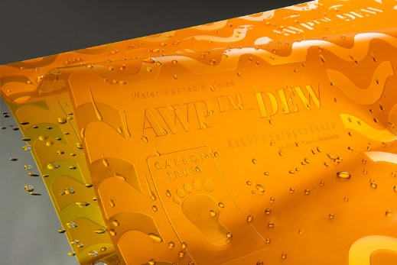
Caption: Asahi’s AWP™-DEW water-washable flexographic plates achieved the Carbon Neutral Certification in compliance with PAS 2060 handed over by the Carbon Trust for Japan, the USA, China and Europe.

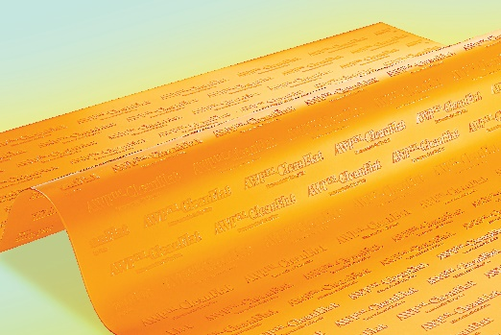
Caption: AWP™-CleanFlat is a water-washable FlatTop plate solution with high-quality printing press consistency. It improves the ink laydown on wide web flexible packaging and beverage carton printing. At the same time, it delivers a sustainable reduction of the printer’s carbon footprint.

About TechNova
TechNova is one of the world's largest suppliers of print solutions. TechNova's innovative and world-class products cater to a wide range of industries, such as Commercial & Newspaper Printing, Publishing, Packaging, Signage, Photo, Textile, Engineering & Medical Imaging.
TechNova's name is derived from the words “technology” and “innovation”, and it is these two ideas that form TechNova's core mission. Globally recognised as a pioneer, TechNova has introduced several breakthrough technologies and innovative products that have transformed various print processes and created new markets.
With its wide distribution and logistics network in India, TechNova's products & services are used by every printer in the country. In addition to its leadership position in India, TechNova markets its products to over 60 countries through its international offices and distribution network.
Uniting all of TechNova's businesses is its value system – a strict code of ethics, commitment to excellence, business conduct based on honesty, fairness & mutual trust, and a “Customer First” philosophy. For more information about TechNova and it products & services, please visit: www.technovaworld.com or follow ollow TechNova Imaging System

About Asahi Photoproducts
Asahi Photoproducts was founded in 1973 and is a subsidiary of the Asahi Kasei Corporation, which has a century of operating history. Asahi Photoproducts is a leading pioneer in the development of photopolymer flexo printing plates. By creating high-quality flexographic solutions and through continued innovation, the company aims at driving print forward in harmony with the environment. Follow Asahi Photoproducts at .
More information is available at www.asahi-photoproducts.com and at:
Monika Dürr  duomedia  monika.d@duomedia.com  +49(0)6104 944895 | Dr. Dieter Niederstadt  Asahi Photoproducts Europe n.v. /s.a.  dieter.niederstadt@asahi-photoproducts.com  +49(0)2301 946743

