Press Release

Asahi Photoproducts is partnering and installing its water-wash equipment in the new Gallus Experience Center
AWPTM-DEW and AWPTM CleanFlat Environmentally Sound CleanPrint solutions to be featured at the event
Tokyo, Japan & Brussels, Belgium, May 30, 2023. Asahi Photoproducts, a pioneer in flexographic photopolymer plate development, today reported it will be attending the Gallus Experience Days at its grand opening, scheduled for customers from the 21th – 23rd of June 2023 at the new Gallus Experience Center in St. Gallen, Switzerland. The motto of the event is Celebrating Innovation and Collaboration. Asahi will be participating in demonstrations of its CleanPrint water-washable plate technology at the event, and Asahi experts will be on hand to explain the Asahi sustainability strategy and its achievement of Carbon Neutral certification for AWPTM plates. In addition, Dieter Niederstadt, Asahi’s Technical Marketing Manager, will be giving a presentation entitled The Road Toward Solvent Zero, which will also explain its new water recycling unit for water-wash plate processing equipment.
“The Asahi water-washable plate has been in the market for 15 years,” Niederstadt said, “and we continue to improve its value to the industry and to the environment. In 2022, our AWPTM-DEW water-washable plate achieved Carbon Neutral certification in partnership with The Carbon Trust, highlighting the company direction to become carbon neutral across all its businesses by 2050. We will also feature the AWPTM CleanFlat plate, a water-washable FlatTop plate solution with high-quality printing press consistency. We are proud to be able to bring these and other important messages to the Gallus Experience Days attendees and the flexo community.”
Gallus expects attendance of up to 800 customers over the duration of the event, as well as many members of the press. Asahi has partnered with Gallus and Esko to set-up an In-Center water wash platemaking production highlighting the companies commitment for a long term partnership.
Registration is possible via the following link www.gallus-group.com/en/gallus/events/gallus-experience-days
To learn more about Asahi Photoproducts’ journey to Carbon Neutrality and the process used by Asahi Photoproducts to achieve its recent certification for Asahi AWPTM-DEW water-washable flexo plates, download our white paper, Carbon Neutrality: A Goal Worth Pursuing.”
For more information about flexographic solutions from Asahi Photoproducts that are in harmony with the environment, visit www.asahi-photoproducts.com.

—ENDS—

About Asahi Photoproducts
Asahi Photoproducts was founded in 1973 and is a subsidiary of the Asahi Kasei Corporation, which has a century of operating history. Asahi Photoproducts is a leading pioneer in the development of photopolymer flexo printing plates. By creating high-quality flexographic solutions and through continued innovation, the company aims at driving print forward in harmony with the environment. Follow Asahi Photoproducts at .
More information is available at www.asahi-photoproducts.com and at:
Monika Dürr  duomedia  monika.d@duomedia.com  +49(0)6104 944895 | Dr. Dieter Niederstadt  Asahi Photoproducts Europe n.v. /s.a.  dieter.niederstadt@asahi-photoproducts.com  +49(0)2301 946743


Image & caption:


Register here: www.gallus-group.com/en/gallus/events/gallus-experience-days

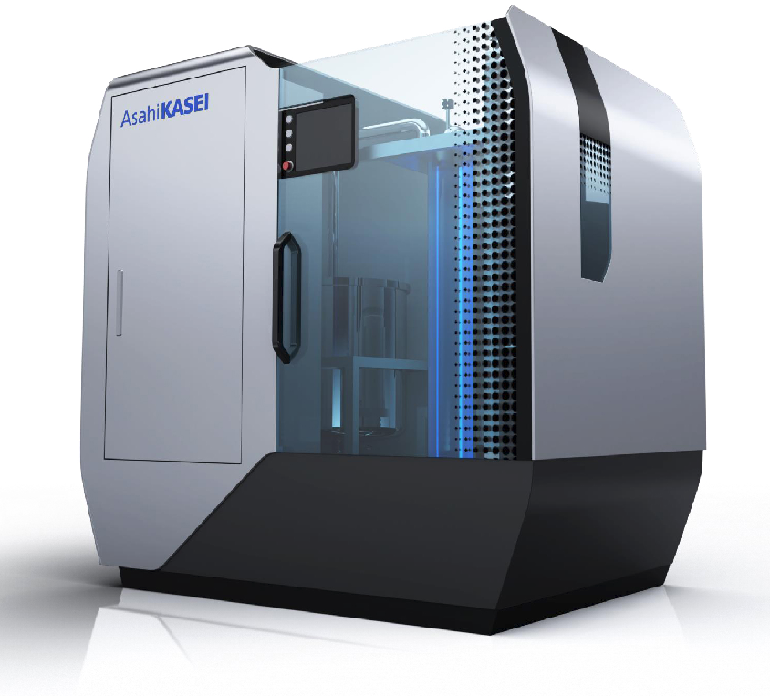
Asahi’s new water recycling unit for the plate processor that reduces wastewater by 75%, and also decreases the amount of detergent required in each cycle by 60%

