Helly Hansen Reinvents its End-of-Line Packing Operation with Ranpak Automation

A global supplier of skiing, sailing and outdoor clothing as well as workwear, Helly Hansen has nearly tripled the number of boxes packed in a 16-hour day, reduced the opportunity for theft during the shipping process, and is benefiting from Ranpak’s automated box erector and reduction in height of filled boxes for a more enjoyable, productive and sustainable packing process.

CONCORD TOWNSHIP, Ohio – May 02, 2023 – Ranpak Holdings Corp. (“Ranpak”) (NYSE: PACK), a global leader of environmentally sustainable, paper-based packaging solutions for e-commerce and industrial supply chains, today reported that Helly Hansen, a global supplier of skiing, sailing and outdoor clothing as well as workwear, has converted its packing operation from a highly manual process, including various staffed stations for picking, packing and shipping, to a highly automated process. Today, the company has replaced the older configuration with an automated End of Line (EOL) system comprised of a Form’it! TM box erector and a Cut’it!™ EVO automated in-line packing machine that reduces packed box height to minimize voids in parcels before shipping. Helly Hansen employes about 1,750 people across all its locations, with about 50 full-time warehouse employees and up to 60 temporary workers in the warehouse depending on seasonal workload. This new configuration has enabled the company to nearly triple its hourly output of ready-to-ship boxes.
Helly Hansen’s Ranpak Automation end-of-line (EOL) solutions include:
- Form’it!TM Case is an automated box erector which creates up to 15 perfectly square boxes per minute. Automated box erecting is a big step forward in efficiency and operator ergonomics. The usage of hotmelt creates extra strong and tamper evident boxes. The Form’it! Case machines are available with single or multiple magazines (up to 4) – as well as with different footprints.
- The Cut’it!™ EVO automated in-line packing machine reduces voids in parcels before shipping, cutting down on shipping costs. It automatically shortens cartons to match their highest point of filling, and then glues a lid securely in place.
Hans Heijdeman, Operations Manager at the Helly Hansen European Distribution Centre, stated, “We moved from a manual pick-and-pack operation where we were preparing and shipping three to four hundred boxes per hour to a fully automated system that can handle 1,000 boxes per hour over a 16-hour day. And the implementation project for our new system took place during a season of record sales, which was quite an achievement. Ranpak was an exceptional partner in helping us achieve this transformation, and we are very happy with the accuracy and reliability of our new system. With Cut’it! EVO, we are no longer shipping air because we are able to adjust the height of the box to its actual contents. And we are able to place more boxes per pallet than we did before which means fewer trucks on the road. In addition, the automated system has significantly increased our throughput, as I noted, positioning us well for competitive advantage as we move into the future.”
Prior to learning about EOL automation solutions from Ranpak, Helly Hansen entertained an offer from a supplier to upgrade part of its system and requested that supplier to add a conveyor and some carton automation. “Unfortunately,” Heijdeman comments, “the solution they came back with did not meet our needs.”
Meanwhile by coincidence, the company’s box supplier introduced Heijdeman to Ranpak, who was located just 20 minutes away. “We went to see what they had to offer and were immediately taken with the Form’it! box erector. It was as simple to use as could be, so that was an easy choice. And we were especially impressed with the Cut’it! EVO, which could reduce the height on our boxes automatically. We liked the fact that Ranpak was only 20 minutes away in case we had any issues. It was truly a no-brainer to take this decision in favor of Ranpak. It came to us at the right moment!”
Heijdeman notes that following implementation of the Ranpak Automation system, the company’s EOL packing flow changed drastically. “It was like going from the Stone Ages to 2022,” he said.
Heijdeman notes a number of other advantages, including:
- Being able to provide more accurate information to shippers, including accurate box measurements and weight, which are available to us immediately.
- Shipping boxes that are the required height to fit the packed contents;
- More easily being able to check carrier invoices against internal data during the accounting process;
- Fewer operational hours required to process boxes; and
- Reduction of theft between the Helly Hansen warehouse and the customer facility.
Because the previous packaging process sealed the boxes with tape, Heijdeman explains, it was too easy for bad actors along the supply chain to cut the tape and pull items out of the box, replacing the cut tape with transparent tape so the tampering was hard to detect. “Plus,” he says, “when you are receiving 15 boxes or a pallet, no one really looks at the bottom of the boxes. Now, with Cut’it! EVO, glued tamper-evident tops are put on the boxes and no tape is used. So we have cut the theft problem down to almost nothing.”
Heijdeman credits Ranpak with a smooth installation which took about three weeks in January 2023, adding, “During the implementation, if we needed help, they would be here the next day, or even the same day. And the employees have been very happy with the training they received and how it has made their work more enjoyable. Finally, the process is not only more efficient, but we are no longer shipping air and that is a big sustainability benefit – for us and for our customers!”
For more information about Ranpak, please visit: www.ranpak.com.
About Helly Hansen
Helly Hansen is a Norwegian clothing brand that was founded in 1877 by Helly Juell Hansen. The company started as a producer of waterproof clothing for sailors, and it quickly became known for its high-quality and durable products. Helly Hansen has continued to innovate and expand its product line over the years, and it now offers a wide range of outdoor clothing and gear for men, women, and children.
One of Helly Hansen's most significant contributions to the outdoor industry was the development of the first supple waterproof fabrics, which was a significant innovation in outdoor clothing. Helly Hansen has continued to be a leader in the development of new materials and technologies for outdoor clothing and gear.
In addition to its high-quality products, Helly Hansen is also known for its commitment to sustainability. The company has set ambitious goals for reducing its environmental impact and is working to implement sustainable practices throughout its operations.
Today, Helly Hansen is a global brand with a presence in over 40 countries. The company's products are used by outdoor enthusiasts, professional athletes, and workers in a variety of industries, including fishing, oil and gas, and construction.

For more information, visit www.hellyhansen.com.

About Ranpak
Founded in 1972, Ranpak's goal was to create the first environmentally responsible system to protect products during shipment. Ranpak’s mission is to deliver sustainable packaging solutions that help improve supply chain performance and costs, reduce environmental impact, and support a variety of growing business needs globally. The development and improvement of materials, systems and total solution concepts have earned Ranpak a reputation as an innovative leader in e-commerce and industrial supply chain solutions. Ranpak is headquartered in Concord Township, Ohio and has approximately 600 employees. Additional information about Ranpak can be found on its website: https://www.ranpak.com.

Media Inquiries:
duomedia PR Consultant
Monika Dürr
+49(0)6104 944895

monika.d@duomedia.com
Images:
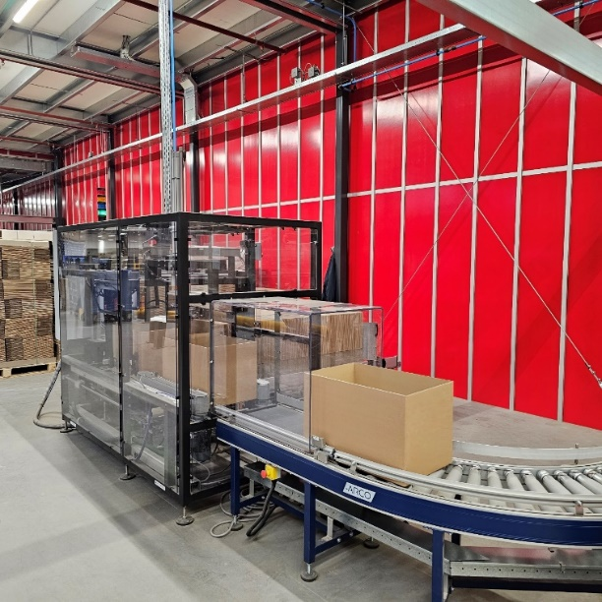
Cartons being formed by the automated Ranpak Form’it! box erector, ready for packing.
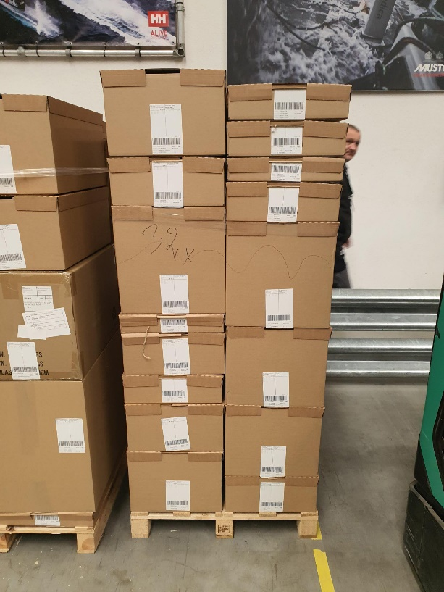
Packed and sealed right-sized boxes ready for shipping.

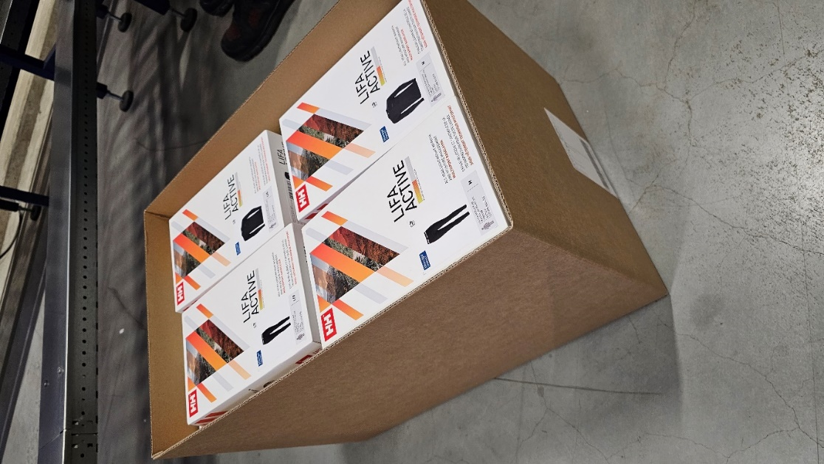
Height of packed boxes is automatically reduced to fit the contents using Ranpak Automation’s Cut’it! EVO, resulting in less shipment of air, more cartons per pallet and fewer trucks on the road

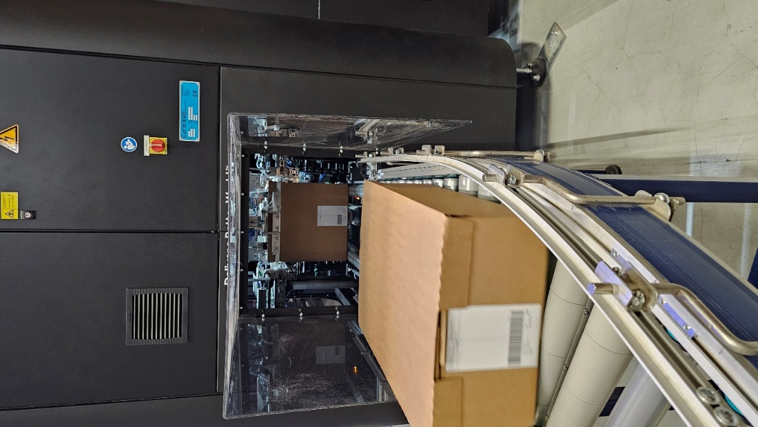
Securely sealed, right-sized carton exiting Ranpak Automation’s Cut’it! EVO, ready for shipping.

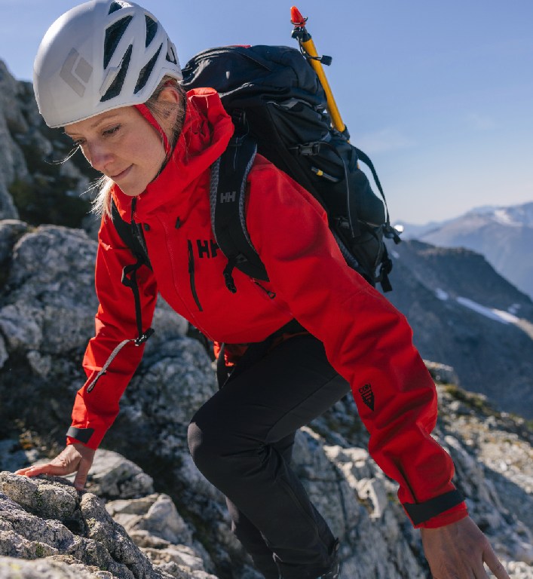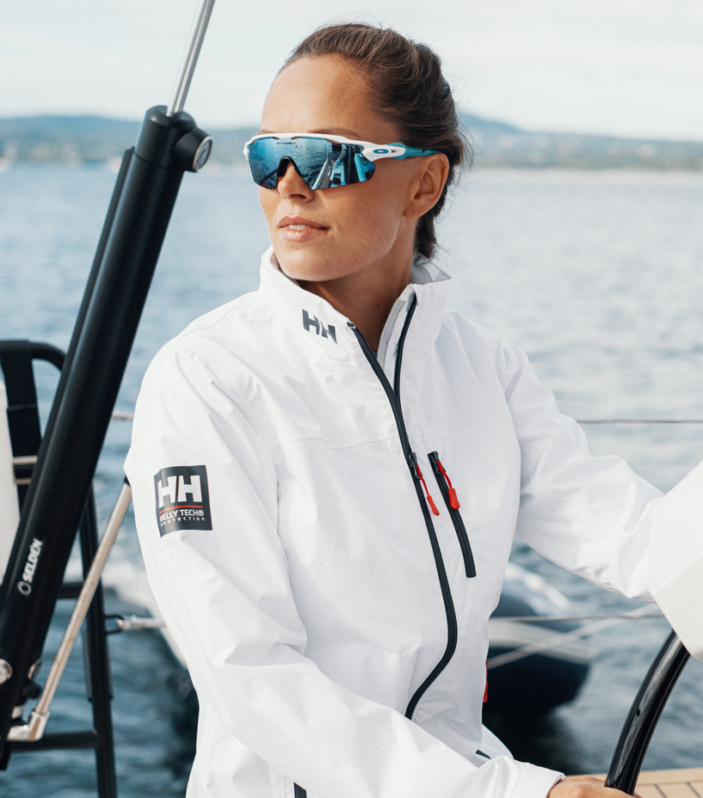
Examples of Helly Hansen Sportswear

