New RICOH Pro™ C9500 to unlock expanded revenue streams and operational efficiency for commercial printers
Workflow efficiency and cost optimisation will help simplify operations, automate tasks, maximise productivity and free up time for other tasks

Ricoh Europe, London, August 2, 2023 – Ricoh Europe is empowering commercial printers to expand revenue streams and enhance operational efficiency with the next generation RICOH Pro C9500 digital colour sheetfed press.
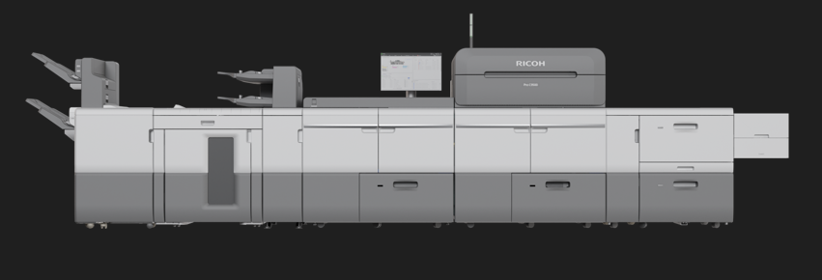
Next generation Ricoh Pro C9500 has been enhanced with performance improving technologies

The evolution of the highly popular RICOH Pro™ C9200 has been enhanced with performance improving technologies designed to elevate productivity and quality, while simplifying operations and expanding application opportunities. It has improved efficiency and automation while developing greater labour savings throughout the entire workflow. Collectively they support cost control, business expansion, and free up time for other tasks.
The flagship toner-based press has also been developed to enable commercial specialists to further accelerate their analogue to digital transition or confidently upgrade their Print on Demand-oriented digital capabilities.
The newly developed RICOH GC OS (Graphic Communications Operating System) engine controller has introduced operational and maintenance management improvements. It includes a larger screen with an intuitive and easy to use user interface and is compatible with external diagnostic systems and maintenance programmes. Users can access the printer from a PC or tablet, and settings can be remotely managed, saving time, even in a multi-skilled environment where printing operators perform numerous tasks.
Greater automation and operational efficiency are powered by the new Auto Color Diagnosis Unit that automates the three critical inspections in commercial printing: quality, registration, and colour fluctuation. It delivers improved inspection accuracy; while there is now greater efficiency post inspection with automatic reprinting and purging functions, and the setting procedure is now easier to operate with seven detection levels to choose from.
Other features and enhancements include:
- Improved media handling of paper between 40gsm and 470gsm with extended input and output options for media up to 1260mm.
- A newly developed fusing system that allows media to pass smoothly through the fusing process whilst applying heat and pressure evenly to achieve high image quality on a wide range of substrates.
- New paper transfer unit to enable improved front to back registration.
- Improved 21.5 inch operator panel enabling the operation of applications in one place.
- New powerful DFE (Digital Front End) options developed in collaboration with Fiery to support operational efficiency and effectiveness.
- Speed upgrade up to 135ppm via a productivity module that can be fitted post installation.
- Improved productivity with fast setup times delivering maximum uptime.
- New finishing options with the GBC StreamPunch Plus for inline creasing and perforating and the Plockmatic Crease Trimmer unit for top and bottom trimming and creasing.

Eef de Ridder, Vice President, Graphic Communications Group, Ricoh Europe, says: “The new Pro C9500 represents a leap forward in the evolution of production technology designed to enable commercial printers to expand their production reach. Its capabilities are further supported by a range of value added software options including RICOH TotalFlow Supervisor™, RICOH TotalFlow Production Manager and RICOH FusionPro that enable clients to maximise their product’s effectiveness and return on their Ricoh investment.”
The Pro C9500 also incorporates proven technologies introduced on the RICOH Pro C9200. They include VCSEL technology (Vertical Cavity Surface Emitting Laser), DEMS (Development Electric-field Modulation System), fusing belt smoothing roller, DSC (Dynamic Shading Correction), registration adjustment, and inline sensor system.
The RICOH Pro C9500 digital colour sheetfed press is available in Europe, Middle East and Africa from September.
For more information visit www.ricoh-europe.com/campaigns/pro-c9500.

-Ends-

| About Ricoh |
Ricoh is empowering digital workplaces using innovative technologies and services that enable individuals to work smarter from anywhere.
With cultivated knowledge and organizational capabilities nurtured over its 85-year history, Ricoh is a leading provider of digital services, information management, and print and imaging solutions designed to support digital transformation and optimize business performance.
Headquartered in Tokyo, Ricoh Group has major operations throughout the world and its products and services now reach customers in approximately 200 countries and regions. In the financial year ended March 2022, Ricoh Group had worldwide sales of 1,758 billion yen (approx. 14.5 billion USD).
For further information, please visit www.ricoh-europe.com
© 2023 RICOH COMPANY, LTD. All rights reserved. All referenced product names are the trademarks of their respective companies.

Media contact:
Ricoh Europe PLC
Jack Gibson
E-mail: media@ricoh-europe.com
Homepage: www.ricoh-europe.com

