Press Release

Excelsior Marking Speeds Flexo Platemaking and Offers Improved Press Performance with Asahi Photoproducts AFPTM-R Reduced Solvent Plates
Platemaking throughput time reduced by 50%; solvent usage reduced by 30%; plates last twice as long on press as compared to other solvent-wash plates
Tokyo, Japan & Brussels, Belgium, January 17, 2024. Asahi Photoproducts, a pioneer in flexographic photopolymer plate development, today reported that Excelsior Marking, located in Akron, Ohio, has adopted Asahi Photoproducts’ AFPTM-R reduced solvent flexographic plates for its service bureau business to support printing of flexo graphics for its customers. The company, founded in 1905, is a marking products company that, in addition to producing flexographic printing plates, also offers metal engraving, metal stamping, and more. It’s 19 talented team members work to provide exceptional services to its trade customers.
“We have used numerous Asahi products in the past,” said Brian Collins, Excelsior’s Technical Sales Manager. “This included AFPTM-DSF, the AFPTM-BFT family of plates, AFPTM-TOP, and AFPTM-TSP. The AFPTM-R plate is the first one where we have worked with Asahi’s distributor Wikoff Color Corporation. In addition to the AFPTM-R plate, we are still using the flat top BFT and medium hard DSF plates, as well.”
The AFP™-R plate is a solvent washable plate with reduced environmental impact and improved pre-press and press productivity. It can save 30% in solvent use and is 50% faster in platemaking, saving time and energy. This is another milestone in Asahi’s sustainability journey, reinforcing its dedication to continuously improving product development in balance with the environment. This is a hard flexo plate for high quality flexible packaging, label and paper applications, featuring several improvements when compared to a standard solvent-wash plate.
Why Use AFPTM-R Flexo Plates
Tami Warlop, Excelsior’s Graphics Manager, noted that key drivers for switching to the Asahi reduced solvent plate related primarily to the faster processing time. “With these plates, our plate turnaround time is about an hour to an hour and a quarter faster. The washout and drying times are cut in half compared to other material we use. And I will say that the number one thing we are seeing with the AFPTM-R plates is the consistency. We rarely have to change the setting for the relief from box to box, which is huge for us. With other products we have tested, the exposure times may change for back exposure from batch to batch, costing us time and effort to get the quality we need.” Collins noted that another key factor was to be able to offer Asahi’s CleanPrint technology to clients. “This is important to them,” he added, “because they achieve better press efficiency since they rarely have to stop the press for plate cleaning, and thus the plates last an average of twice as long. Some are using solvent inks; others are using UV inks. And both types of clients are very happy with these plates.” Collins reported that flexo platemaking comprises about 50% of the company’s business.
CleanPrint plates from Asahi Photoproducts have been specifically engineered by Asahi’s chemical engineers to transfer all remaining ink to the printed substrate, reducing makeready time, ink consumption, and press stops for plate cleaning while delivering exceptionally consistent quality.
Another benefit for Excelsior is that the company has gained new customers as a result of working with Asahi Photoproducts and Wikoff and adding these new plates.
For more information about flexographic products and services from Asahi, visit www.asahi-photoproducts.com or contact us at hello@asahi-photoproducts.com.
—ENDS—

About Asahi Photoproducts
Asahi Photoproducts was founded in 1973 and is a subsidiary of the Asahi Kasei Corporation, which has a century of operating history. Asahi Photoproducts is a leading pioneer in the development of photopolymer flexo printing plates. By creating high-quality flexographic solutions and through continued innovation, the company aims at driving print forward in harmony with the environment. Follow Asahi Photoproducts at .
More information is available at www.asahi-photoproducts.com and at:
Dr. Dieter Niederstadt
Asahi Photoproducts Europe n.v. /s.a.
dieter.niederstadt@asahi-photoproducts.com
+49(0)2301 946743



Image & caption:

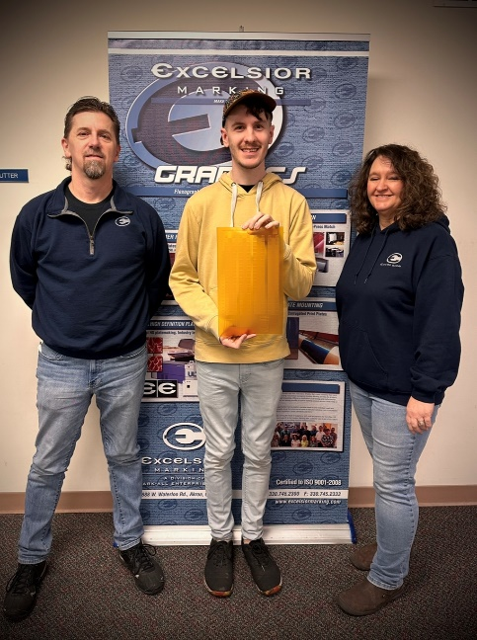
Caption: left to right, Brian Collins (Technical Sales), Mitchell Kline (Lead Plate Technician) and Tami Warlop (Graphics Manager).


Caption: Excelsior Marking company logo

