Yoursurprise drives innovation and growth with RICOH Pro™ Z75 B2 inkjet press technology
Dutch producer of personalised gifts delivers 50,000 orders per day in 30 countries

London, January 16, 2023 – Dutch personalised gift specialist, Yoursurprise, seamlessly managed the busiest time of the year last month – producing and delivering 50,000 customised gifts every day – following the installation of Europe’s second Ricoh Pro Z75 B2 inkjet press.
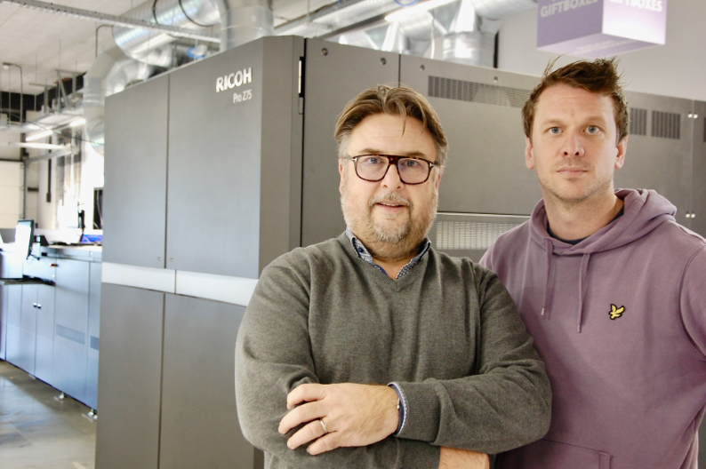
Yoursurprise’s Nico Veenendaal (left) and Bartjan van Damme say the Ricoh Pro Z75 supports innovation and accelerates growth

Yoursurprise was formed 18 years ago. It collaborates with renowned brand owners in exclusive partnerships for personalised packaging (ranging from chocolates to whisky) where the demand for print quality is increasing. The quality achieved at beta installation Heeter in America was central to the decision to invest in the Pro Z75.

Pushing the limits, continuing to innovate and accelerate growth

Production manager Bartjan Van Damme explains: “Colour quality and consistency are very important to our partners. And this is where the Ricoh Pro Z75 really excels – even though we do not have professional print operators running the press. That says a lot about the high level of automation of this machine, and its user friendliness.”

He continues: “We have really been eagerly anticipating the arrival of the Pro Z75. Its ability to handle B2+ (585mm x 750mm) sized substrates allows us to further innovate and accelerate growth.”

Nico Veenendaal, director of Business & Gifts Development, says the B2+ format allows the development and addition of completely new products. He adds: “Its speed of 4,500 sheets per hour ensures high production capacity, making it easy to manage peak moments. This opens a whole new chapter for us.”

Taking partnership with Ricoh to the next level

Essential to the investment was Yoursurprise’s partnership with Ricoh. Mr. Veenendaal says: “Ricoh has been listening very carefully to the market demands and needs before developing this B2 inkjet press to enable innovative businesses like Yoursurprise to keep pushing the limits and prosper.”

He concludes the investment cements the business ethos at Yoursurprise: “Sales, process automation and print production – all add up to a highly successful business model.”

Sander Sondaal, Director Commercial Print Sales, Graphic Communications Group, Ricoh Europe comments: “The Pro Z75 is the perfect solution for this extremely demanding and highly streamlined production environment, where speed, flexibility and reliability are of the utmost importance. As Yoursurprise is aiming for continued growth, it also needs to keep innovating and broadening its capabilities. That matches perfectly with our philosophy ‘HENKAKU’ – the Japanese term for transformational innovation.”

For more information visit https://www.ricoh-europe.com

-Ends-
| About Ricoh |
Ricoh is a leading provider of integrated digital services and print and imaging solutions designed to support digital transformation of workplaces, workspaces and optimize business performance.

Headquartered in Tokyo, Ricoh’s global operation reaches customers in approximately 200 countries and regions, supported by cultivated knowledge, technologies, and organizational capabilities nurtured over its 85-year history. In the financial year ended March 2023, Ricoh Group had worldwide sales of 2,134 billion yen (approx. 16.0 billion USD).

It is Ricoh’s mission and vision to empower individuals to find Fulfillment through Work by understanding and transforming how people work so we can unleash their potential and creativity to realize a sustainable future.

For further information, please visit www.ricoh.com

© 2023 RICOH COMPANY, LTD. All rights reserved. All referenced product names are the trademarks of their respective companies.

