Ranpak Announces Cut’it!™ EVO Multi-Lid at LogiMAT 2024

Ranpak experts will be on site at LogiMAT 2024 to discuss how end-of-line automation supports unrivaled ROI and customer experience, as well as the features of Ranpak’s solutions.

CONCORD TOWNSHIP, Ohio – February 20, 2024 – Ranpak Holdings Corp. (“Ranpak”) (NYSE: PACK), a global leader of environmentally sustainable, paper-based packaging solutions for e-commerce and industrial supply chains, today announced the development of Cut’it!™ EVO Multi-Lid, a solution that allows up to four distinct lids to be applied via one Cut’it!™ EVO machine, dramatically improving customer experience and managing multiple branded lid requirements through a single packaging line.

Ranpak reported it will be bringing its automated end-of-line (EOL) packaging solutions to LogiMAT 2024, scheduled for 19-21 March at the Stuttgart Trade Fair Centre. Ranpak will exhibit in Hall 5, Stand 5B67. During the show, Ranpak will be demonstrating its comprehensive portfolio of automated solutions including its Cut’it!™ EVO in-line packaging machine, with materials and consultation on the features of the Cut’it!™ EVO Multi-Lid solution available as well. These solutions maximize packaging efficiency for customers, enabling them to achieve their goals related to compliance with the EU Packaging Directive, reaching the 40% void target required by 2030.

Unbox the Future of Packaging with Four Unique Branded Lids on a Single Cut’it! EVO Machine

Ranpak’s Cut’it!™ EVO solution automatically shortens cartons to match their highest point of filling and then glues a lid securely in place. Cut’it!™ EVO delivers unrivaled ROI by enabling labor savings, EOL flow optimization, an enhanced unboxing experience, shipping cost reduction, reduced material usage, and improved stock management. Overall, it assists packaging operations in reducing costs and improving performance and sustainability.

Today, growth in e-commerce is driving more complex warehouse operations, including managing multiple branding requirements. Flexible box branding has become paramount for companies to navigate direct sales alongside B2B activities or providing fulfilment for different brands from one facility. In response to these trends, Ranpak’s Cut'it!™ EVO Multi-Lid emerges as a game-changer. With up to four unique branded lids available on a single machine, it addresses demand for flexible box branding. This innovative solution allows a single packaging line to efficiently serve multiple customers, optimizing space and future-proofing businesses.

Moreover, Cut'it!™ EVO Multi-Lid enhances the unboxing experience with easy-to-open boxes featuring a tear-off strip. The visually appealing boxes are both strong in construction and tamper evident due to glued lids, which minimizes damage during shipping, leading to fewer returns.

“We look forward to welcoming visitors to our exhibit at LogiMAT,” said Bryan Boatner, Global Managing Director of Automation at Ranpak. “As market dynamics shift, the evolution of Cut'it!™ EVO Multi-Lid stands at the forefront, redefining the future of packaging and offering unrivalled ROI that extends far beyond labor savings. It truly offers customers the ability to transform their end-of-line supply chain operation.”

Ranpak also invites you to join us for an informative presentation during the LogiMAT Exhibitor Insights on Tuesday, 19 March, at 10:30 AM. Saar Davidi, Director of Automation Solutions at Ranpak, will discuss how automated EOL solutions can deliver unrivalled multidimensional ROI while right sizing packaging in line with upcoming EU regulations.

To schedule a personal briefing and/or packing experience during the show, please contact dorien.c@duomedia.com or make an online appointment here.

For more information about Ranpak, please visit: www.ranpak.com.

About Ranpak
Founded in 1972, Ranpak's goal was to create the first environmentally responsible system to protect products during shipment. Ranpak’s mission is to deliver sustainable packaging solutions that help improve supply chain performance and costs, reduce environmental impact, and support a variety of growing business needs globally. The development and improvement of materials, systems and total solution concepts have earned Ranpak a reputation as an innovative leader in e-commerce and industrial supply chain solutions. Ranpak is headquartered in Concord Township, Ohio and has approximately 600 employees. Additional information about Ranpak can be found on its website: https://www.ranpak.com.

Media Inquiries:
duomedia PR Consultant
Dorien Cooreman
+32 (0)478 98 60 58
dorien.c@duomedia.com

Images

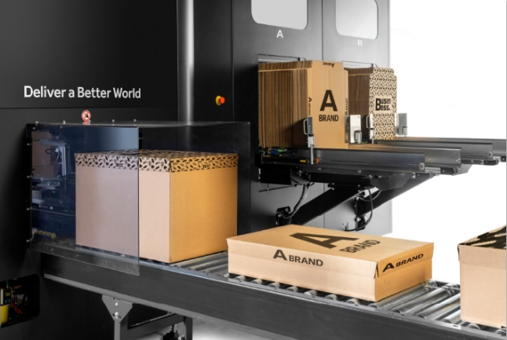
With up to four unique branded lids available on a single machine, Cut'it!™ EVO Multi-Lid addresses demand for flexible box branding.

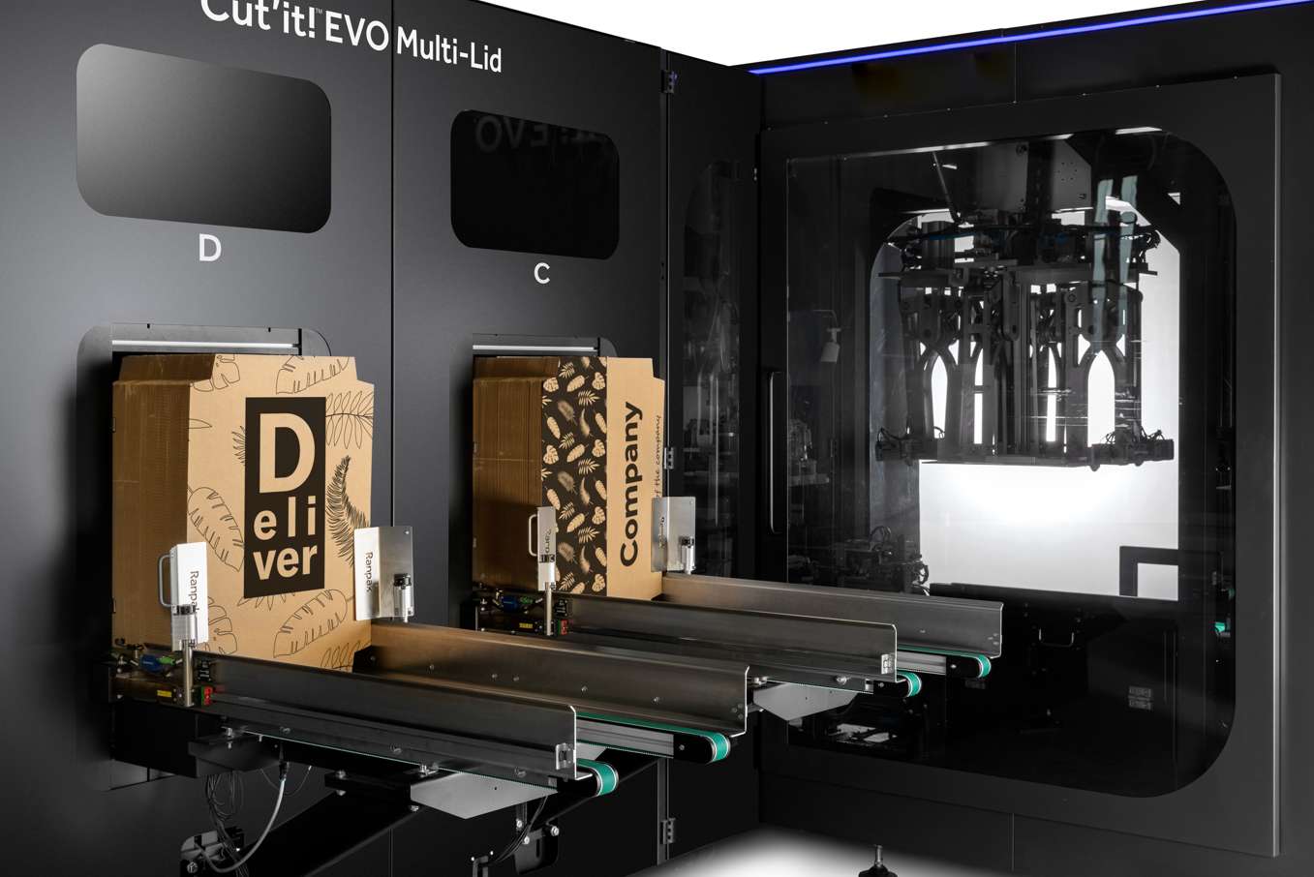
With up to four unique branded lids available on a single machine, Cut'it!™ EVO Multi-Lid addresses demand for flexible box branding.

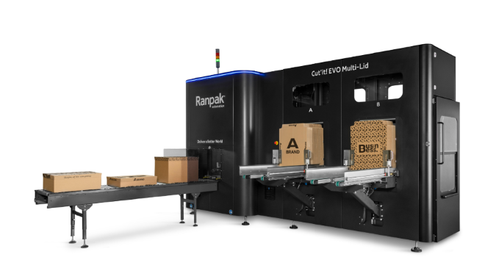
This solution allows a single packaging line to efficiently serve multiple customers, optimizing space and future-proofing businesses.

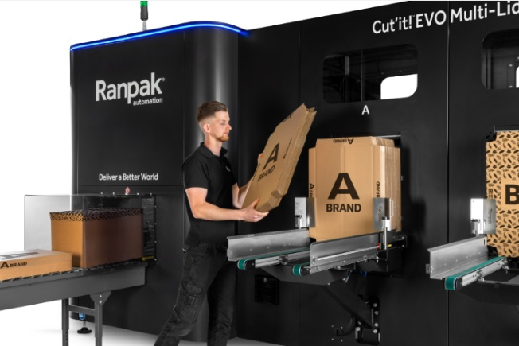
Cut'it!™ EVO Multi-Lid enhances the unboxing experience with easy-to-open boxes featuring a tear-off strip. The visually appealing boxes are both strong in construction and tamper evident due to glued lids, which minimizes damage during shipping, leading to fewer returns.

