Step into Ricoh’s HENKAKUVERSE at drupa 2024
Explore fresh and inspiring ways to deliver agile and responsive capabilities sustainably

Ricoh Europe London, March 7, 2024 – Visitors to Ricoh’s drupa stand will be invited to experience the HENKAKUVERSE, a virtual production environment where they can learn about how Ricoh’s leading edge technologies can be harnessed for the benefit of their print operations. The Ricoh stand at drupa 2024 will be in Hall 8a of the Messe Düsseldorf, Germany, May 28 to June 7.
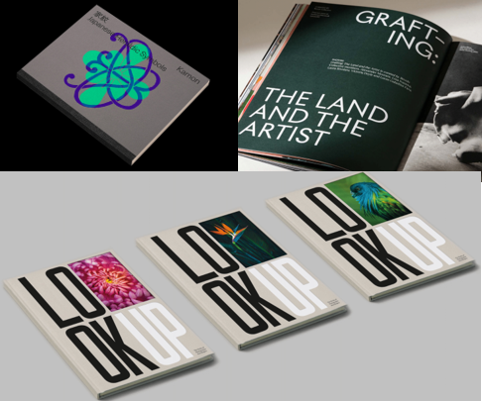

An array of applications will showcase the production possibilities of Ricoh’s broad technology portfolio

On the stand print specialists will be able to engage with a host of new technologies brought together for the first time including some that have never been seen publicly before in Europe, including the Dragon – the RICOH ProTM Z75 B2 sheetfed digital inkjet press. Shaking up the B2 sheetfed space, the first B2 perfecting (auto-duplexing) sheetfed inkjet platform using aqueous ink, accelerates the shift from offset to digital with higher print quality, faster turnaround times, and fewer demands on staff.

Joining it is the new RICOH ProTM VC80000 digital colour high speed inkjet webfed press, also known as the Harpy Eagle. With its AI capability, its new generation Ricoh printheads and its high level of integration with finishing equipment it enables commercial, book, and direct mail printers to enjoy breakthrough performance in terms of its consistently high print quality and new levels of productivity, shift after shift.
Helping print specialists ensure they thrive are both new digital colour sheetfed presses - the Jaguars. The next generation 135ppm RICOH ProTM C9500 empowers commercial printers to expand revenue streams and enhance operational efficiency with its labour-saving automation. It will be complemented by the latest in agile, versatile flexible and responsive toner-based technology in the form of the five colour RICOH ProTM C7500 digital colour sheetfed press.

Designed for speed, precision, and durability, Ricoh’s market leading printheads deliver optimum print quality while minimising downtime. Visitors can explore Ricoh’s latest generation printheads and some selected applications on the stand as well as gain insights into the inkjet printhead roadmap.
All the production technologies on display are built on Ricoh’s commitment to sustainable and responsible operations that last month achieved a double A score from global environmental non-profit organisation CDP for climate change and for water security. Ricoh also secured its 12th inclusion among the Global 100 Most Sustainable Corporations list. Visitors will see how Ricoh’s automation technologies can support print businesses’ drive to reduce their impact on the planet.
Ricoh’s software area will focus on production automation, combining cloud based and on premise solutions that aid maximum production efficiency. There will be a raft of value added software solutions that focus particularly on workflow automation, such as RICOH TotalFlowTM Producer, and RICOH SupervisorTM, as well as FusionPro® that crafts highly personalised data driven communications. Visitors will also be able to explore Ricoh’s expanding Professional Services consultancy offer including the extensive colour management support that is available.

High quality and consistent results are ensured by an array of specially developed solutions including the award winning, trailblazing RICOH Auto Color Adjuster which provides precise colour management and matching capability without the need for a colour specialist.

Some of the many ways these technologies can prove transformative for forward thinking businesses, from data driven, book, and commercial printers to enterprise operations, will be dramatised by an immersive theatre experience at the heart of the stand, where the HENKAKUVERSE and its opportunities will be presented in a spectacular way.

To spark creativity and new approaches and fire up the imagination is a print bar and applications garden featuring inspiring client cases that illustrate how Ricoh’s co-innovation approach can help different types of Print Service Provider future proof their business. Printed samples from across the technologies will be on show as well as those from Ricoh’s versatile large format systems.

Eef de Ridder, Vice President, Graphic Communications Group, Ricoh Europe: “We are excited to create a partnership environment focused on helping print production specialists unleash the power of co-innovation. We are looking forward to helping visitors from all sectors unlock business evolving opportunities with an eye on sustainable production that will enable them to responsibly shape their business success. Our expert team will be on hand to help them explore innovative ways to transform and redefine their own environments.”

For more information visit https://www.ricoh-europe.com/news-events/events/drupa-2024/.

-Ends-
| About Ricoh |
Ricoh is a leading provider of integrated digital services and print and imaging solutions designed to support digital transformation of workplaces, workspaces and optimize business performance.

Headquartered in Tokyo, Ricoh’s global operation reaches customers in approximately 200 countries and regions, supported by cultivated knowledge, technologies, and organizational capabilities nurtured over its 85-year history. In the financial year ended March 2023, Ricoh Group had worldwide sales of 2,134 billion yen (approx. 16.0 billion USD).

It is Ricoh’s mission and vision to empower individuals to find Fulfillment through Work by understanding and transforming how people work so we can unleash their potential and creativity to realize a sustainable future.

For further information, please visit www.ricoh.com

© 2023 RICOH COMPANY, LTD. All rights reserved. All referenced product names are the trademarks of their respective companies.

