Press Release

All4Labels Hamburg Boosts Productivity with Automated Platemaking

German site has benefitted from installation of CrystalCleanConnect – an automated platemaking system developed by Asahi Photoproducts, ESKO, and Kongsberg. Visitors to Asahi Photoproducts’ drupa stand will be able to learn more about this breakthrough solution.

Tokyo, Japan & Brussels, Belgium, May 16, 2024. Asahi Photoproducts, a pioneer in flexographic photopolymer plate development, today reported that All4Labels’ site near Hamburg, Germany, has seen a significant boost to its productivity since installing the CrystalCleanConnect automated platemaking system developed by Asahi Photoproducts, ESKO, and Kongsberg.

Half a year ago the German label converter installed the system to replace a manual platemaking process which resulted in ‘errors and scheduling problems,’ according to Mirco Wilke, head of prepress, flexo printing, at All4Labels Hamburg.

“Hamburg is one of the main printing facilities in the All4Labels Group,’”explains Wilke. “At the time of the installation, the focus of the prepress department was on flexibility in production and high output through all our different presses. But it was a very manual process which had some drawbacks and restricted future development. We had no automation or connectivity to our workflow systems. It was hard work for the operators to handle all the different machines. It was stressful for them and could result in errors or scheduling problems.

“CrystalCleanConnect had answers to all these problems. We could connect to our workflow systems, automate the whole process, and minimise the operator’s hands-on work.”

Collaboration
The system is the result of two years of joint development between flexo photopolymer plate pioneer Asahi Photoproducts, integrated software and hardware specialist ESKO, and Kongsberg Precision Cutting Systems, and was prompted by All4Labels Hamburg’s desire to produce plates during a night shift with minimal operator input and consistent quality.

CrystalCleanConnect fully automates the entire platemaking process, from imaging and exposure through to plate cutting, reducing the number of steps in the flexo platemaking process from 12 to just one. It delivers a 90% reduction in dedicated operator time, an average 25% increase in press OEE, and reduces ink usage by 20% .

“A standard platemaking machine with two operators can normally produce 24 plates in an eight-hour shift,” says Dieter Niederstadt, technical marketing manager at Asahi Photoproducts. “With CrystalCleanConnect, the total operator time of just one person is one hour. Everything is automated, from the laser imaging to the plate cutting, which wasn’t possible in the past. Additionally, the machine uses water-washable plates – which are certified as carbon neutral by the Carbon Trust – to allow for a solvent-free, more environmentally sustainable production.

“Standardisation is another key benefit. With different operators working different shifts, inevitably you will have different plate qualities. But if you have an automated process, then everything is standardised – every day, every month, every year – which is a huge benefit to the printer.”

According to Pascal Thomas, director of ESKO’s flexo business, CrystalCleanConnect is particularly suited to larger operations running multiple shifts. “It is a system that works well in a 24-hour operation; for example, it can be run during a night shift by a press operator who makes a few plates and then goes back to printing. Because it’s fully automatic, you don’t need much training to operate it. It’s plug and play.”

Flexibility
Mirco Wilke cites flexibility and quality as the key demands from All4Labels Hamburg’s customers – requirements that CrystalCleanConnect helps the company to deliver. “As print runs become shorter, we must always be flexible in our print production and time to market. Quality is also crucial. We have to be faster; we have to be sustainable; we have to automate as much as possible and connect with our customers in all kinds of processes and workflows.

“When we invest in new technology, we always look at the connectivity to our automation systems and workflows, and at the productivity of the machine. And of course, at the price – it must be a sustainable product for our customers and for us.”

All4Labels Hamburg was producing plates on the new system after just a couple of weeks of training. “The process was straightforward,” says Wilke. “The fact that CrystalCleanConnect allows us to put our print files directly from prepress into a whole connected system, reduce waste, reduce operator input, and automate the whole platemaking process, are huge advantages.”

“Sustainability has been at the heart of our business since we started in 1973,” says Asahi Photoproducts’ Dieter Niederstadt. “We have always used solvent-free technology. The quality is even higher than that of existing solvent-washed plates because our plates have a very low surface energy, which means that during printing all the ink is transferred to the substrate, which is a big advantage.”

A further development from Asahi, which can be linked to CrystalCleanConnect, will be unveiled at drupa. The AWP-LOOPTM system is a closed-loop waste-water recycling solution based on Asahi Kasei microza© Technology, which can recover and reuse 70 percent of the water used in the plate washing process.

A video of the interview is available here and also at the Asahi’s drupa booth.

For more information about products and services from Asahi Photoproducts that are in harmony with the environment, visit www.asahi-photoproducts.com
—ENDS—

About Asahi Photoproducts
Founded in 1973, Asahi Photoproducts is a subsidiary of Asahi Kasei Corp., which has a century of operating history. Asahi Photoproducts is a leading pioneer in the development of photopolymer flexo printing plates. By creating high-quality flexographic solutions through continued innovation, the company aims to drive printing forward in harmony with the environment. Follow Asahi Photoproducts at .
More information is available at www.asahi-photoproducts.com.
Contact:
Dr. Dieter Niederstadt
Asahi Photoproducts Europe n.v./s.a.
dieter.niederstadt@asahi-photoproducts.com
+49(0)2301 946743



Images & captions:
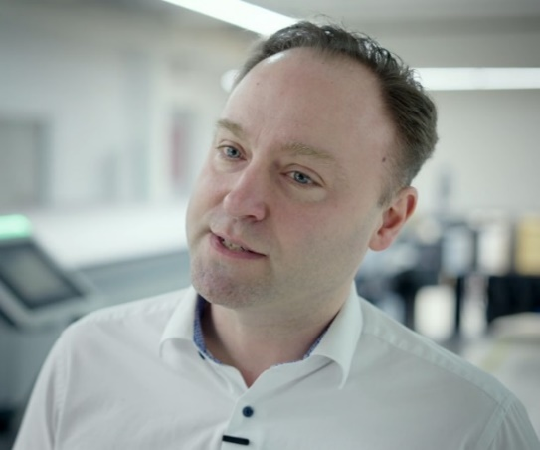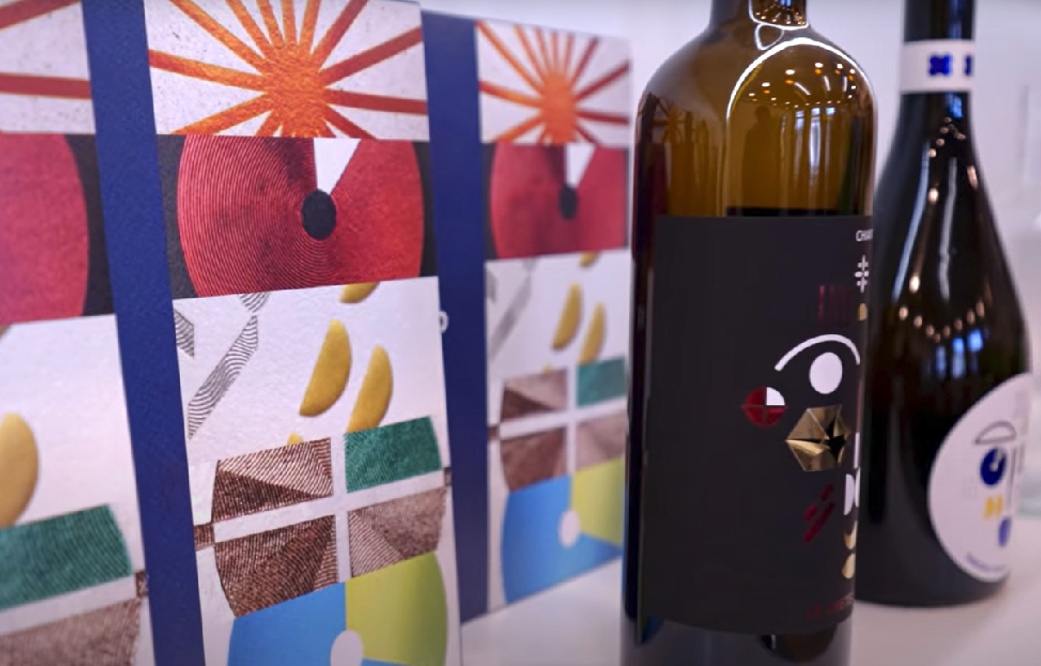
Mirco Wilke, head of prepress, flexo printing, at All4 Labels shows off a label application produced using plates created with CrystalCleanConnect.
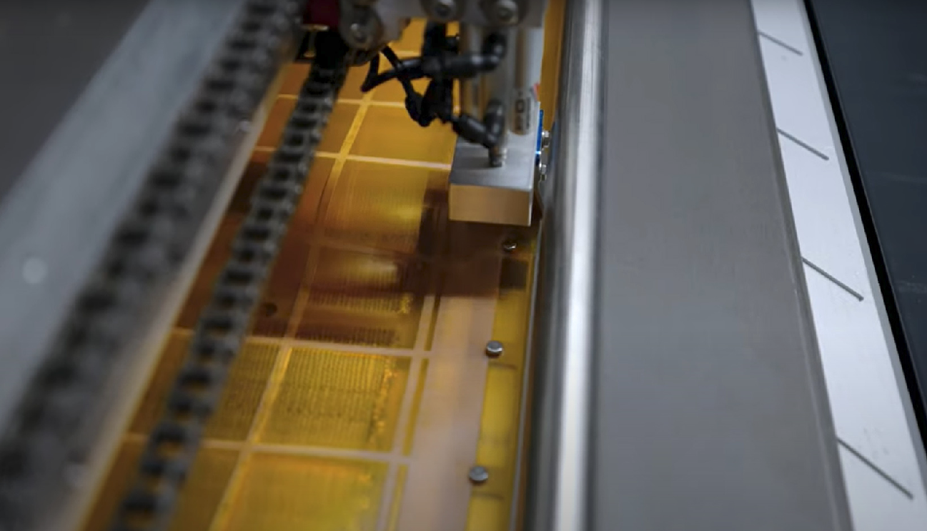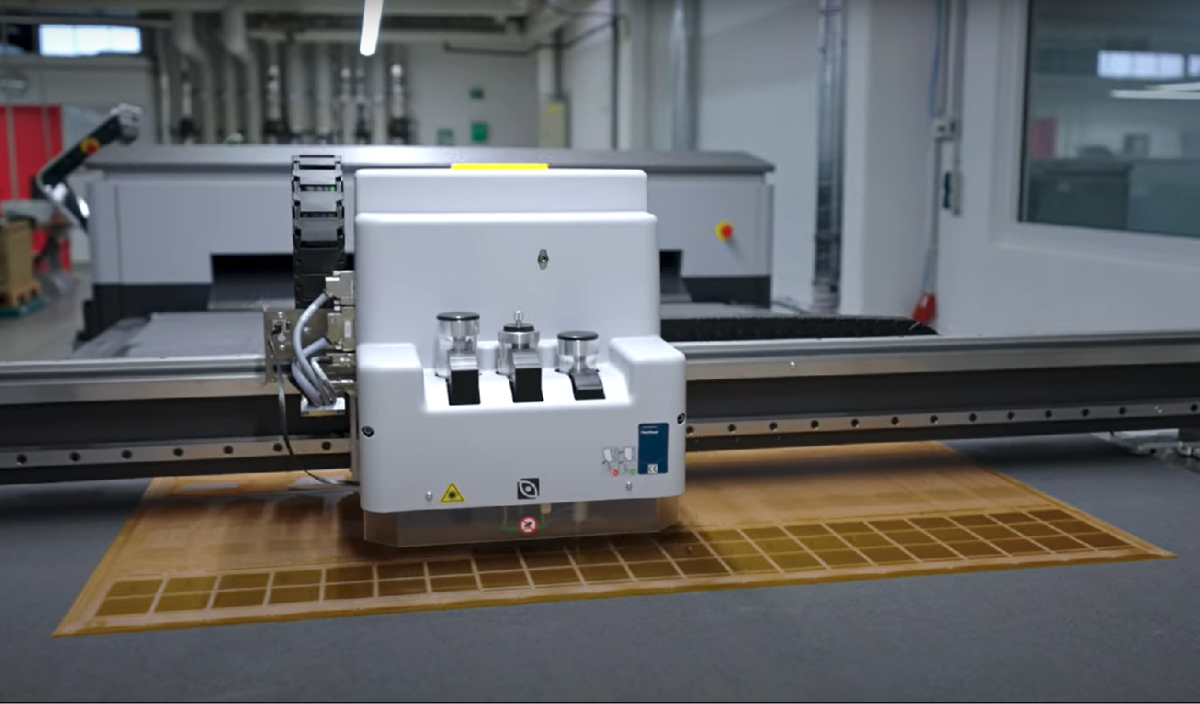
Quality Control is an important element of the packaging production process and helps eliminate waste. CrystalCleanConnect has built-in quality control to meet this critical requirement.
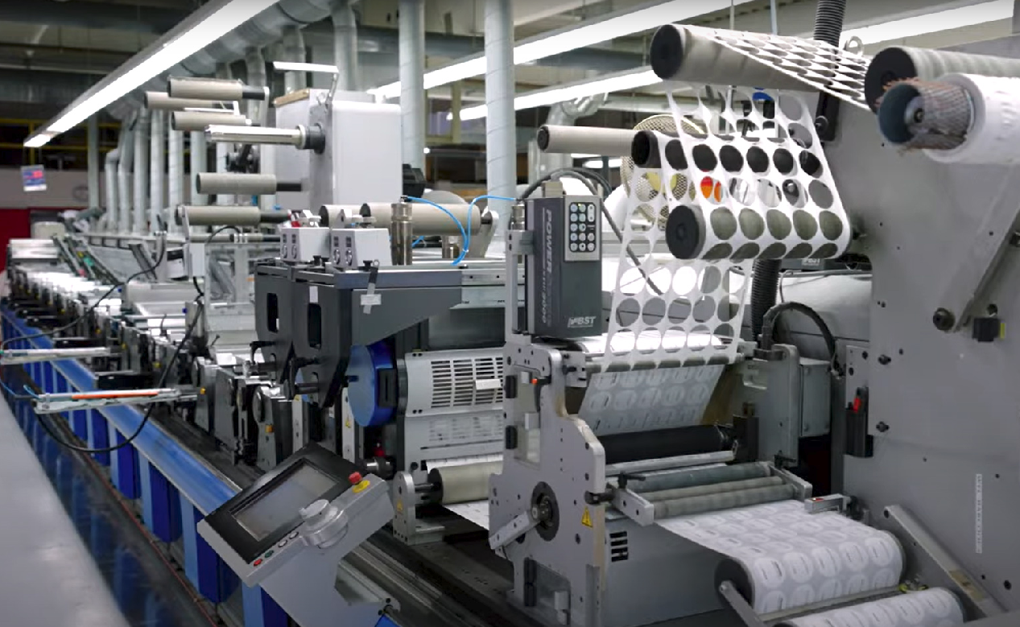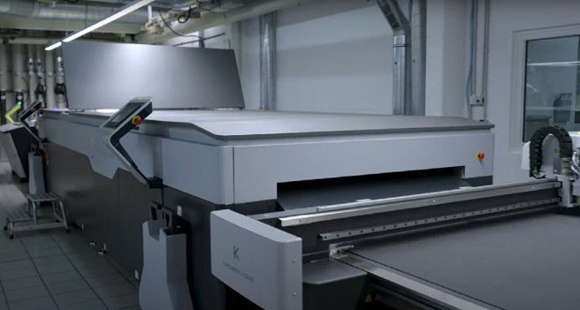
Press room at All4Labels CrystalCleanConnect at All4Labels in Hamburg

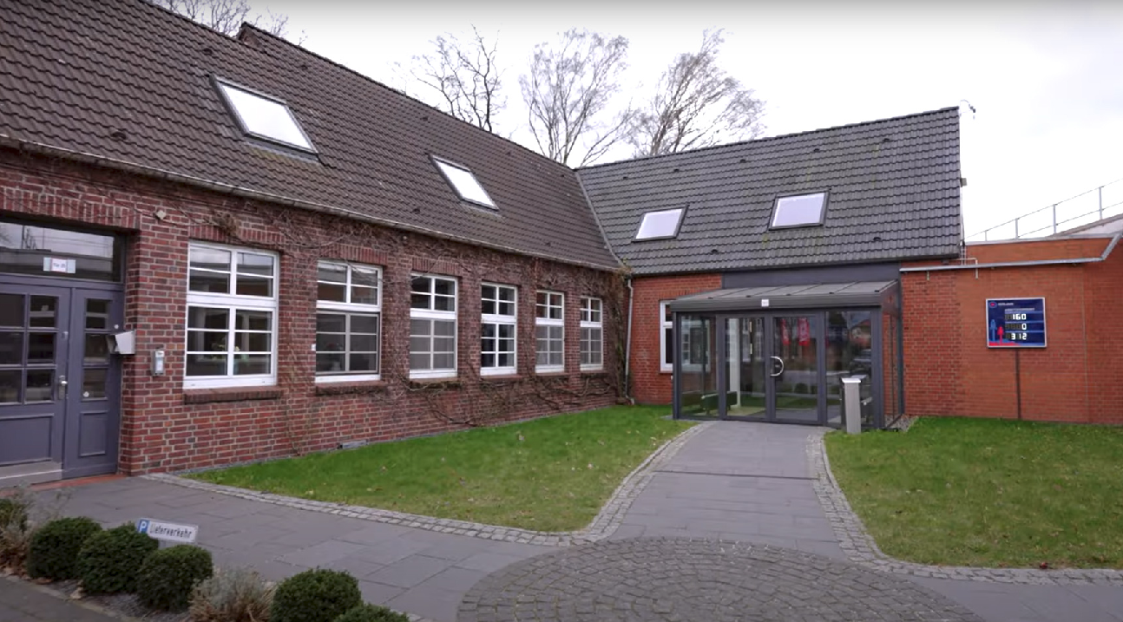
All4Labels building near Hamburg, Germany

