Application versatility broadened by Ricoh’s new High Caliper Media Customisation enhancement
Ability to print on substrates up to 800 microns unleashes fresh opportunities for RICOH Pro™ C9500 production

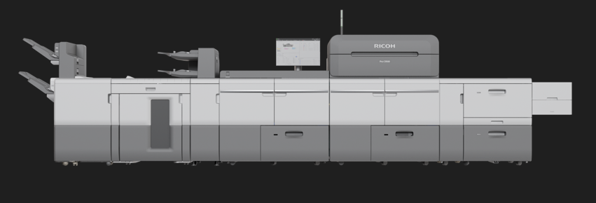
London, January 09 2025 – Digital print production versatility has been enhanced with Ricoh’s new High Caliper Media Customisation service. The latest technology upgrade for the Ricoh Pro C9500 digital colour sheetfed press enables printing on a range of Ricoh approved paper thicknesses of up to 800 microns.

Ricoh’s new High Caliper Media Customisation service broadens the Ricoh Pro C9500’s application capabilities

The High Caliper Media Customisation service will enable Print Service Providers (PSPs) to target growth with exciting market opportunites ranging from loyalty and gift cards to thick media brochures, bespoke luxury packaging, compostable food cartons, high impact direct mail inserts, and eyecatching point of purchase applications.
The versatile and responsive production of crisp, vibrant, and sharp print, with inline personalisation and coding capabilities, on heavier substrates, supports the cost effective provision of profitable short runs, customised offers, and localised promotion.
Erwin Busselot, Director Business Innovation & Solutions, Ricoh Graphic Communications, says: “The High Caliper Media Customisation service is the latest enhancement for the Pro C9500, and it demonstrates our continuing commitment to developing the production versatility of our digital systems as part of our Co-innovation strategy. This new enhancement supports a wider range of exciting application possibilities, enabling our clients to grow their businesses. This includes the production of loyalty and gift cards and co-innovative collaborations such as the recently announced partnership with Green Gift Cards. It also presents fresh opportunities in high margin areas such as luxury business cards, swing tags, and gift card packaging.”

Ricoh’s High Caliper Media Customisation service is available now in Europe on new Pro C9500 presses. It is also retrofittable.

-Ends-
| About Ricoh |
Ricoh is a leading provider of integrated digital services and print and imaging solutions designed to support digital transformation of workplaces, workspaces and optimize business performance.

Headquartered in Tokyo, Ricoh’s global operation reaches customers in approximately 200 countries and regions, supported by cultivated knowledge, technologies, and organizational capabilities nurtured over its 85-year history. In the financial year ended March 2024, Ricoh Group had worldwide sales of 2,348 billion yen (approx. 15.5 billion USD).

It is Ricoh’s mission and vision to empower individuals to find Fulfilment through Work by understanding and transforming how people work so we can unleash their potential and creativity to realize a sustainable future.

For further information, please visit www.ricoh.com

© 2024 RICOH COMPANY, LTD. All rights reserved. All referenced product names are the trademarks of their respective companies.

Media contact:
Ricoh Europe PLC
Charlotte Fernandez
E-mail: media@ricoh-europe.com
Homepage: www.ricoh-europe.com

