Press Release
Asahi Photoproducts to Showcase Sustainable Flexographic Innovations at Print4All 2025 on the Road to Solvent ZERO
Asahi Photoproducts showcases proven flexographic plate solutions that help printers reduce their environmental footprint and boost operational efficiency—advancing the industry’s shift toward sustainable production.
Milan, Italy – March 24, 2025 – Asahi Photoproducts, a pioneer in flexographic photopolymer plate development and a subsidiary of Asahi Kasei, announced today that it will exhibit at Print4All 2025, taking place May 27–30 at Fiera Milano City in Milan. Located at Pavillon 9P, Stand C07 D10, the company will showcase its technologies under the theme “The Road to Solvent ZERO,” demonstrating how its solutions support the industry’s shift toward more sustainable and efficient flexographic production—without compromising on quality.
Print4All is recognized as a leading European event for the printing and converting sector, spotlighting innovations in automation, digital transformation, and environmentally responsible production. Asahi Photoproducts’ presence will demonstrate how its portfolio of solutions—both solvent-reducing and water-wash—responds to these trends in a practical, scalable way.
"At Print4All, we’re not just presenting products—we’re showcasing a clear path forward for flexographic printers,” said Andrea Belloli, Italian Branch Manager at Asahi Photoproducts. “At our booth, we’ll highlight our Road to Solvent ZERO in platemaking, bridging from our solvent-saving AFP™-R family plates—fully compatible with existing workflows—to our latest innovation, the AWP™ water-washable flexographic plate Eco-System. Designed to eliminate VOC solvents from the washout solution while boosting quality and efficiency, this breakthrough solution is setting new standards for both sustainability and performance.”
Key Technologies on Display
• AFP™-R Plate Family (AEPF/AEPR) Part of Asahi’s roadmap toward more sustainable platemaking, the AFP™-R plate family is designed to reduce solvent consumption by approximately 30%, while shortening plate processing time by more than 50%. Available in flat (AEPF) and round (AEPR) formats, these plates are fully compatible with existing solvent-based equipment, allowing printers to upgrade sustainability and performance without major workflow changes.
• AWP™ Water-Washable Eco-System
Asahi’s flagship water-wash platemaking solution enables printers to eliminate VOC solvents entirely from the plate processing workflow. In addition to supporting safer and cleaner operations, the AWP™ plates deliver exceptional print quality, consistent performance, and measurable improvements in Overall Equipment Effectiveness (OEE).
• AWP™-LOOP System
A breakthrough in washout water recycling, this closed-loop system enables up to 70% reuse of process water. AWP™-LOOP contributes to a smaller environmental footprint and supports printers in achieving their sustainability goals without compromising throughput.
A Long-Term Partner not only for the Italian Market
Asahi Photoproducts has been active in the Italian market since 1980, working closely with local printers to provide high-quality plate materials and tailored technical support. While the company operates on a global scale, its presence at Print4All 2025—coordinated by its Italian subsidiary—underscores its commitment to local customers and their evolving needs in packaging and label production.
Join Us at Print4All
Visitors to Asahi’s booth at Print4All 2025 will learn firsthand how the company’s plate technologies contribute to a smarter, cleaner, and more productive flexo platemaking process. From reducing VOC solvent use to achieving full VOC solvent elimination, Asahi offers a roadmap that meets printers where they are—while helping them prepare for where the industry is going.
For press interviews, please contact Monika Dürr via email at monika.duerr@prservices24.onmicrosoft.com
For more information about products and services from Asahi Photoproducts, visit us at www.asahi-photoproducts.com.
—ENDS—
About Asahi Photoproducts
Founded in 1973, Asahi Photoproducts is a subsidiary of Asahi Kasei Corp., which has a century of operating history. Asahi Photoproducts is a leading pioneer in the development of photopolymer flexo printing plates. By creating high-quality flexographic solutions through continued innovation, the company aims to drive printing forward in harmony with the environment. Follow Asahi Photoproducts at  .
More information is available at www.asahi-photoproducts.com.
Contact:
Dr. Dieter Niederstadt
Asahi Photoproducts Europe n.v./s.a.
dieter.niederstadt@asahi-photoproducts.com
+49(0)2301 946743



Image & caption :

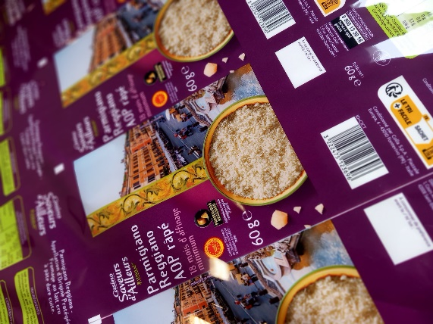
Explore award-winning flexographic print samples at the Asahi Photoproducts booth reveal what’s possible when sustainability meets high-performance. These prints reflect the future of packaging and label production.

