Press Release
Asahi Photoproducts expands its AWP™ Ecosystem at Labelexpo Europe 2025 in Barcelona
Compact Ecosystem enables sustainable flexo plate processing without detergents and up to 90% water reuse for small-format flexographic printers
Brussels and Tokyo – June 26, 2025 – Asahi Photoproducts, a pioneer in sustainable flexographic plate development, will present its latest solutions for the label market at Labelexpo Europe 2025, hosted at the Gallus partner booths 3E23 & 3E29. The company will highlight the AWP™ Ecosystem, a water-based flexographic plate processing solution that aligns with Asahi’s “Solvent ZERO” strategy”.
Detergent reduction for Small-Format Flexographic Printers
At the heart of Asahi’s sustainable flexo strategy is the AWP™ Ecosystem. It is designed to eliminate solvents and minimize resource consumption, delivering both environmental advantages and measurable gains in production efficiency and Overall Equipment Effectiveness (OEE).
At the exhibition, Asahi will outline its future direction by demonstrating the concept of the recently installed new AWP™ system using just water and no detergents in their plate processing.
- New AWP™ water plate.
A water-washable photopolymer plate that requires just water for processing—eliminating the need for detergents. It offers high-resolution print quality and contributes significantly to reduced press downtime, consistent performance, and simplified handling.
- AWP™-2530AA Plate Processor
A compact, all-in-one processor engineered for small-format plate sizes. It features a user-friendly interface, refined brush design for easy washout, and optimized fine-screening capabilities to ensure consistent color reproduction in short-run environments.
- AWP-LOOP™ Petite
A closed-loop water recycling unit that uses Asahi Kasei’s Microza™ membrane filtration technology to recover and reuse up to 90% of the process water. This significantly reduces wastewater and operating costs, enabling a more sustainable and efficient platemaking workflow.
By integrating these components, the AWP™ Ecosystem sets a new benchmark for solvent-free, small-format flexo platemaking, delivering both sustainability and enhanced productivity.
The first AWP™ system which is using just water with less detergents in the washout solution is currently installed at The Oldham Group in the United States. The solution is expected to be commercialized soon. In addition to the AWP™ Ecosystem, Asahi will also provide insights into upcoming flexographic innovations.
New AWP™ flat top plate enters high-quality segment compatible with all ink applications.
Asahi will be showcasing printing samples by a new FlatTop plate, which is currently developed to perform together with the latest screening and laserimaging technologies, aiming to meet the demands of high-end label and flexible packaging printers. The new plate is designed for high solid ink densities and fine, crisp, detailed printed characters and print samples could be previewed at Labelexpo.
Outlook
Asahi plans to expand the modular AWP-LOOP™ system to support larger formats in the future. With growing interest in fully water-washable, detergent-free plate processing, the company continues to expand its portfolio of sustainable solutions aimed at helping printers improve quality and reduce environmental impact.

For representatives of the media / appointments at Labelexpo:
To schedule a meeting or background briefing at the show, please contact Monika Dürr, press coordinator for Asahi Photoproducts: monika.duerr@prservices24.onmicrosoft.com
For more information about Asahi Photoproducts and its sustainable solutions, please visit www.asahi-photoproducts.com or contact hello@asahi-photoproducts.com.

—ENDS—

About Asahi Photoproducts
Founded in 1973, Asahi Photoproducts is a subsidiary of the Asahi Kasei Corporation, established in Japan in 1922. Asahi Photoproducts is a pioneer in the development of photopolymer flexo printing plates, committed to advancing flexographic printing through high-quality solutions and cutting-edge technologies.
Our flexo plates are engineered to deliver outstanding print quality while reducing waste in production and enabling faster press speeds for higher overall efficiency. These advancements are driven by our long-term sustainability strategy, focused on reducing solvent use and promoting a complete switch to water-wash technology.
We believe that sustainable innovation is key to the future of print — and we support our customers in being trailblazers in achieving both environmental and production goals.
Follow Asahi Photoproducts at  .
More information is available at www.asahi-photoproducts.com.
Contact:
Dr. Dieter Niederstadt
Asahi Photoproducts Europe n.v./s.a.
dieter.niederstadt@asahi-photoproducts.com
+49(0)2301 946743

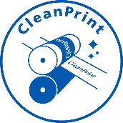

Images & captions :

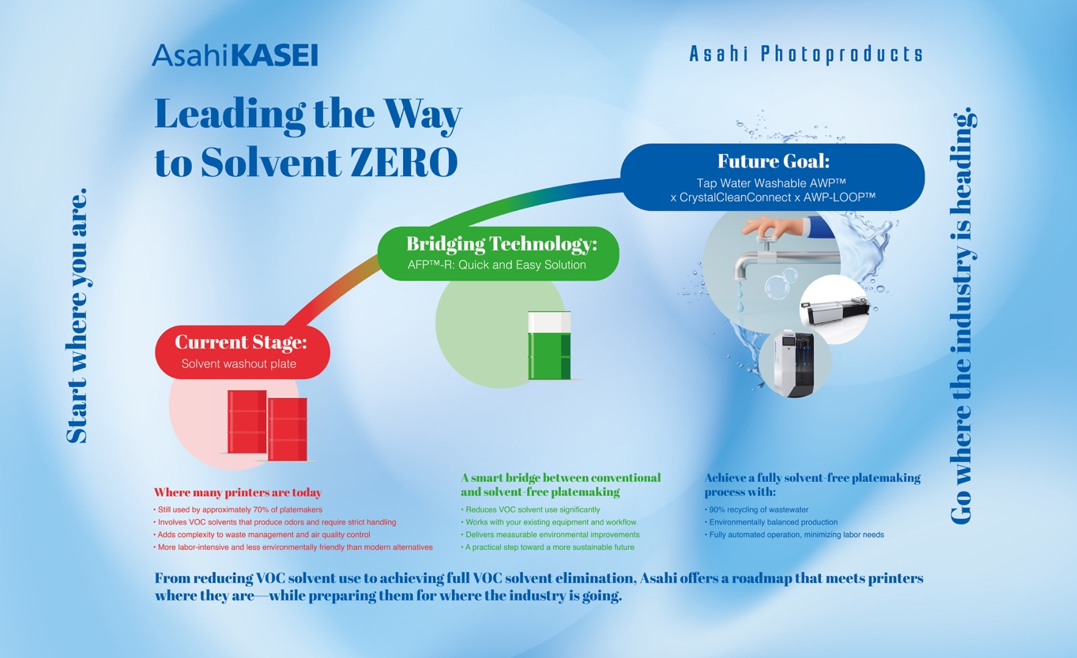
Graphic: Leading the Way to Solvent ZERO – At Labelexpo Europe 2025, Asahi Photoproducts presents its vision for Solvent ZERO, advancing the future of sustainable platemaking through innovation and environmental responsibility.

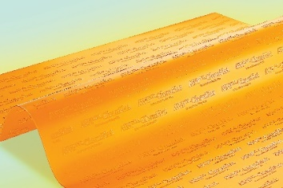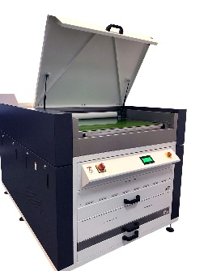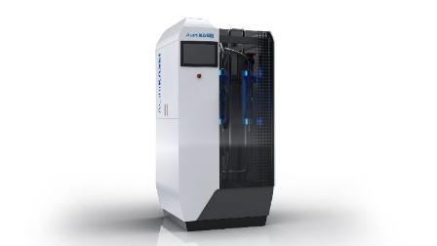
The new AWP™ Ecosystem is specially designed to offer a complete sustainable solution for small-format platemaking needs.

