What happens when you combine Artificial Intelligence, print, and great art?

By Angelo Mandelli, Senior Product & Business Development Manager, Large Format & Flatbed EMEA Product Marketing, Ricoh Graphic Communications Group

Ricoh Europe, London, July 11 2025 – What if we could see Venice through the eyes of great 19th and 20th century painters who never actually painted it?

Apparently, it would look a lot like this:
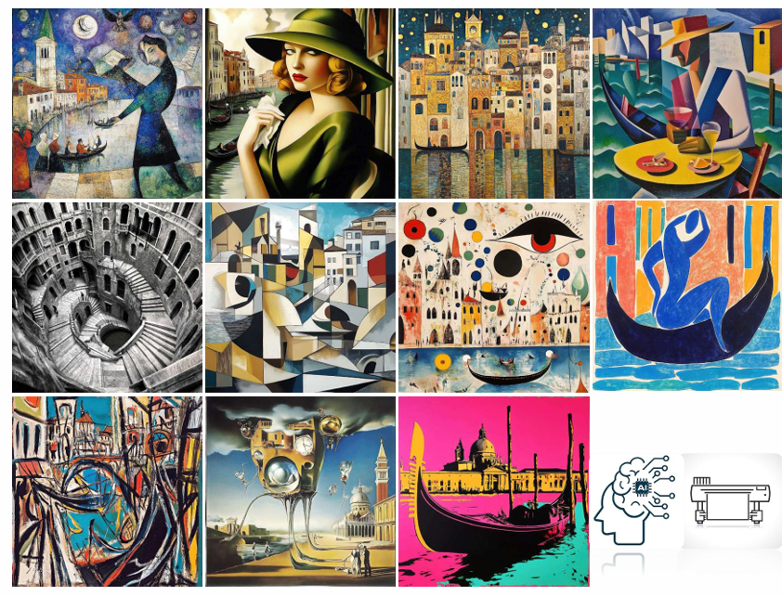
Who do you recognise? Picasso, Escher, Lempicka? How about Dali, Chagall, or Warhol?

These are what the students at Salesiani Don Bosco Graphic Arts School created when we asked them to imagine how legendary painters would have captured their home city of Venice.
Using Artificial Intelligence and state of the art Ricoh printing technology - the RICOH Pro™ TF6251 flatbed UV printer - a virtual collection of works about Venice was curated in the style of the legendary artists who never painted it.

Firstly, art movements including Expressionism, Surrealism, and Abstract, were researched. Each painter’s techniques, colour palettes, compositional choices, and stylistic approaches were analysed. Mood boards were created to capture each artist's unique creative vision.

Secondly, the AI-created mood board provided the basis for informing the most effective design criteria and special instructional prompts that trained AI for each unique aesthetic. The works were then generated, curated, and the output upscaled for high quality print production.

The digital artworks were transformed into physical pieces by the Pro TF6251 flatbed printer.

With results like this:

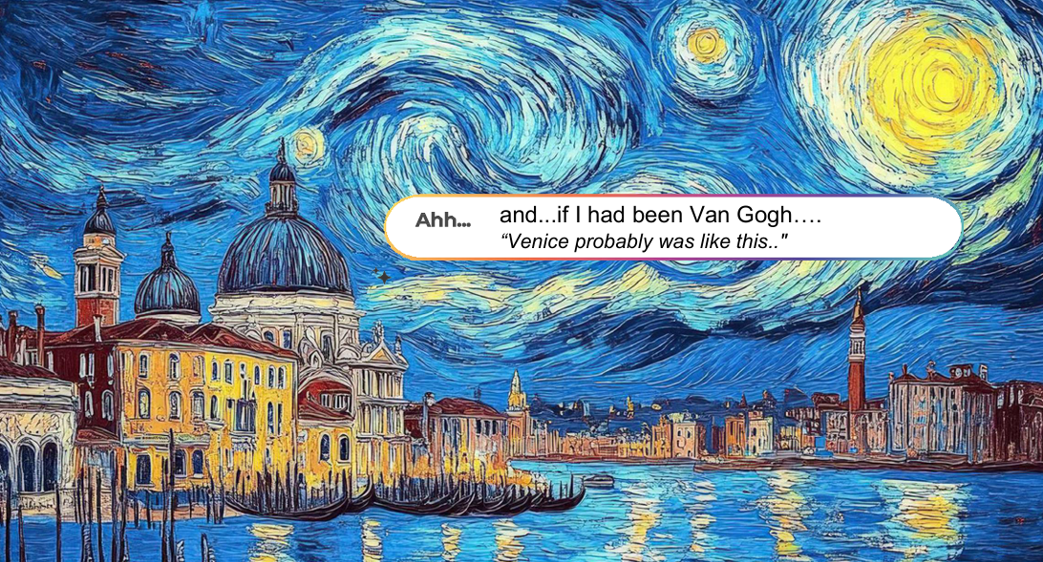

AI-generated artwork that not only looks but feels like it was painted by human hands.

The technology brought these virtual visions to life with:
- Multilayer printing that simulated real brushstroke textures.
- Multiple drop size technology with Ricoh fifth generation printheads for intricate detail.
- ColorGATE RIP software for colour management and ICC profile optimisation.
- Flexible UV inks that handle a wide variety of surfaces and materials.
- The capability to print directly on media up to 10cm thick, including canvases.

Ricoh’s technology served not just as a tool, but as an enabler of imagination - una musa senza tempo (an eternal muse).

By Co-innovating with the educators and students of Salesiani Don Bosco, we have created a real life example of how print and AI can expand the possibilities and push the boundaries of communication, design, and human expression. Talk to us to learn more.

| About Ricoh |
Ricoh is a leading provider of integrated digital services and print and imaging solutions designed to support digital transformation of workplaces, workspaces and optimize business performance.

Headquartered in Tokyo, Ricoh’s global operation reaches customers in approximately 200 countries and regions, supported by cultivated knowledge, technologies, and organizational capabilities nurtured over its 85-year history. In the financial year ended March 2024, Ricoh Group had worldwide sales of 2,348 billion yen (approx. 15.5 billion USD).

It is Ricoh’s mission and vision to empower individuals to find Fulfilment through Work by understanding and transforming how people work so we can unleash their potential and creativity to realize a sustainable future.

For further information, please visit www.ricoh.com

© 2025 RICOH COMPANY, LTD. All rights reserved. All referenced product names are the trademarks of their respective companies.

