Faster operation and greater usability powered by the new RICOH Pro™ C5400 Series

Enhanced usability and print quality meet the diverse needs of commercial and enterprise operations

London, June 9, 2025 – Ricoh, a print and digital services leader, has today announced the launch of the new RICOH Pro C5400 Series of colour production printers. This latest production printer, which combines both enhanced speed of production and operation with greater usability, has been built to ensure it continues to meet the diverse needs of commerical and enterprise operations.

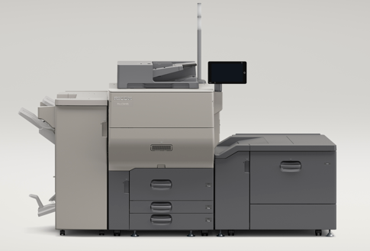
The new RICOH Pro C5400 Series will help clients drive revenue growth

Building on the high speed output and excellent paper handling strengths of its predecessors, the RICOH ProTM C5310S/C5300S/Pro C5300SL systems, the Pro C5400 Series features significant improvements in overall core performance.
For commercial printing applications, the high quality production printers deliver improved image registration accuracy achieved through enhanced paper feeding stability and more precise image adjustment functions.

The series supports various types of media, including coated paper, waterproof paper, envelopes, clear files, and long sheet printing up to 1,300 mm. It will enable clients to meet a wide range of promotional material production needs, with improved ease of use and greater operational efficiency while also helping to drive revenue growth. These enhanced core specifcations include:

- Warm up time drastically reduced from 120 seconds to 26 seconds^{*1} for the Pro C5410S and 30 seconds^{*1} for the Pro C5400S.
- Faster scanning^{*3} speed. Duplex scanning up to 300 pages per minute. Workflow efficiency is elevated by new AI-powered orientation detection and support for continuous scans of small format documents such as business cards.
- Increased touchscreen capabilities significantly improving usability.
- Elevated paper setting user interface, ensuring consistent print quality.
- Finisher option featuring an industry-first^{*2} stapleless binding function that uses water to moisten and press the papers together, enabling stapeless binding up to 16 sheets for corner binding, or up to 12 sheets for two position binding.
- New envelope fusing option, with faster envelope printing speed, that boosts productivity.
- Space saving compact folding unit reduced to a width of 209 mm, less than half of the previous model.
- Improved paper transport stability and enhanced image registration accuracy for duplex and long sheet printing with a redesigned Vacuum Feed Large Capacity Input Tray (LCIT).
- Higher precision image alignment with trapezoidal and right-angle correction functions.
- Simplified transfer conditions adjustment streamlining setup and minimising preprinting adjustment time.

The use of recycled materials has been increased by more than five times in this series compared to its predecessor, contributing to clients' environmental management initiatives.

“Greater production capacity and versatility is enabled by the new Pro C5400 Series that has been designed to help commercial and enterprise operations expand their capabilities,” says Eef de Ridder, Vice President, Graphic Communications Group, Ricoh Europe. “Print production environments need to consistently and flexibly meet greater demand for a wider range of short run applications. The comprehensive upgrades are all focused on powering consistent, high quality print on a range of substrates to ensure operations can confidently and repeatedly achieve that.”

The RICOH Pro™ C5400 series is commercially available from July in EMEA.

For more information visit https://www.ricoh-europe.com/products/production-printers/cut-sheet-printers/pro-5400s-series/

-Ends-
| About Ricoh |
Ricoh is a leading provider of integrated digital services and print and imaging solutions designed to support digital transformation of workplaces, workspaces and optimise business performance.
Headquartered in Tokyo, Ricoh’s global operation reaches customers in approximately 200 countries and regions, supported by cultivated knowledge, technologies, and organisational capabilities nurtured over its 85-year history. In the financial year ended March 2025, Ricoh Group had worldwide sales of 2,527 billion yen (approx. 16.8 billion USD).
It is Ricoh’s mission and vision to empower individuals to find Fulfillment through Work by understanding and transforming how people work so we can unleash their potential and creativity to realise a sustainable future.
For further information, please visit www.ricoh.com

Media contact:
Ricoh Europe PLC
Charlotte Fernandez
E-mail: media@ricoh-europe.com
Homepage: www.ricoh-europe.com

