Enhanced textile production versatility delivered by the latest addition to Ricoh’s textile portfolio: the XTF D430
Endless application creativity made possible by the versatile, compact, and affordable system

London, June 26, 2025 – Next generation textile on demand production quality and versatility for small to medium Print Service Providers is delivered by the XTF D430.
Ideal for business to business or business to consumer operations due to its low investment, stable quality, low running costs, ease of use, and small footprint, the direct to film system powered by Ricoh can produce an endless variety of printed applications including t-shirts, hoodies, hats, and shoes.

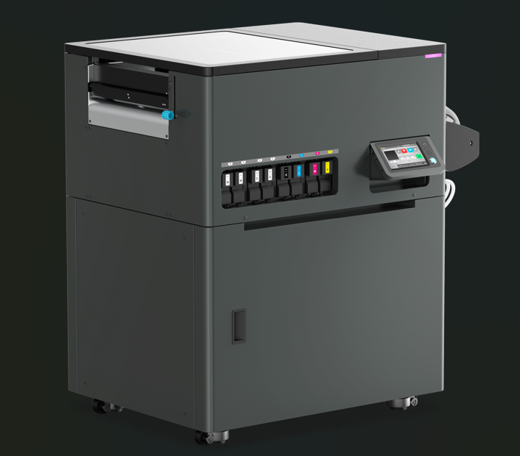
The XTF D430 delivers next generation on demand production versatility

The compact solution achieves production quality and versatility, adopting Ricoh’s own inkjet printheads to deliver 1200 x 1200 dpi. An integrated cutting unit will offer roll to roll and roll to cut options for material widths up to 432mm. Its wet cap technology keeps nozzles clog free while the independently controlled four zone heater system enables rapid drying, ensuring each colour and white layer of ink is sharp.
Key features of the latest addition to Ricoh’s textile solutions portfolio include:
- Superior print quality - Unmatched colour accuracy and detail are enabled by Ricoh’s own highly robust and reliable piezo printheads.
- Seamless workflow and precise colour control – Working with ColorGATE Productionserver software supports elevated print capabilities.
- Versatile applications - Ideal for a diverse array of customised apparel and promotional products.
- Ease of use – Intuitive touch screen simplifies control and allows operations to speed up and automate production processes.
- Exceptional durability - The XTF D430 is designed to withstand wear and tear, ensuring that prints maintain their vibrant appearance over time.
Graham Kennedy, General Manager, Industrial Solutions, Ricoh Printing Solutions Europe, comments: “Ricoh’s innovative mindset has enabled us to push the boundaries of what’s possible in custom DTF printing. The versatile XTF D430 is a testament to our commitment to quality, creativity, and service, providing our clients with a tool that I am confident will not only meet, but exceed, their expectations.”
The XTF D430 is now available across EMEA, distributed by Ricoh Printing Solutions Europe Ltd.
-Ends-
| About Ricoh |
Ricoh is a leading provider of integrated digital services and print and imaging solutions designed to support digital transformation of workplaces, workspaces and optimise business performance.
Headquartered in Tokyo, Ricoh’s global operation reaches customers in approximately 200 countries and regions, supported by cultivated knowledge, technologies, and organisational capabilities nurtured over its 85-year history. In the financial year ended March 2025, Ricoh Group had worldwide sales of 2,527 billion yen (approx. 16.8 billion USD).
It is Ricoh’s mission and vision to empower individuals to find Fulfillment through Work by understanding and transforming how people work so we can unleash their potential and creativity to realise a sustainable future.
For further information, please visit www.ricoh.com
Media contact:
Ricoh Europe PLC
Charlotte Fernandez
E-mail: media@ricoh-europe.com
Homepage: www.ricoh-europe.com

