Press Release
Sustainable Pasta Packaging: Don Quijote’s Shift to Flexographic Printing
Water-Washable Technology Reduces CO₂ Emissions by 60% in Printing Process
Tokyo, Japan – July 24, 2025 – In response to growing concerns over the environmental impact of food packaging, Japanese companies are taking innovative steps to cut emissions without compromising quality. A new collaboration between Don Quijote Co., Ltd. (Pan Pacific International Holdings Corporation), Sagawa Printing Co., Ltd., and Asahi Kasei—parent company of Asahi Photoproducts—has led to a significant reduction in CO₂ emissions in the printing of frozen pasta packaging.
For the private-label “Yaba Mori Pasta” series, Don Quijote Co., Ltd. has chosen to implement water-based flexographic printing, using Asahi’s AWP™ water-washable flexographic plate. This printing method replaces conventional solvent-based gravure printing, a dominant practice in Japan, and marks a forward-thinking step in sustainable food packaging.
Sagawa Printing established the optimal printing conditions for this transition in close collaboration with Asahi Kasei. According to their calculations, this method is expected to reduce CO₂ emissions from the printing process by approximately 60 percent compared to conventional gravure systems.
Water-based flexographic printing inherently generates fewer emissions, thanks to the water-based inks and the AWP™ plate’s development process.
While solvent-based gravure printing continues to dominate Japan’s packaging industry, growing environmental awareness is driving interest in more sustainable alternatives. The “Yaba Mori Pasta” packaging serves as a tangible example of how food brands can reduce their environmental footprint through innovation in print technology.
Through partnerships like this, Asahi aims to contribute to a more sustainable society, promoting the elimination of VOCs and supporting cleaner production processes across the food packaging sector.
Further background on the technology behind this sustainable shift:
Asahi’s AWP™ (Asahi Water-Washable Plate) represents an innovative approach to flexographic platemaking, replacing traditional solvent-based processes with water-based solutions. This advanced technology eliminates the need for organic solvents during plate development, significantly reducing volatile organic compound (VOC) emissions and improving safety and environmental performance at printing sites. Moreover, AWP™ plates enhance print consistency, improve productivity, and deliver exceptional print quality, making them particularly suitable for high-standard food packaging applications.
The adoption of AWP™ technology is central to Asahi’s broader Solvent ZERO initiative, aimed at helping the packaging and printing industries transition away from solvent-based systems towards fully sustainable production methods. Through Solvent ZERO, Asahi encourages printers worldwide to adopt water-based flexographic systems, promoting cleaner air, safer working environments, and substantial reductions in carbon footprints. The “Yaba Mori Pasta” packaging project clearly demonstrates the practical benefits of embracing such advanced flexographic solutions, highlighting measurable sustainability gains without compromising print quality or operational efficiency.
By driving industry-wide adoption of its Solvent ZERO principles, Asahi actively supports global sustainability goals and the growing demand for environmentally responsible packaging solutions.
A Japanese version of this press release is available here.
For more information, please reach out via email at hello@asahi-photoproducts.com or visit our website at www.asahi-photoproducts.com.
—ENDS—
About Asahi Photoproducts
Founded in 1973, Asahi Photoproducts is a subsidiary of the Asahi Kasei Corporation, established in Japan in 1922. Asahi Photoproducts is a pioneer in the development of photopolymer flexo printing plates, committed to advancing flexographic printing through high-quality solutions and cutting-edge technologies.
Our flexo plates are engineered to deliver outstanding print quality while reducing waste in production and enabling faster press speeds for higher overall efficiency. These advancements are driven by our long-term sustainability strategy, focused on reducing solvent use and promoting a complete switch to water-wash technology.
We believe that sustainable innovation is key to the future of print — and we support our customers in being trailblazers in achieving both environmental and production goals.
Follow Asahi Photoproducts at  .
More information is available at www.asahi-photoproducts.com.
Contact:
Dr. Dieter Niederstadt
Asahi Photoproducts Europe n.v./s.a.
dieter.niederstadt@asahi-photoproducts.com
+49(0)2301 946743



Images & captions :
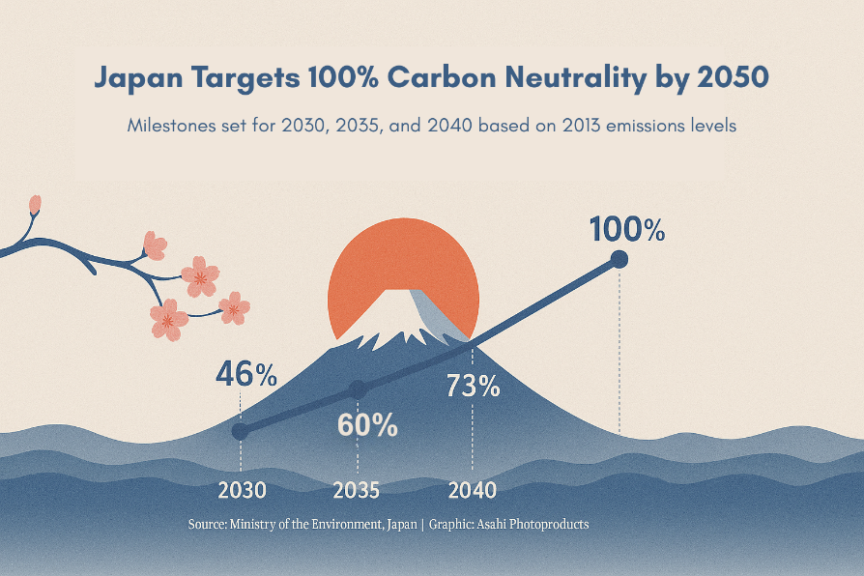
Caption: Japan’s carbon neutrality roadmap highlights planned emission reductions of 46% by 2030 and full neutrality by 2050. The country’s packaging and printing industry, including innovations by Asahi Kasei, is seen as a key contributor to these goals.
Source: Figures based on data from the Ministry of Foreign Affairs of Japan (https://www.mofa.go.jp/mofaj/ic/ch/page1w_000121.html), Image credit: Asahi Photoproducts.
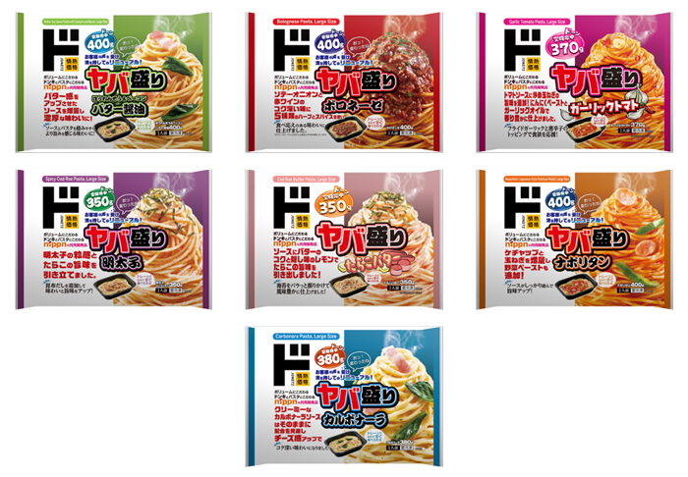

Caption: Packaging with purpose – Yaba Mori Pasta now printed with 60% fewer CO₂ emissions.
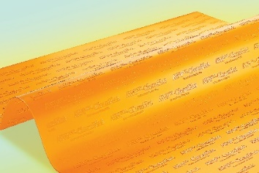
Caption: From plate to package: Asahi’s AWP™ technology drives sustainable print for food brands.

