Press Release
Asahi Photoproducts Introduces a Flexographic REVOlution at Labelexpo Europe 2025 in Barcelona with the REVO SERIES
Introduction of the new REVO SERIES, a product family of sustainable flexographic solutions combining modern technology with a simplified, more reliable workflow.
Brussels and Tokyo – September 16, 2025 – Asahi Photoproducts, a pioneer in sustainable flexographic plate development, is presenting its latest solutions for the label market at Labelexpo Europe 2025, hosted at Gallus partner booths 3E23 and 3E29. The company is highlighting its new REVO SERIES plates.
Incorporating both AWP^{TM-}REVO and AFPTM REVO plate technologies, the series delivers reduced environmental impact, faster turnaround and consistent quality. These plates are part of the AWP™-REVO Ecosystem, a water-based flexographic plate processing solution that aligns with Asahi’s “Solvent ZERO” strategy; as well as AFP™-REVO for reduced solvent plate production.
Whether converters use water-wash or solvent processing, they benefit from the same stable quality, powered by Asahi’s CleanPrint technology. As part of the harmonization, Asahi has now integrated its award-winning AFPTM-R solvent plate products under the brand name of AFPTM-REVO, which has already received Esko’s Quartz Certification and is designed to meet the demanding requirements of high-end flexible packaging as well as label print production.
AWP™-REVO Ecosystem for Small-Format Flexo Printers: The Details
The AWP™-REVO Ecosystem is a detergent-free, water-based flexographic plate processing solution that reduces solvents and minimizes resource consumption, delivering environmental benefits and measurable gains in production efficiency. In practice, it produces print-ready AWP™-REVO plates in about an hour, and with CleanPrint technology, converters experience excellent ink transfer, and fewer press stops for plate cleaning. With the AWP-LOOP™ Petite water recycling unit, up to 90% of washout water is recycled for reuse. AWP™-REVO plates are available in two versions — AWP™-REVO WHR (RoundTop) and AWP™-REVO WHF (FlatTop) - to address a wide array of label applications.
Key components of the AWP™-REVO Ecosystem include:
- New AWP™-REVO water-washable plate: Water-washable photopolymer that requires only water and anti-former (no detergents). High-resolution quality, reduced press downtime, consistent performance, simplified handling.
- AWP™-REVO 2530AA Plate Processor: Compact, all-in-one processor for small-format plate sizes with user-friendly interface, refined brush design for easy washout, and optimized fine-screening for consistent color reproduction in short-run environments.
- AWP-LOOP™ Petite: Closed-loop waste-water recycling using Asahi Kasei’s Microza™ membrane filtration to recover and reuse up to 90% of process water, significantly reducing waste liquid and operating costs.
By integrating these components, the AWP™-REVO Ecosystem sets a new benchmark for detergent-free, small-format flexo platemaking, delivering both sustainability and enhanced productivity. The solution is expected to be commercially available soon.
To learn more about AWP™-REVO, watch the YouTube video here:
New AFP™-REVO Plates target the high-quality segment and are compatible with all ink systems
Asahi is also showcasing printing samples using AFP™-REVO reduced solvent plates, which have been developed to perform together with the latest screening and laser imaging technologies such as Esko Quartz, aiming to meet the demands of high-end flexible packaging printers, and suitable for label production. These new plates are designed for high solid ink densities and fine, crisp, detailed printed characters. The reduced solvent plates feature around 30% less solvent consumption during the plate making process, reduced drying time and drying energy usage as compared with conventional solvent plates.

Outlook
Asahi plans to expand the AWP™-REVO Ecosystem to support larger formats in the future. With growing interest in fully water-washable, detergent-free plate processing, the company continues to expand its portfolio of sustainable solutions aimed at helping printers to reduce their environmental impact with higher efficiency and improved quality leading to a Solvent ZERO plate production.

For representatives of the media / appointments at Labelexpo:
Members of the media are invited to drop by booths 3E23 & 3E29 during the show. To schedule a specific time for a briefing, please contact Monika Dürr, press coordinator for Asahi Photoproducts: monika.duerr@prservices24.onmicrosoft.com
For more information about Asahi Photoproducts and its sustainable solutions, please visit https://www.asahi-photoproducts.com/ or contact hello@asahi-photoproducts.com.

—ENDS—

About Asahi Photoproducts
Founded in 1973, Asahi Photoproducts is a subsidiary of the Asahi Kasei Corporation, established in Japan in 1922. Asahi Photoproducts is a pioneer in the development of photopolymer flexo printing plates, committed to advancing flexographic printing through high-quality solutions and cutting-edge technologies.
Our flexo plates are engineered to deliver outstanding print quality while reducing waste in production and enabling faster press speeds for higher overall efficiency. These advancements are driven by our long-term sustainability strategy, focused on reducing solvent use and promoting a complete switch to water-wash technology.
We believe that sustainable innovation is key to the future of print - and we support our customers in being trailblazers in achieving both environmental and production goals.
Follow Asahi Photoproducts at  .
More information is available at www.asahi-photoproducts.com.
Contact:
Dr. Dieter Niederstadt
Asahi Photoproducts Europe n.v./s.a.
dieter.niederstadt@asahi-photoproducts.com
+49(0)2301 946743

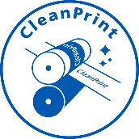

Images & captions :

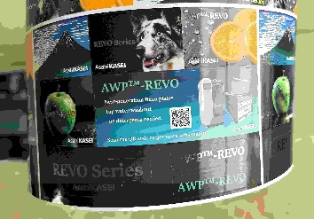
Samples at Labelexpo: Asahi is also showcasing printing samples using the new AWPTM-REVO plates.

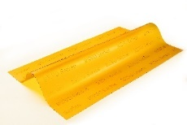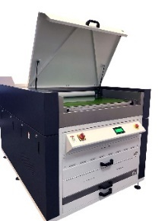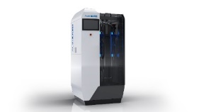
The new AWP™-REVO Ecosystem is specially designed to offer a complete sustainable solution for small-format flexographic platemaking needs.

